JAPANESE GEOTECHNICAL SOCIETY
International Seminar

THE FLAT DILATOMETER (DMT) and its APPLICATIONS to GEOTECHNICAL DESIGN
by Silvano MARCHETTI
University of L'Aquila, Italy
Tokyo, 12 Feb 1999
INDEX
- DMT equipment
- Field equipment for insertion
- Procedure in the field
- Derivation of geotechnical parameters
- Presentation of results
- Deformations due to penetration
- Comparisons with other tests
- Applications to engineering problems
Design via parameters
Settlements - "Operative modulus"
Coeff. of Consolidation and Permeability (clay)
Pore pressure in situ (sand)
Verify if a slope contains slip surfaces
Laterally loaded piles
Liquefiability of sands
Densification control & DMT sensitivity to σh
Pavement subgrade compaction control
Subgrade Kh for diaphragm walls
DMT for FEM input parameters

Revised version with expanded section on liquefaction (see also key paper by Sladen referenced there) and addition of the "Table of operative moduli by textbooks".
<marchetti@flashnet.it>
Many papers mentioned in this report may be downloaded at the bibliographic site : www.marchetti-dmt.it

1980 | ASCE paper by Marchetti  Describes original correlations (details ➔ paper)  Principle : calibrate DMT results vs high quality parameters from well documented sites

standards - recommendations
1986 | ASTM suggested method
1997 | Eurocode 7
1992 | US DOT FHA, Briaud & Miran (a manual)

soA - COMPREHENSIVE REPORTS
1989 | Lunne et al, Rio de Janeiro
1988 | Lutenegger, Orlando
1997 | Marchetti, Cairo
2001 | Totani et al. , IN SITU 2001 Bali Indonesia

GENERAL LAYOUT OF THE DILATOMETER TEST (DMT)
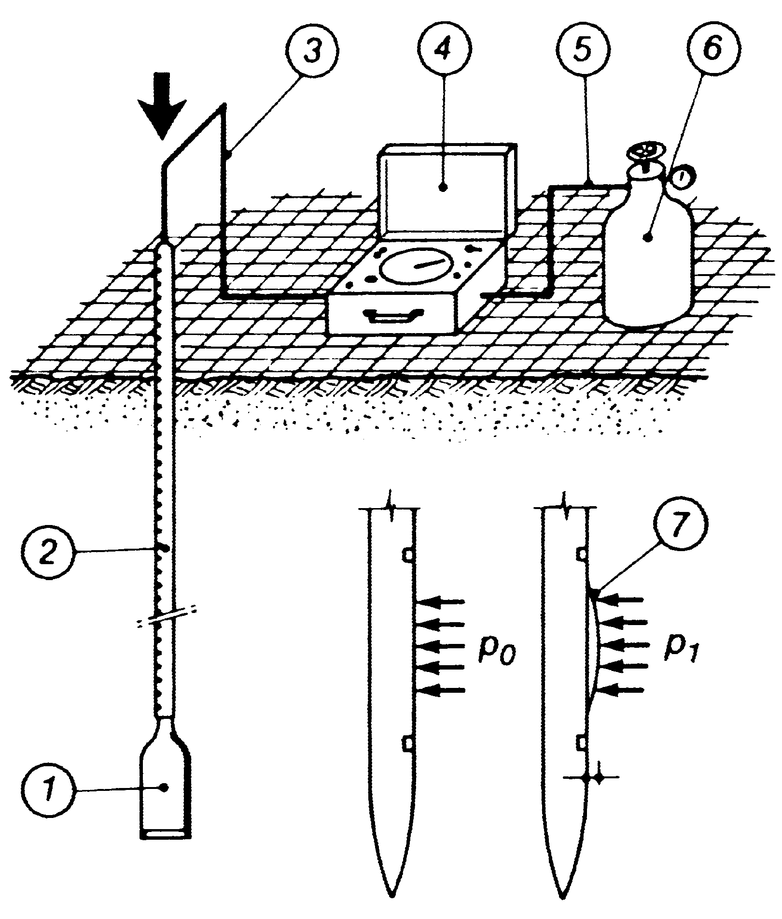
Push force provided by penetrometer or drill rig or other equipment
1.1 mm

1. Dilatometer blade | 4. Control box
2. Push rods (eg.: CPT) | 5. Pneumatic cable
3. Electric-pneumatic cable | 6. Gas tank
7. Expansion of the membrane

INTERMEDIATE DMT INDEXES
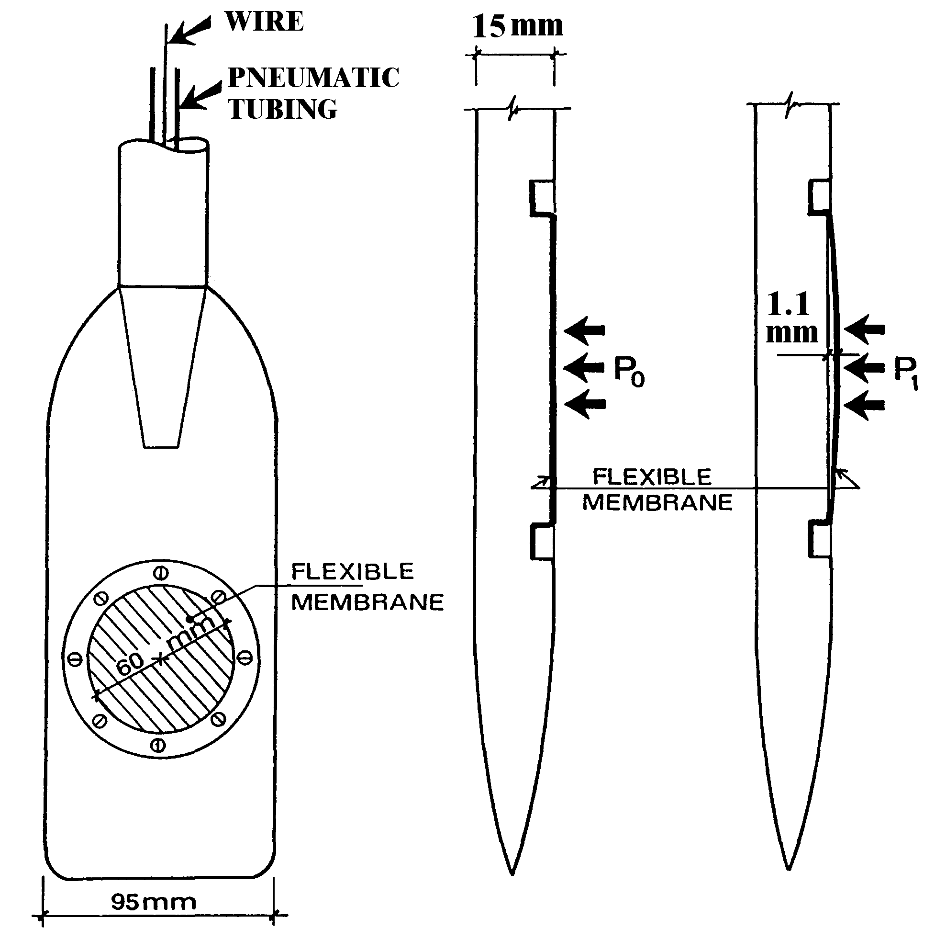

$I_{D}=\frac{p_{1}−p_{0}}{p_{0}−u_{0}}$ MATERIAL INDEX
$K_{D}=\frac{p_{0}−u_{0}}{σ_{v0}^{'}}$ HORIZONTAL STRESS INDEX
$E_{D}=\text{34}\text{.}7(p_{1}−p_{0})$ DILATOMETER MODULUS

- BUT DMT IS A TWO PARAMETER TEST !!!. (ONLY TWO INDEPENDENT, NO CREATION OF INFO)
- MEMBRANE NOT A MEASURING ORGAN (= GAGE at GROUND SURFACE). ACCURACY IS THAT OF GAGE
- MEMBRANE = PASSIVE SEPARATOR SOIL-GAS
- BALANCE OF ZERO (NULL METHOD) ACCURATE
- BLADE = ELECTRIC SWITCH (ON/OFF) (non electronic)

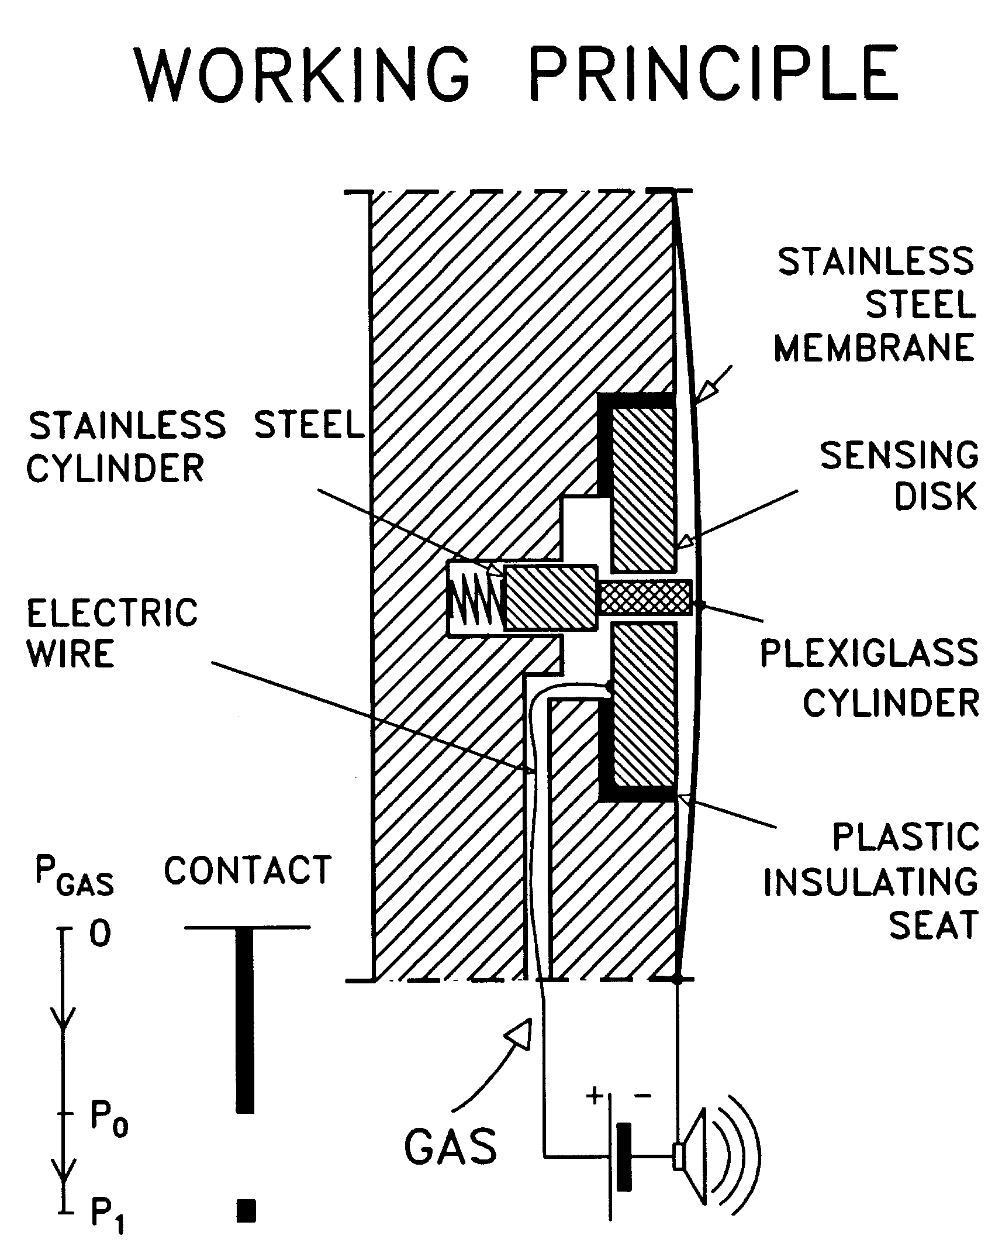

CALIBRATION OF MEMBRANE :
ΔA & ΔB ≈ TARES to be detracted
DA, DB needed to correct A,B into Po and P1
B
A
free

Layout of connections during calibration
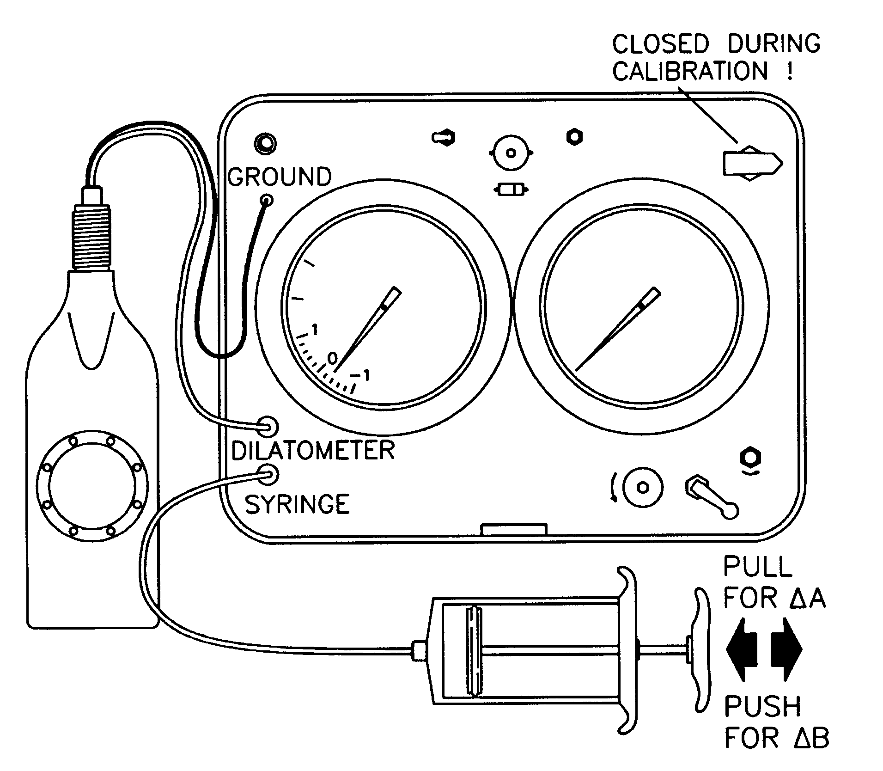

INSERTION OF THE DMT BLADE

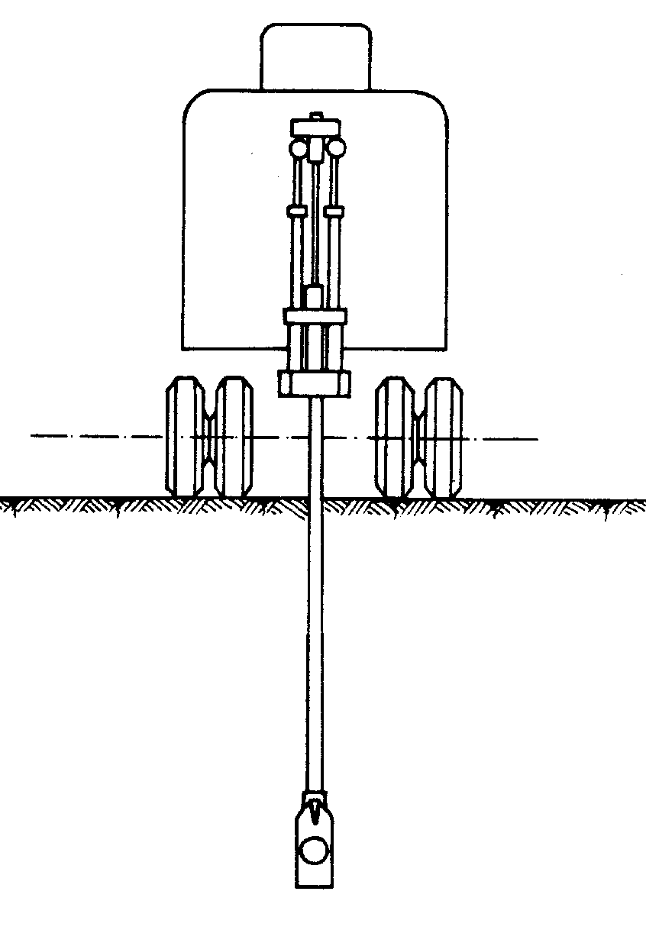
DMT USING A
PENETROMETER

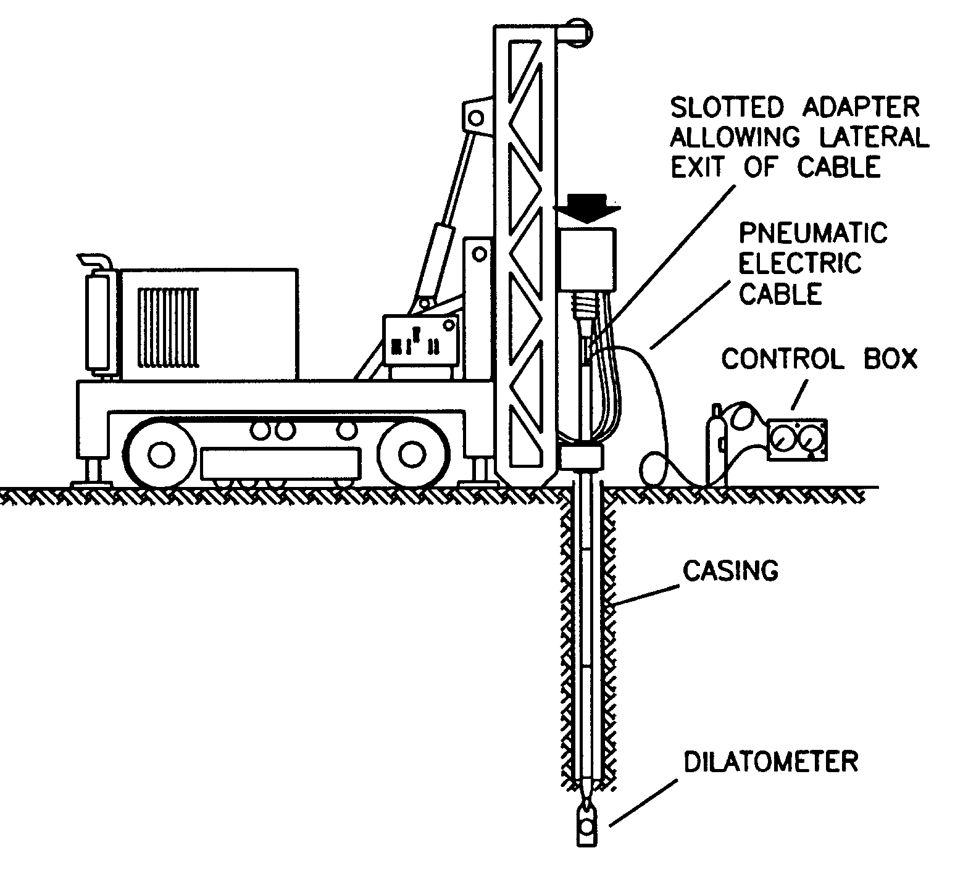
DMT USING A
DRILL RIG

PERCUSSION (e.g. SPT) : tolerated (except v. loose sands and sensitive clays) but not recommended

SOILS that CAN BE TESTED by DMT
- Suitable for SANDS, SILTS, CLAY (when grains small vs membrane D=60 mm). But can cross through GRAVEL layers ≈ 0.5 m
- Due to the balance of zero (null method) : high resolution even in nearly liquid soils
- Very robust, can penetrate soft rocks (safe push on blade 25 ton)
- Clays : Cu = 2- 4 KPa to Cu= 10 bar (marls)
- Moduli : 5 to 4000 bar (0.5 to 400 MPa)
- Firms with insufficient pushing can do DMT only in soft soils. But LIMIT is push capacity.
20 ton trucks do DMT fast and easily in hard soils.

REPRODUCIBILITY of DMT

Performed by 4 alternating operators
Cestari (SGI), Lacasse (NGI), Lunne (NGI), Marchetti (Aq)

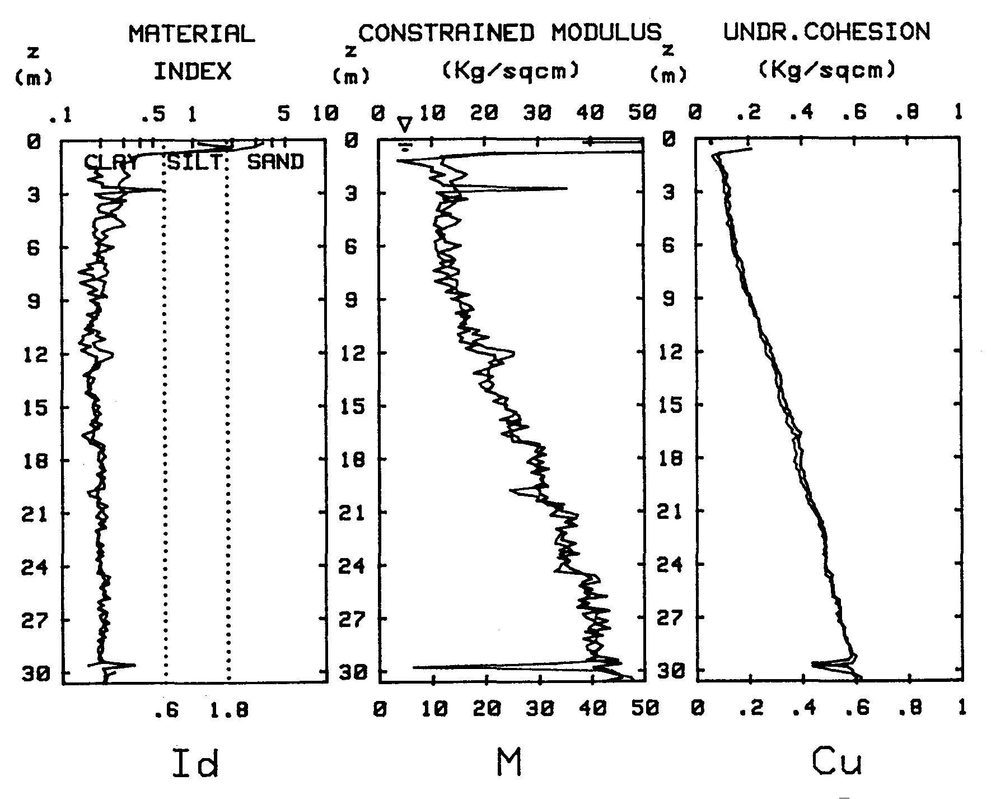
Marine NC sensitive clay
(Onsoy, Norway)

WHAT TO DO with Po and P1

 |  |  | STEP 1 |  |  | STEP 2
 |  |  | CALCULATE  INTERMEDIATE (OBJECTIVE) |  |  | Convert Id Kd Ed to COMMON PARAMETERS  (via CORRELATIONS)
Z | Po | P1 | Id | Kd | Ed | Ko | OCR | M | Cu | φ
m | Bar | bar |  |  | bar |  |  | bar | bar
1.0 | 1.1 | 3.3 | 1.87 | 6.3 | 73 |  |  | 151 |  | 38.3
1.2 | 1.3 | 1.8 | .33 | 6.6 | 15 | 1.4 | 6.5 | 31 | .19
1.4 | 1.2 | 1.7 | .37 | 5.7 | 15 | 1.3 | 5.1 | 29 | .17
1.6 | 1.2 | 1.6 | .28 | 5.3 | 11 | 1.2 | 4.6 | 21 | .16
1.8 | 1.1 | 1.4 | .21 | 4.6 | 8 | 1.1 | 3.6 | 13 | .14

- Basic philosophy : evaluate familiar parameters (users can check vs other tests). Design via parameters.
- No correlations to bearing capacity, foundations etc.

NOTE in TABLE
-In clay (Id < 1.2) : Cu In sand (Id > 1.2) : φ
-In Sand the automatic reduction by PC gives no Ko & OCR.
Methods exist, but require cautious use!

BASIC DMT REDUCTION FORMULAE

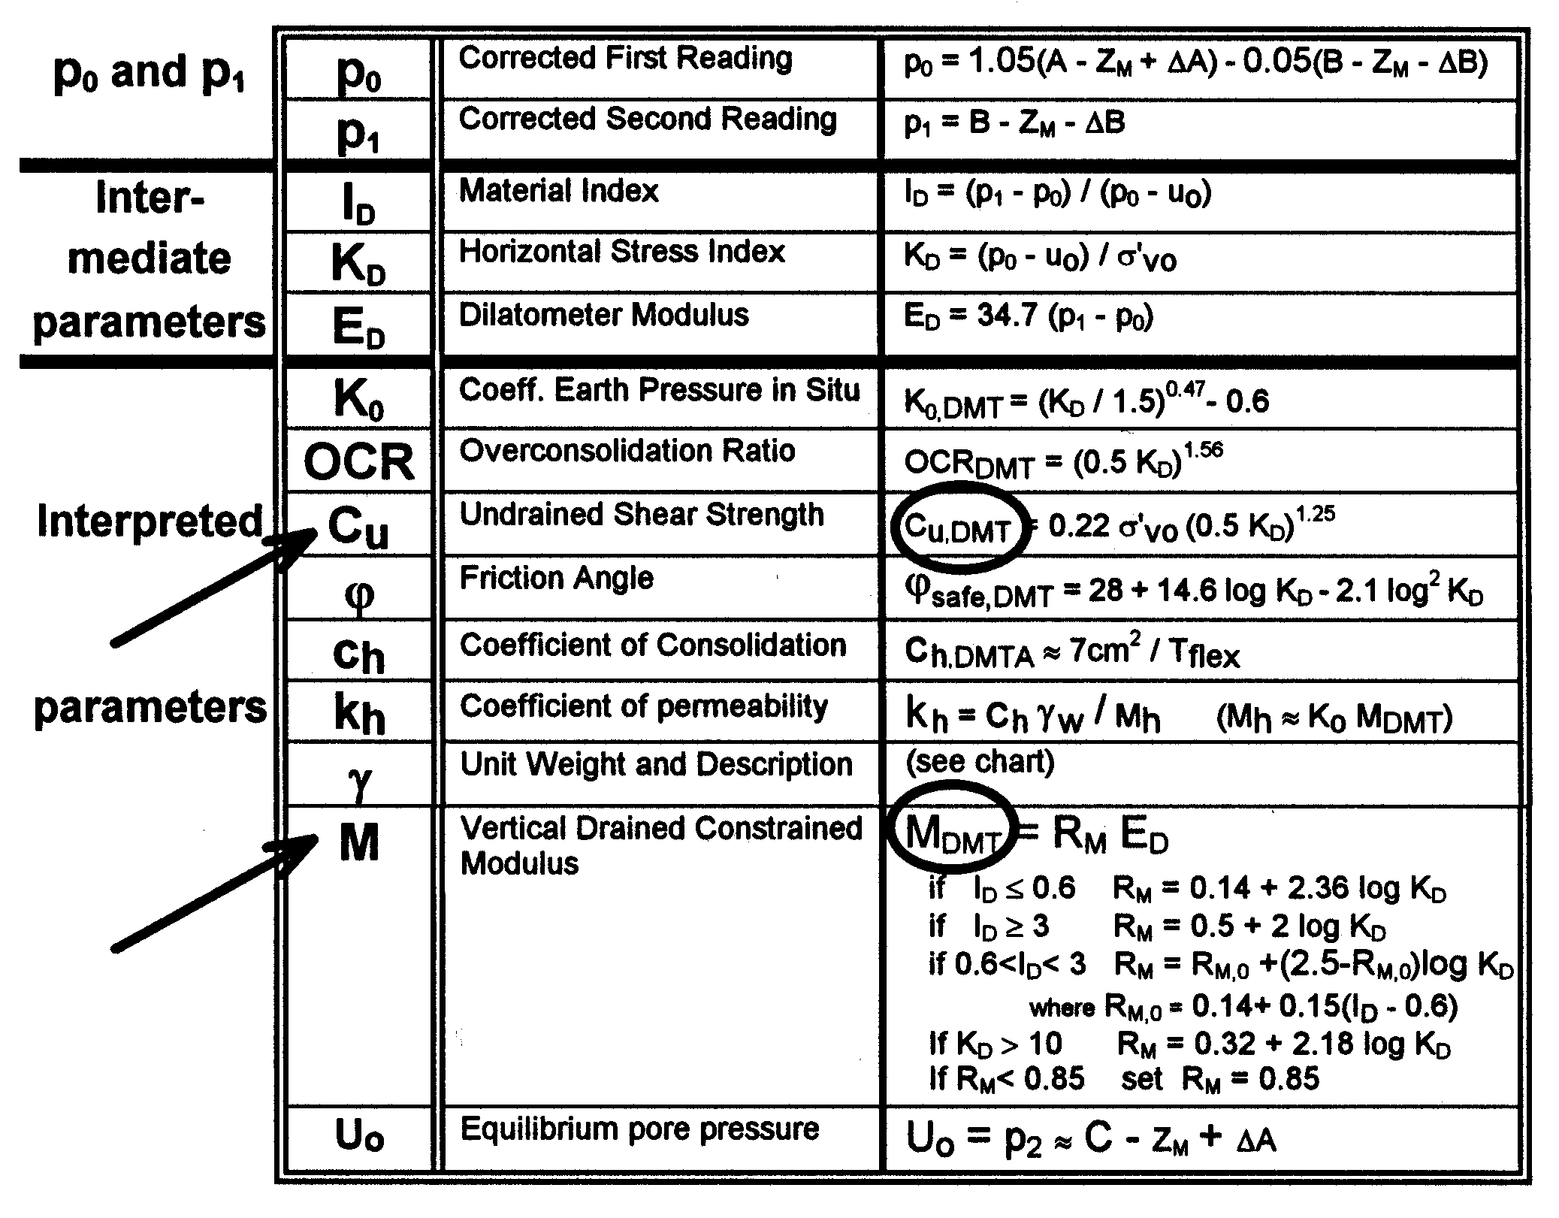

The outlined parameters (M and Cu) are generally quite accurate and the DMT most widely used.

Id - Material Index (soil type)

Whoever does dmt 1st time notes :
p
p
po
p1
po
p1
CLAY
SANDLAY

∴came natural (apart theory) define Id as a "vicinity ratio"
Id = (P1-Po)/(Po-Uo)

Experience has shown
- Id v. sensitive, 0.1 to 10 (2 log cycles)

0.1 | 0.6 | 1.8 | 10

CLAY | SILT | SAND

- Like FR in CPT but : amplified, highly reproducible
- Not primary scope, but a nice extra - generally reliable
- ID not result of sieve analysis, but from mechanical response (≈ rigidity index)
- Eg clay + sand described by ID as silt ⇒ behaves mechanically as... (incorrect for grain size, + relevant mechanical behavior)
- If interest in permeability, (besides ID ) other index UD

SOIL DESCRIPTION and estimated γ / γw

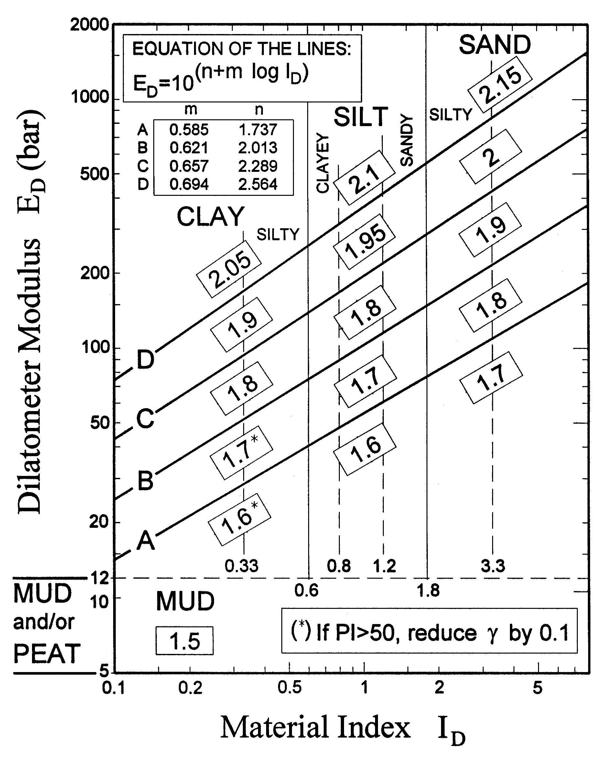

Kd - Horiz Stress Index (soil type)

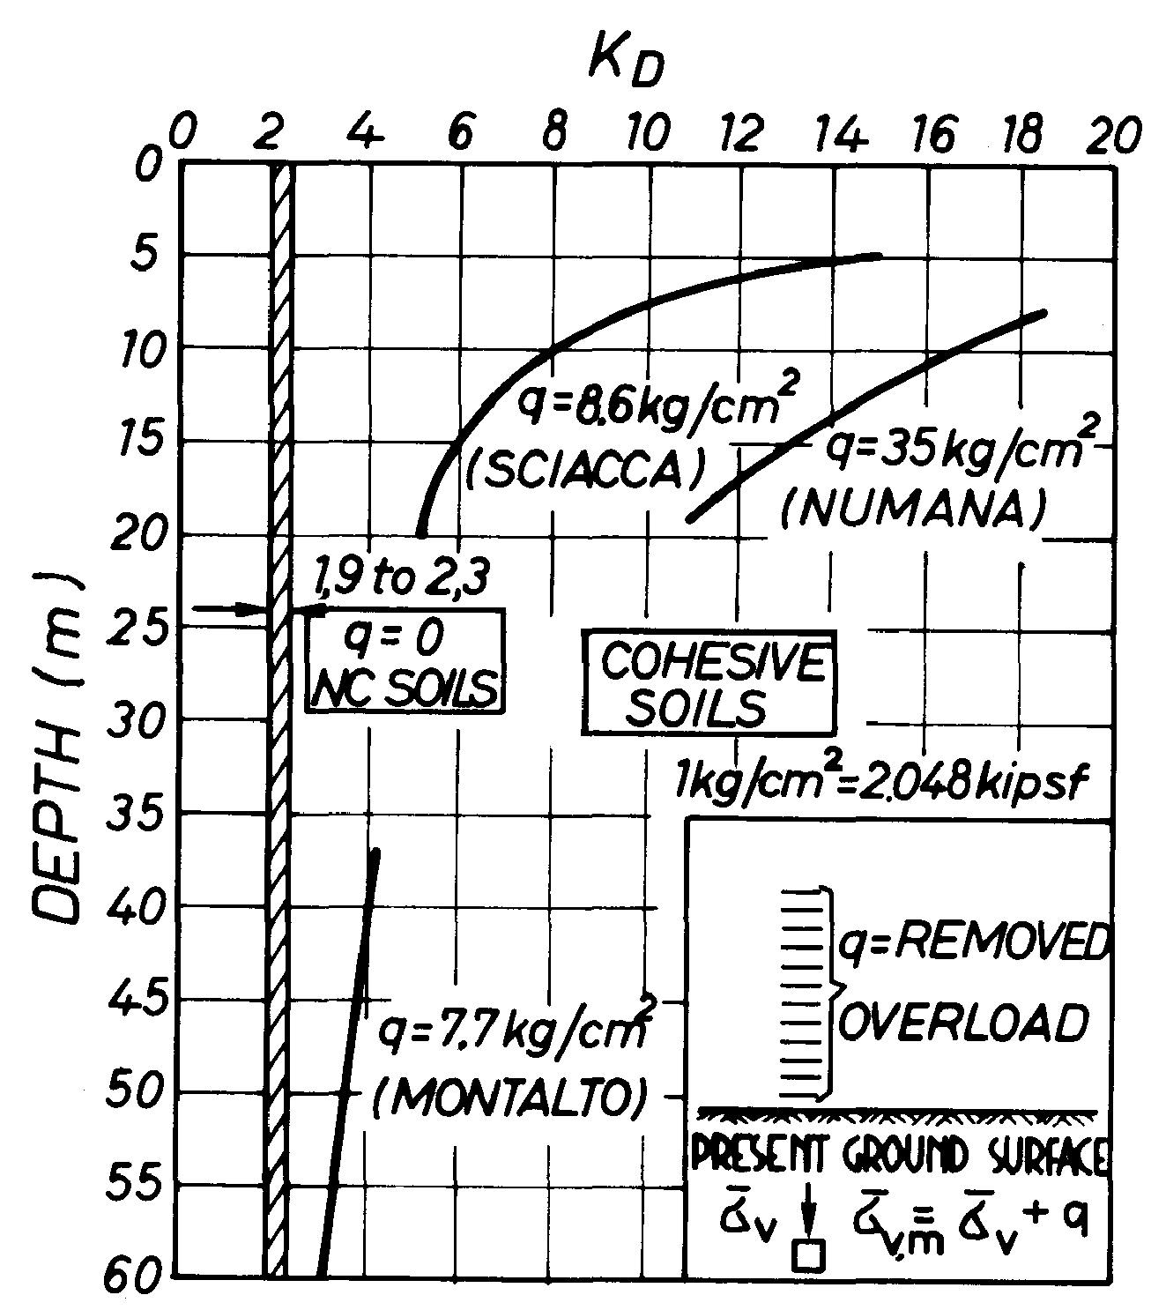
≈ amplified Ko
Kd ≈ 2 in NC clays

Note similarity Kd - OCR. (This prompted in 1980 the correlation Kd-OCR)

(next step : from OCR ⇒ Cu via Ladd 1977 - Soa Tokyo V.2 p. 440)

Cu/p' ≈ (Cu/p')NC • OCR≈0.8

Kd ≈ 2 in NC clays (1.8-2.3)
Kd evidences clearly crusts (current/ old)

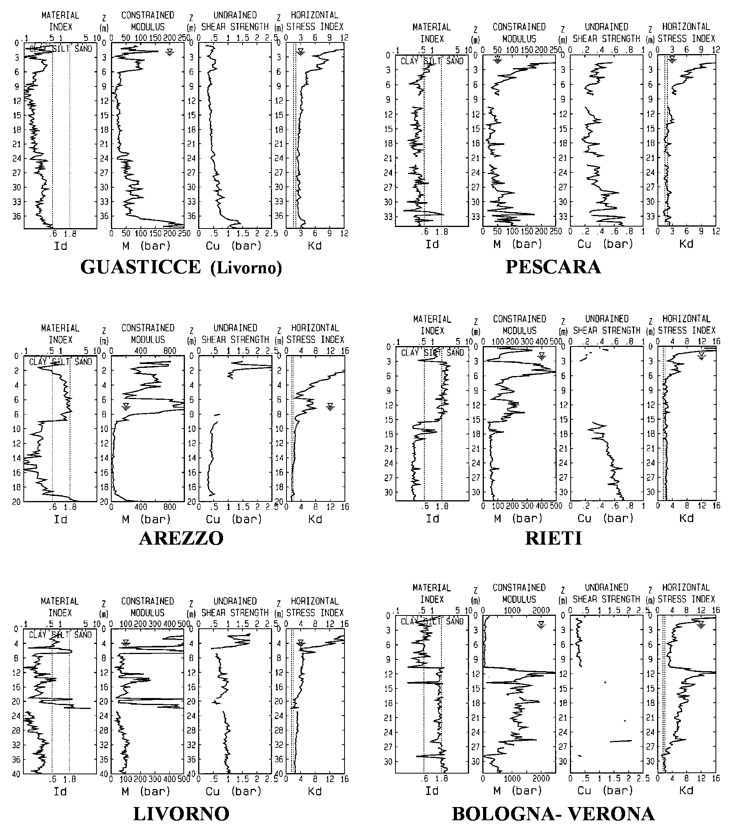

OCR from oedometer vs OCR from DMT

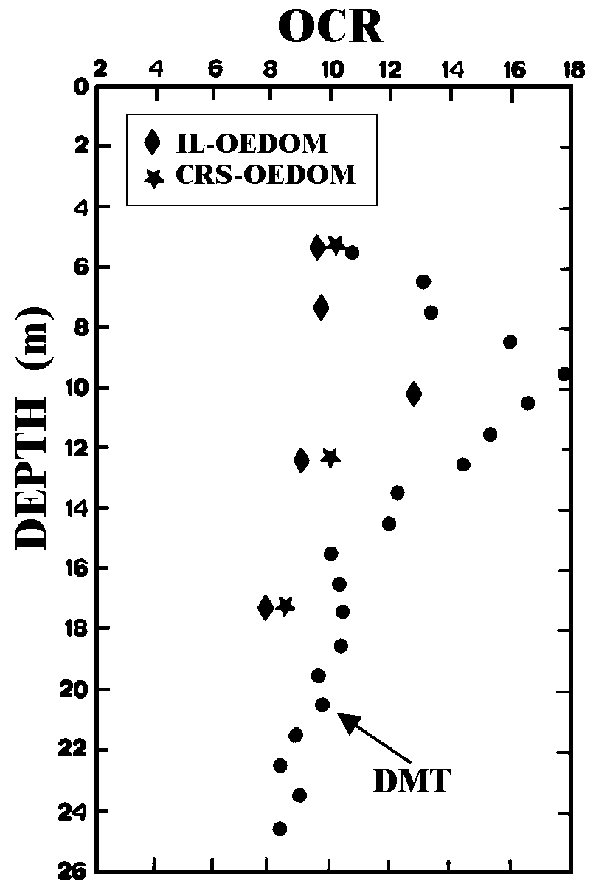

Overconsolidated Augusta clay (Sicily)

Jamiolkowski, 1988, ISOPT I,1, p. 271

OCR from DMT at BOTHKENNAR
National Research Site in UK, soft clay
- Investigated for years : most refined sampling techniques (piston samplers, Laval samplers, Landva's trimming technique..) and also DMT.
- Results summarized in 1992 (June) Géotechnique
- Based on all other tests, Authors stated (p. 171): "despite scatter, it is apparent OCR ≈ constant" (see in their Fig. 8b the vertical line labeled "suggested profile"). DMT, however (also in Fig. 8b) indicated differently, namely two branches with a break at ≈ 11 m.

See diagrams next page

- One year later Building Res. Establishment + Imperial College reviewed all tests, added new results, sent a questionnaire inviting research proposals worldwide. Documentation included an updated OCR very similar to OCRDMT
∴
- In this case DMT captured details of OCR-SHAPE undetected by refined sampling/lab work by scrupoulos technicians (non commercial !).
- OCRDMT : negligible cost / couple of hours.

OCR estimates at BOTHKENNAR

1 1.5 2
0
5
10
15
20
0
5
10
15
ALL OTHER TESTS
DMT
OCR from investigations up to 1992
OCR after additional investigations (1993)
Géotechnique, June 1992, p.171, Fig. 8b

CORRELATION OCR vs Kd

Kamei T. and Iwasaki K.(1995). "Evaluation of Undrained shear strenght of cohesive soils using a flat dilatometer"
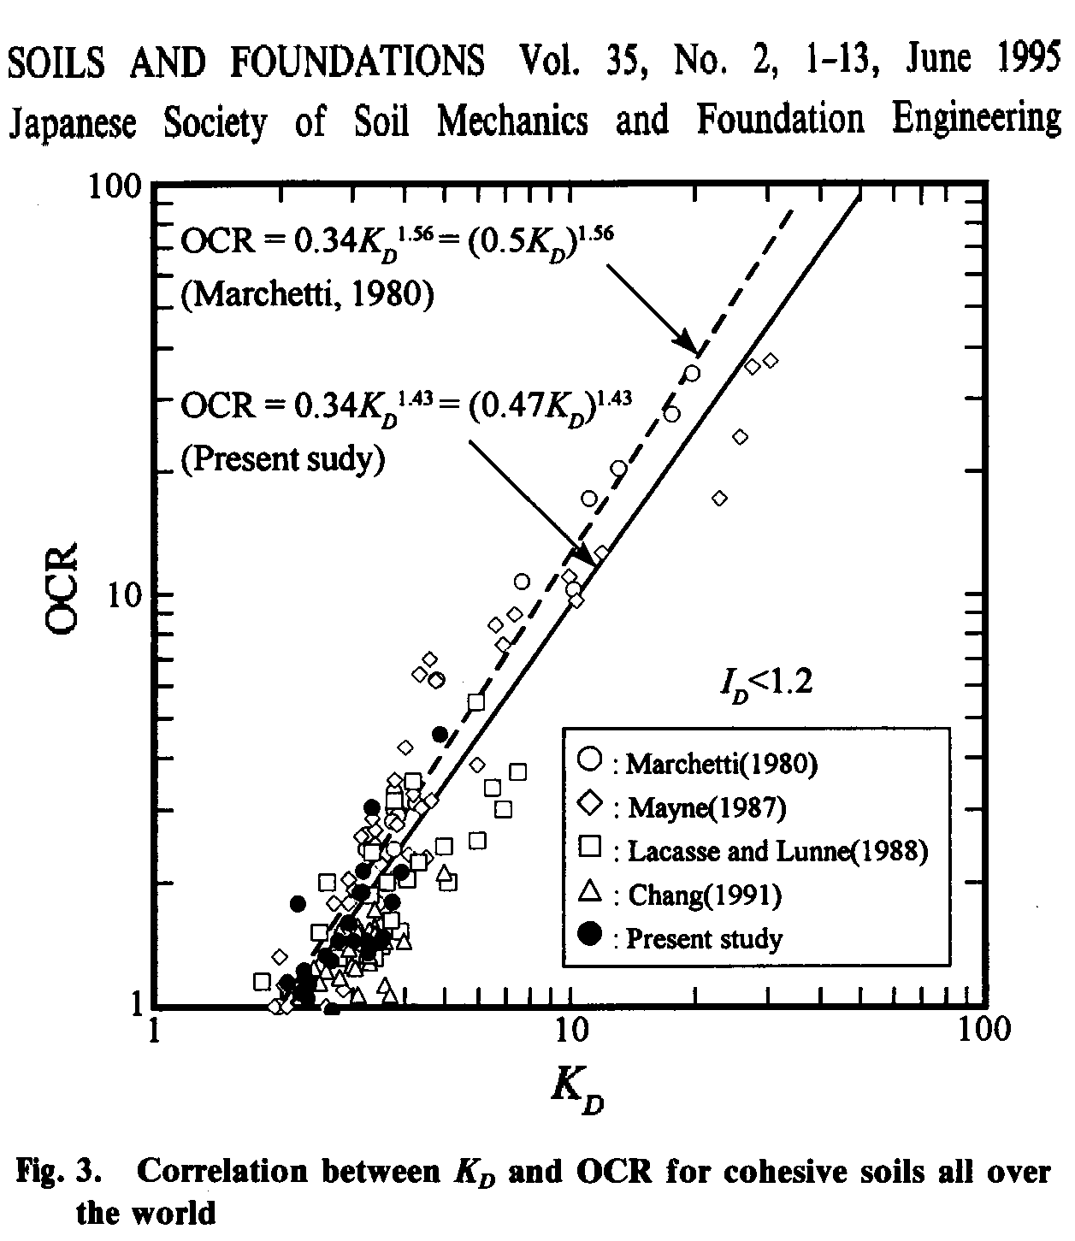

COMMENT
Practically no appreciable difference vs 1980 correlation

Cu predicted by DMT vs Cu by FV / UU

NC OC
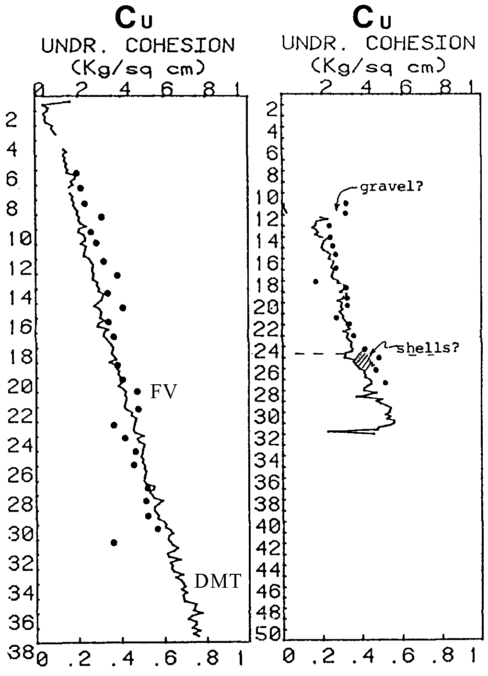
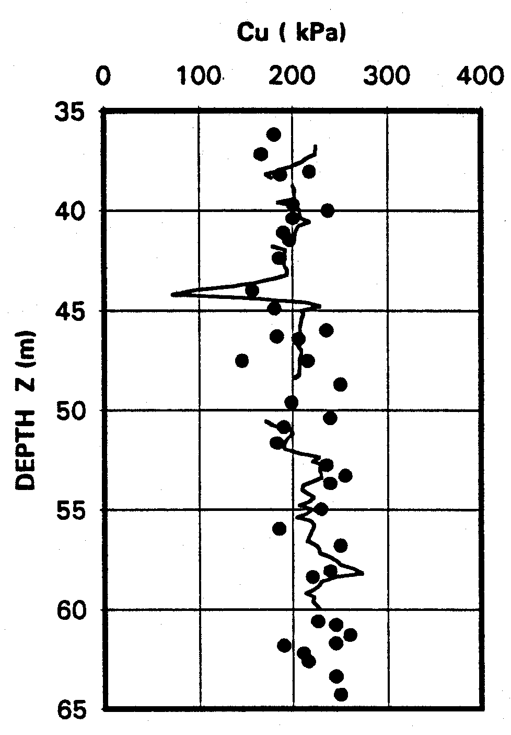
(Cu)DMT vs (Cu)Field Vane
(Skeena Ontario Canada, Soft clay)
(Cu)DMT vs (Cu)Lab Trx UU
(Montalto di Castro, Italy)

Mekechuk J. "DMT Use on C.N. Rail Line British Columbia", First Int.Conf. on the Flat Dilatometer, Edmonton, Canada, Feb 83, 50

UNDRAINED SHEAR STRENGTH from uu triaxial and from DMT

Iwasaki, Tsuchiya, Sakai, Yamamoto (1991)
Geotechnical Research Center
Kiso-Jiban Consultants Company, Tokyo

TOKYO BAY COHESIVE ALLUVIAL DEPOSITS
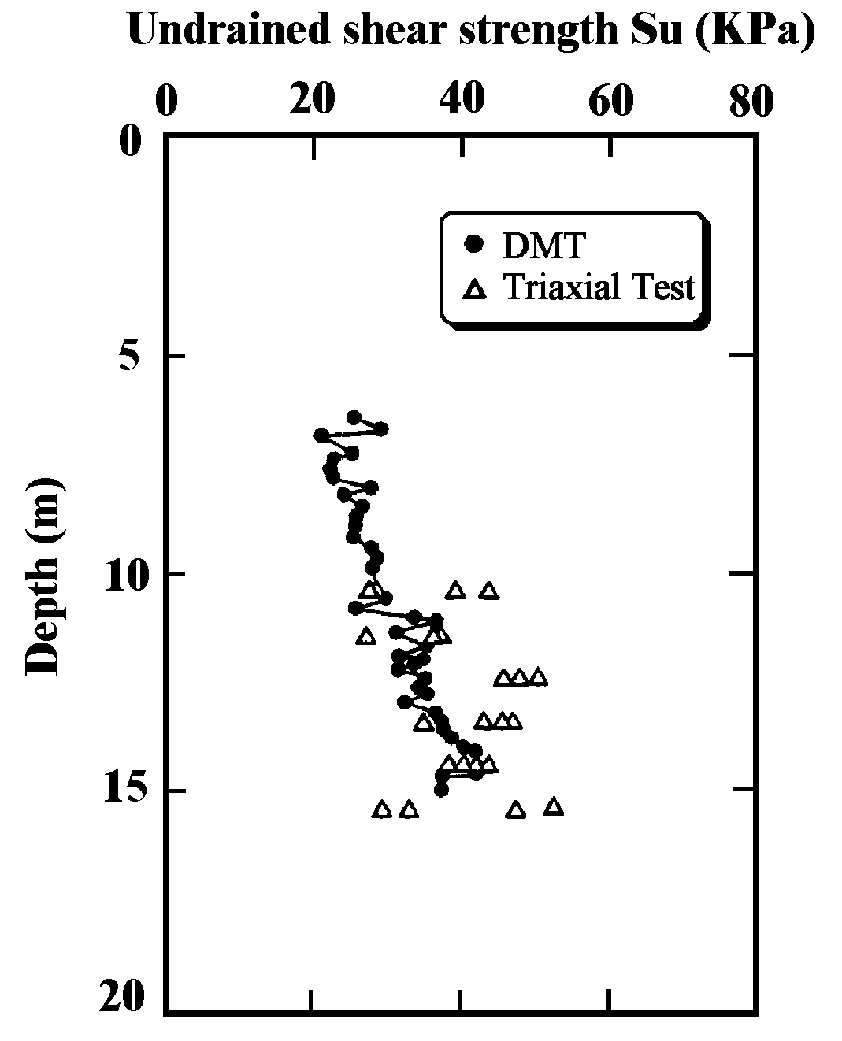

Iwasaki, K Tsuchiya H., Sakai Y., Yamamoto Y. (1991) "Applicability of the Marchetti Dilatometer Test to Soft Ground in Japan", GEOCOAST '91, Sept. 1991, Yokohama 1/6

QUALITY of Cu,DMT
- Generally v. satisfactory for everyday practice
- Of course we know existance of many Cu (TRX compression - ext., simple shear, pl. strain, FV..)
- But how often designers use more than one Cu ?
- Available results (Fucino, Bothkennar…) indicate CuDMT fits right in middle of other Cu.
- As to Cu(TRX UU) : Designers (unless samples of exceptional quality) often prefer Cu from insitu.
- Cu often from Qc (Cpt), but Nc=10 to 20 (?) relatively wide range
- ≈ Accuracy of CuDMT likely consequence of sensitivity of DMT to σh , strictly related to Cu (σh and Cu both largely determined by OCR)
(think of similarities of correlations Cu=f(OCR) and Ko=f(OCR) )

Cu at National Site BOTHKENNAR UK
0
5
10
15
20
Z (m)
KPa

Nash et al., Géotechnique, June 1995, p. 173

Cu at National Site FUCINO
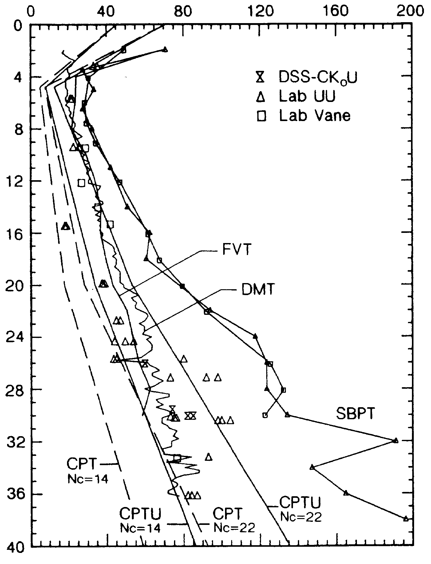
Z (m)
KPa

Nc= 10 to 20 or 14 to 22 ?

A.G.I., 10th ECSMFE Firenze 1991 Vol. 1, p. 37

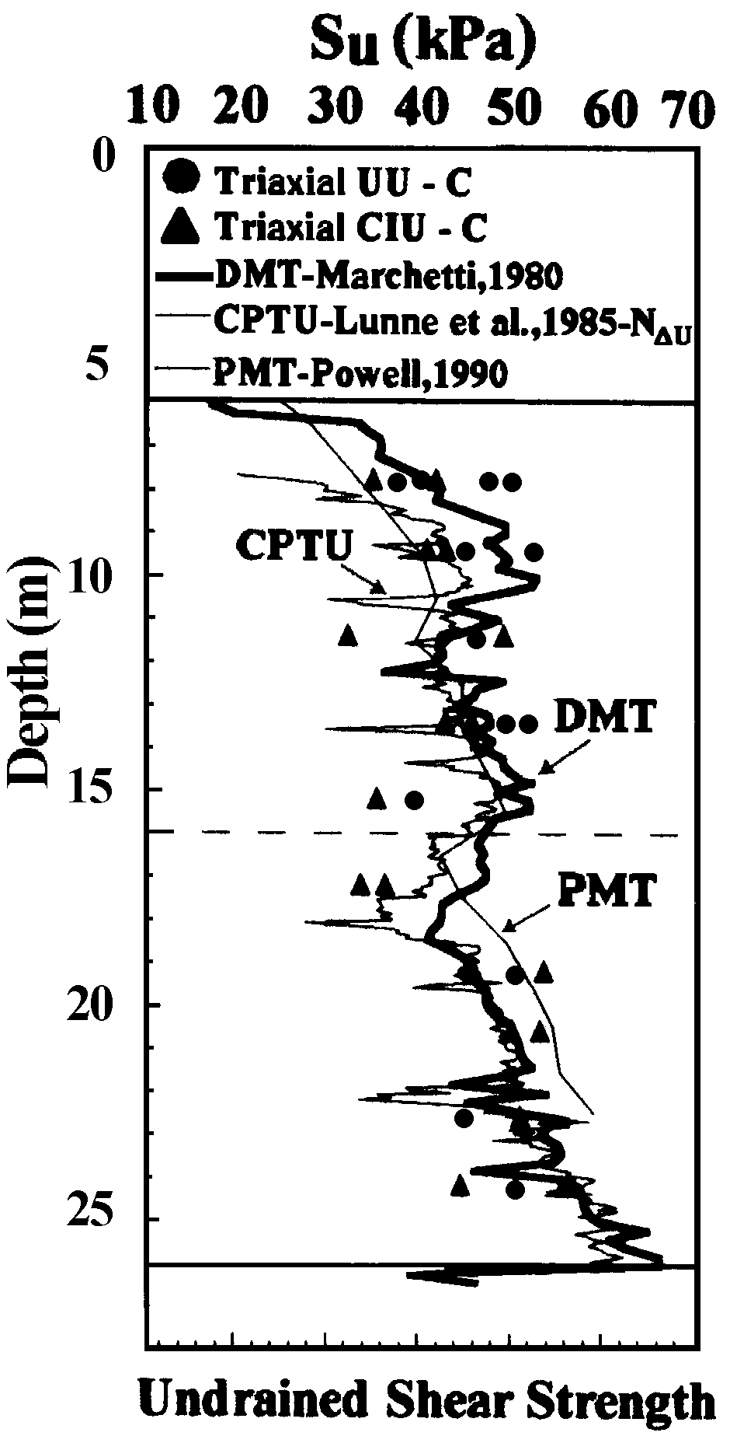
Su,dmt vs Su predicted by other tests

University of Pernambuco
BRAZIL

Research site 1
Recife Clay

Coutinho et al., Conf. Atlanta ISC 1999, Vol. 2, 1006

- COST : 1 or 2 (Trx UU) ≈ as entire DMT profile (+ no worry operator/ sample quality)
- TIME : Trx : weeks (months). Insitu : same day

Need compare in many geogr. areas : when in new regions, ≈ no need local correlation

HARDEST CLAYS testable by DMT
CHIETI - D5 (#8995)
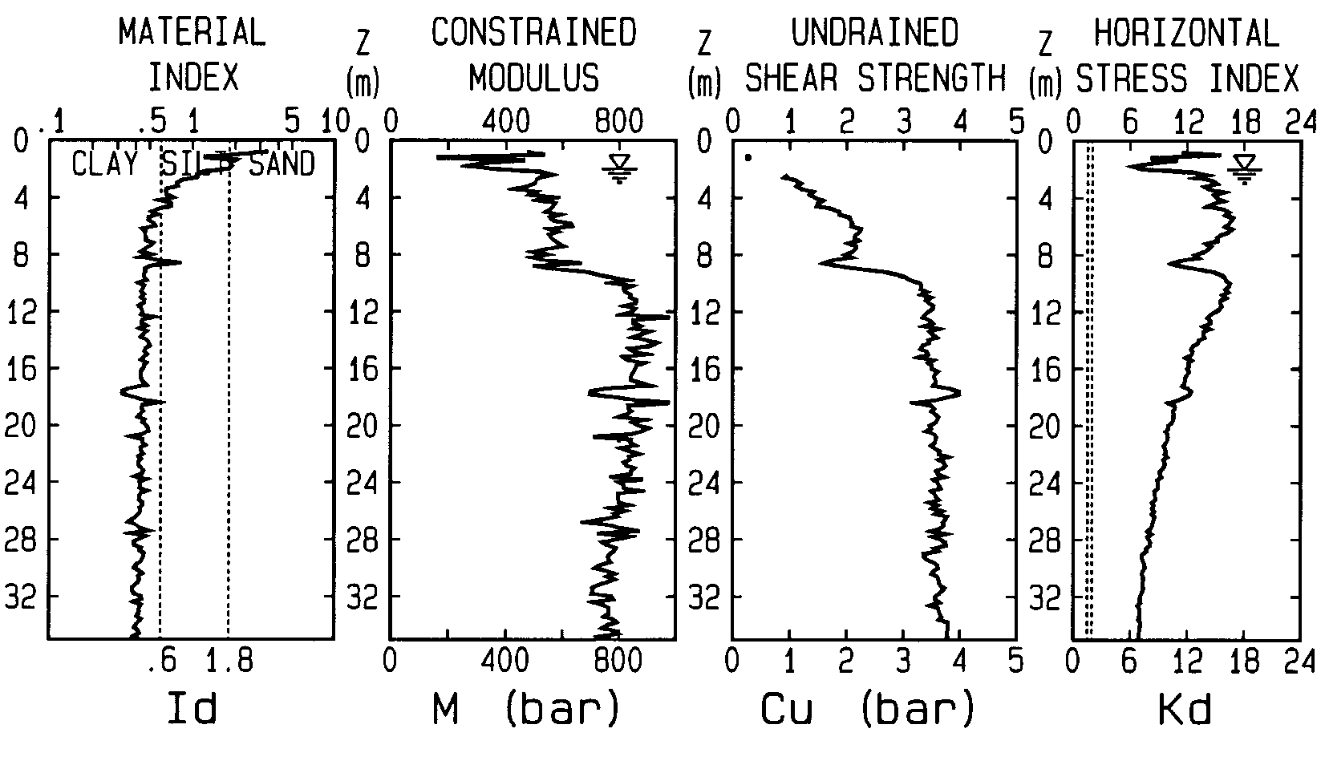

S. BARBARA (AR) - D6 (#8843)
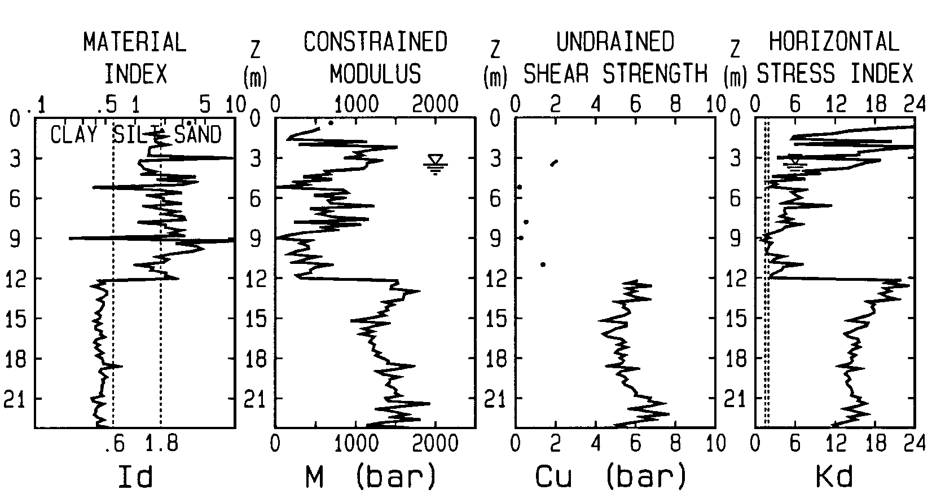
up to 4000
up to 10

CORRELATION (1980) Ko-Kd generally satisfactory in cohesive soils( Id< 1.2)

(But expect just a broad Ko evaluation)

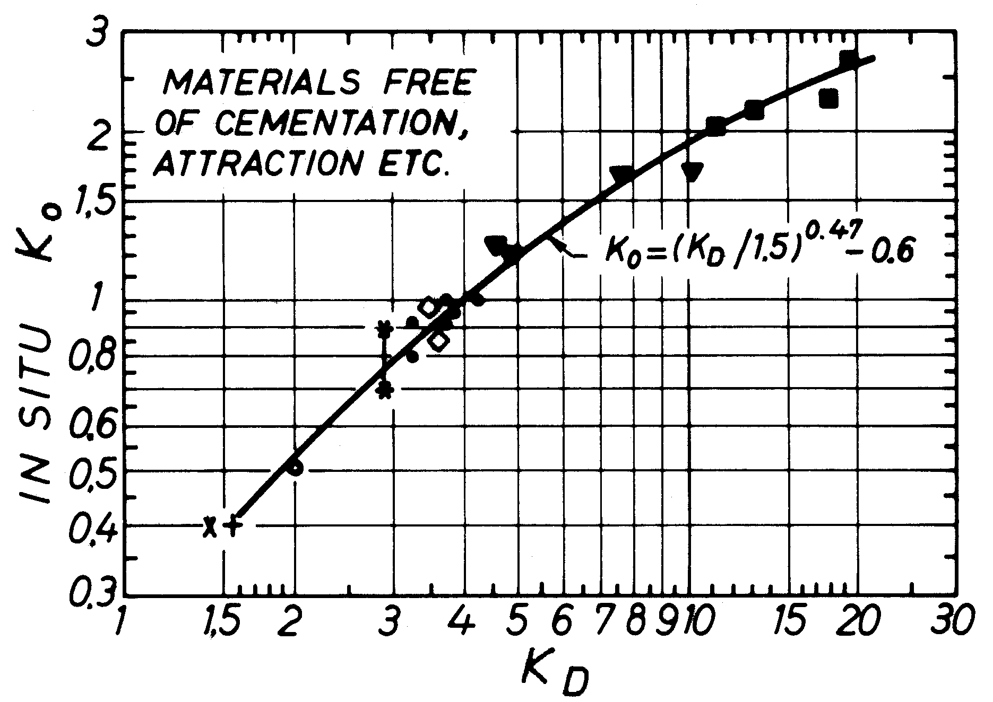

Even in "DEVIATING" CLAYS the 1980 Ko-Kd correlation is a REASONABLE AVERAGE
Results on "Special clays" by Kulhawy(1990), Powell & Uglow (1986) and Lacasse & Lunne (1988) indicate:
- Such clays deviate from original correlation (above or below). Yet similar trend, ≈ parallel.
- Original correlation is a good average, fits well in between (hence still the one most used today)

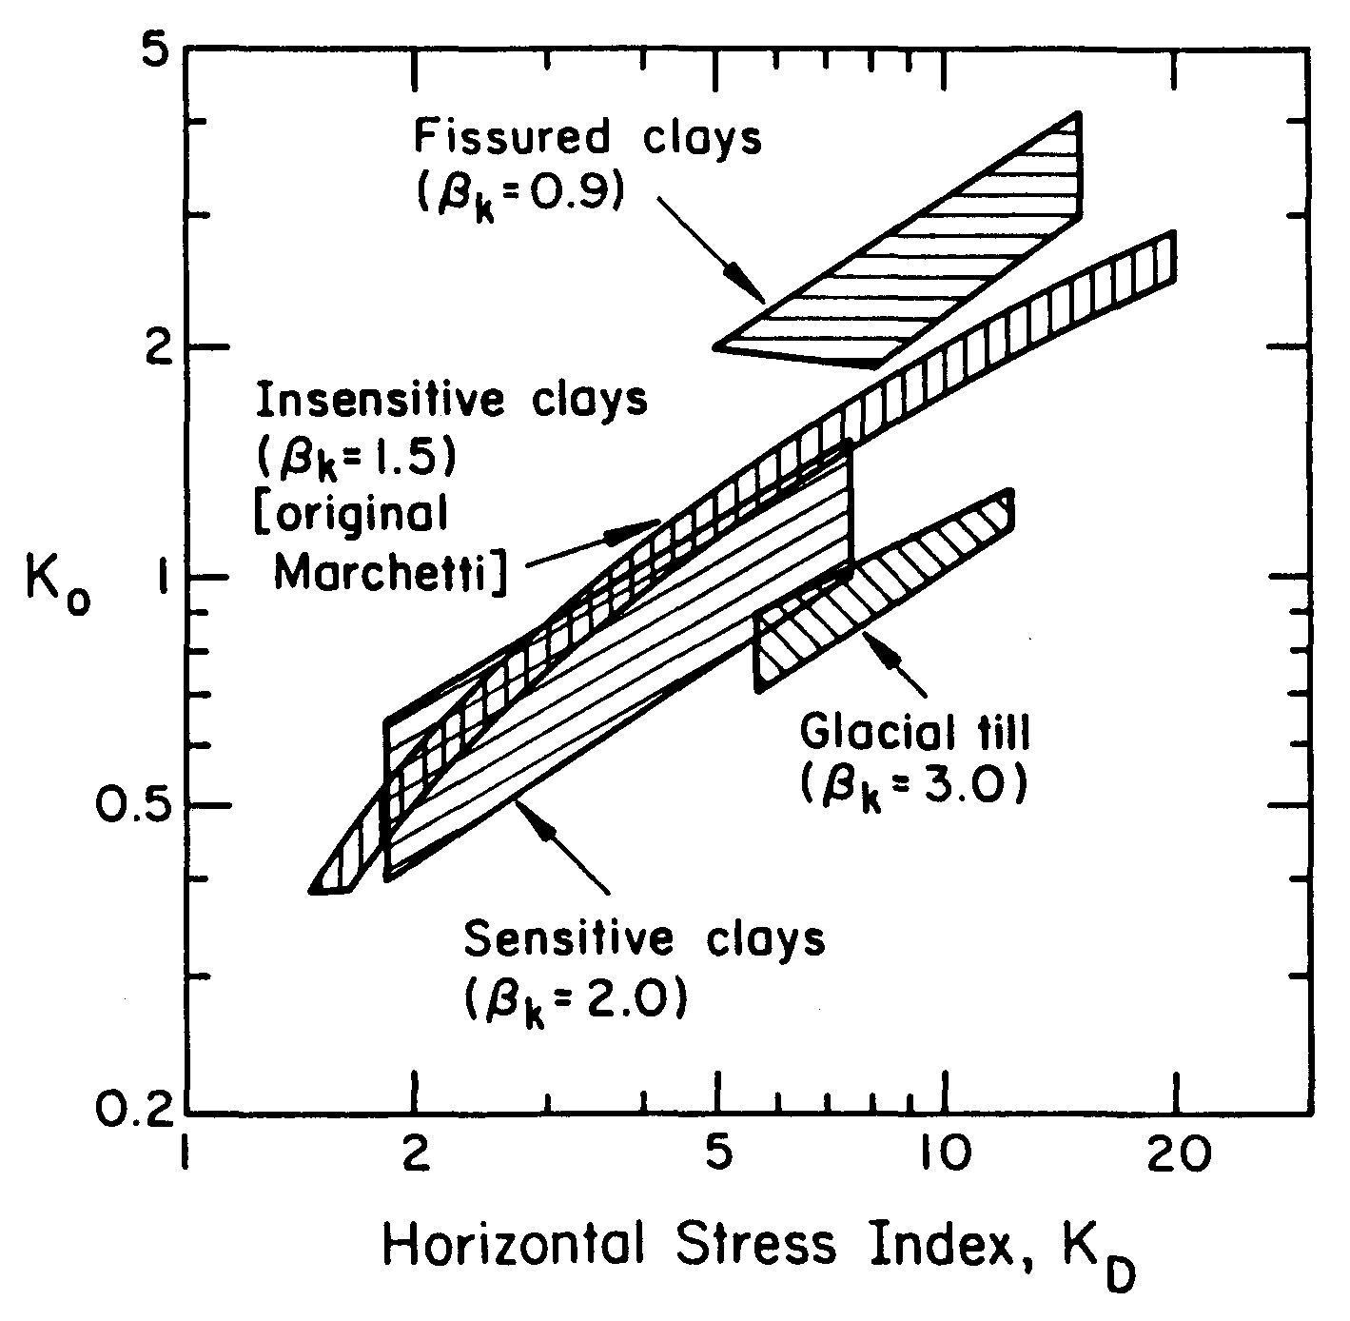

Ko in Sand: 1980 Correlation unsatisfactory
In sand evaluating Ko is still possible, having available, besides Kd, Qc from CPT:

Ko= C1 + C2 Kd + C3 Qc/Sigmav
with
C1= 0.376 C2= 0.095
C3= -0.002 for artificial, freshly placed sand
C3= -0.005 for natural seasoned sand

Disadvantages (a) Subjectivity in the choice of C3 (b) Difficult to match Kd-Qc of same layer (c) Reliability ?
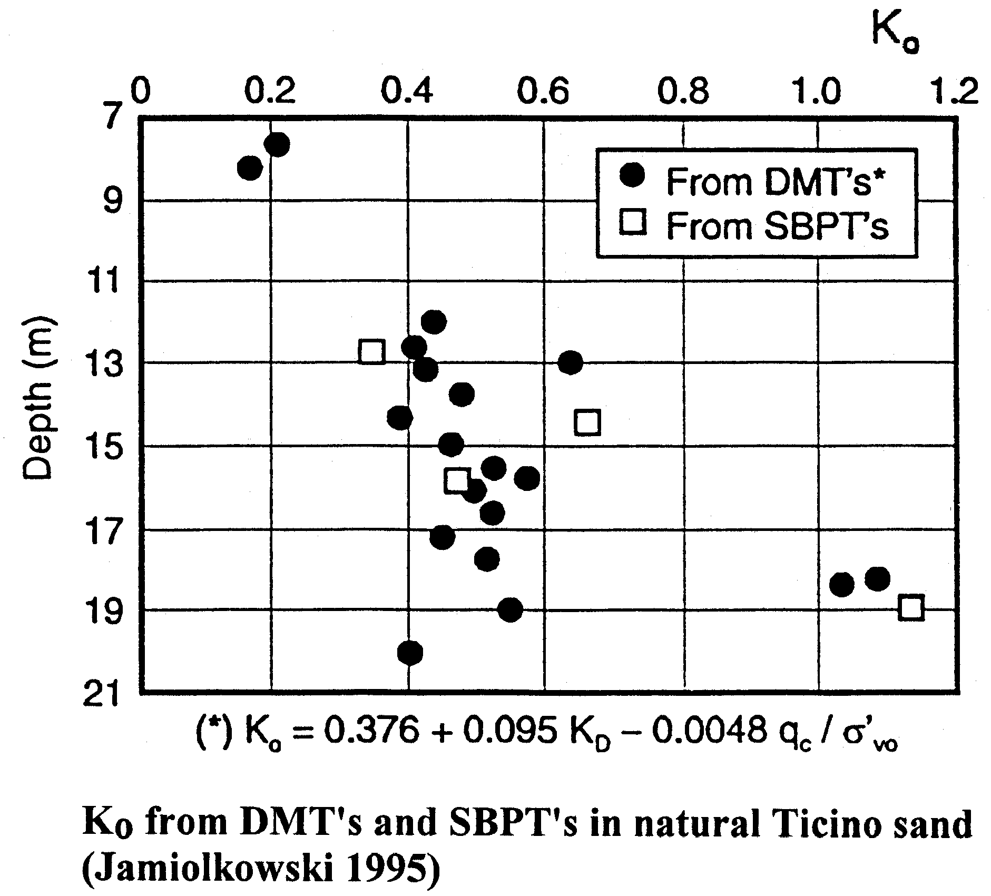
Though unpractical for routine use, some satisfactory Ko predictions have been reported (Jamiolkowski, CPT '95, Linköping - Sweden, Welcome address, Fig. 6):

φ' from DMT in sand (often STUDIED with Ko)

1980 | ASCE unique Ko-Kd (clay OK), in sand unsatisfactory
1983 | Schmertmann combines  (CC) Ko=f(Kd, φ) + (D&M) qc =f(Ko, φ) (b.c. with Ko)  By measuring qc, Kd : 2 eqns, 2 unknowns → Ko, φ
1985 | Marchetti  - Combine the 2 above eqns (exactly as Schmertmann 1983) eliminating φ (peak, residual, cv, pl strain, trx), thereby obtaining relation (see chart) Ko, Kd, qc.  - Translate in graphical form D&M (see chart) qc, Ko, φ  Then (1) Obtain Ko (Kd, qc) from 1st chart  (2) Obtain φ (Ko, qc) from 2nd chart
1986 | Baldi...Marchetti..al...  Idea still relation Ko, Kd, qc, but abandoning previous eqns., and fitting all accumulated CC database  Ko = 0.376 + 0.095 KD - 0.0046 qc / σ'vo  (hence Ko). For φ → D&M chart
1991 | Campanella & Robertson  Add scale for Kd in D&M chart, hence can read φ (with a rough estimate of Ko)
1996 | Marchetti  Uses Campanella & R. (1991) to obtain Kd-φ curves.(for 3 Ko assumptions, get 3 curves). Since for low φ the 3 curves appear to overpredict φ (vs CC data) draw a lower line. Tentative recommended line. Not meant to be most likely estimate of φ, but operative low estimate.(e.g. maybe helpful in case of disturbed samples) ( ≈ verified for sites qc-Kd)

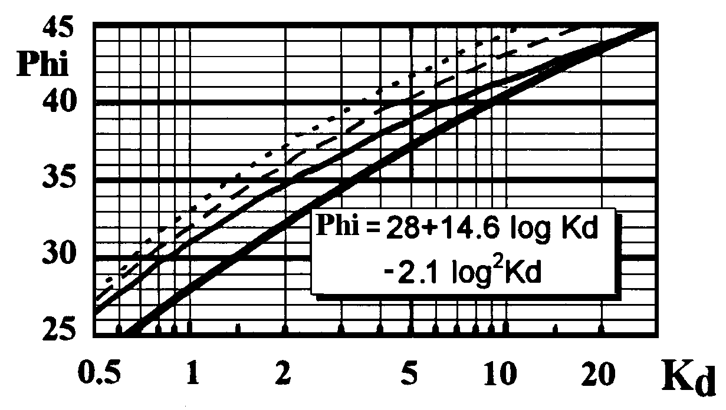

Use lower curve (or equation) for a safe estimate (lower bound) of φ (uncemented sands). Marchetti, 1997

Marchetti S. (1997). "The Flat Dilatometer : Design Applications". Third Geotechnical Engineering. Conf. Cairo University, Jan. 1997, Keynote lecture, 26 pp.

Ed | Dilatometer Modulus  (deduced by theory of elasticity)

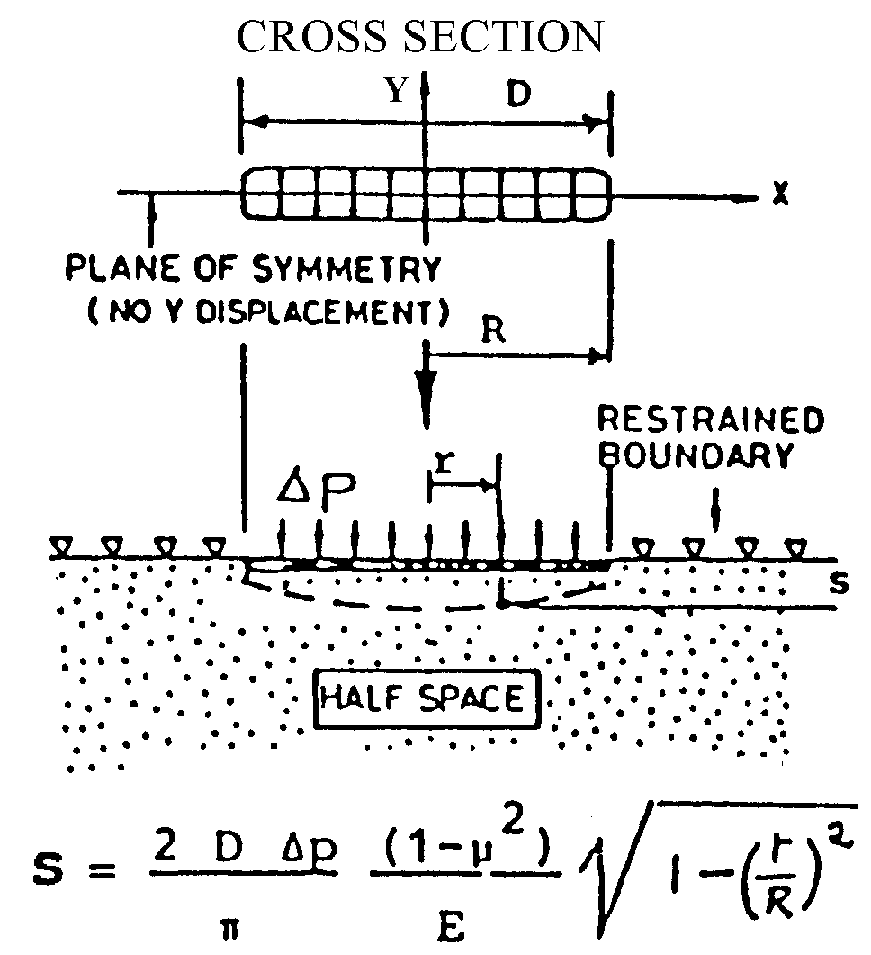

At center, Δp has caused 1.1 mm.
For D=60 mm, S = 1.1 mm formula ⇒
Dilatometer Modulus = Ed = E/(1-ν²) = 37.4 Δp
Ed=34.7 Δp

-------------------------
Elastic formula by Gravesen S. "Elastic Semi-Infinite Medium bounded by a Rigid Wall with a Circular Hole", Danmarks Tekniske Højskole, No. 11, Copenhagen, 1960, p. 110.

Before use, Ed must be converted to M
Correction factor Rm = f(Kd, Id) Soil type
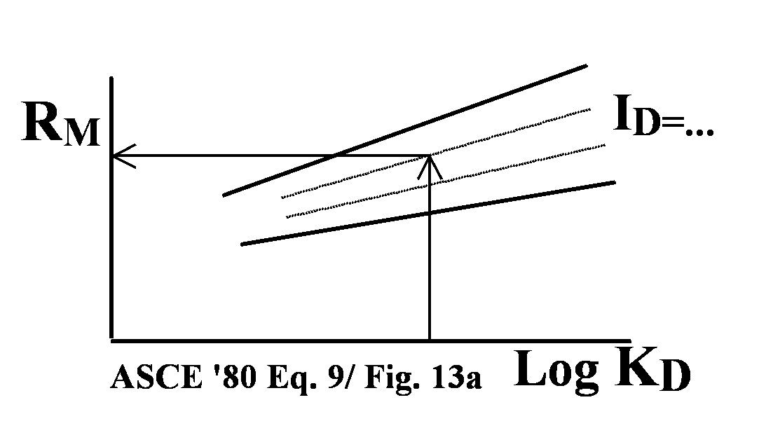
Stress history

M=Rm Ed
(M=1-D modulus)

- Rm similar to K in M=K qc (CPT) with the difference
-K= 2-20 = f(OCR ??, Dr)
-Rm = 1-3 = f(Id, Kd)

- Ed should not evoke Young's E'
-Ed lacks Stress Hist. (not to be used in deform analysis) (same situation as trying to derive E from Qc without Stress History)
-Use M. If E' required, infer it from M (E' ≈ 0.8 M)

Reasons of RM : many TASKS (CONVERSIONS)
- Ed on distorted soil  - Horizontal-vertical  - Drained-Undrained  (Skempton param.) | function  of  ➔ | - Soil type (ID)  - Stress Hist. (KD)

Above reasons support correl. M-Ed (ID, KD parameters), but last word to real life e.g. comparing highly qualified:
(1) M/ Mref (2) Settlement observed/ predicted ≈ OK

CONSTRAINED 1-D MODULI
FROM OEDOMETER AND FROM DMT

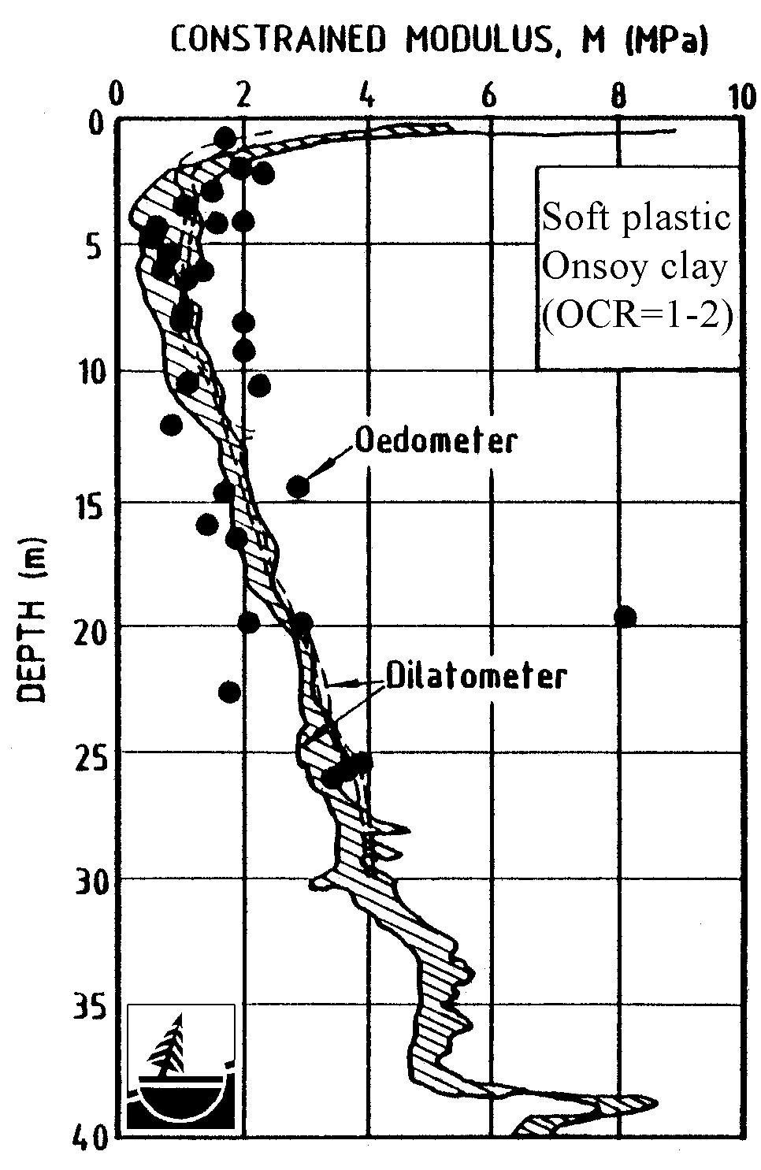

Norwegian Geotechnical Institute (1986). "In Situ Site Investigation Techniques and interpretation for offshore practice"
Report 40019-28 by S. Lacasse, Fig. 16a, 8 Sept 86

CONSTRAINED 1-D MODULI
FROM OEDOMETER AND FROM DMT

Iwasaki, Tsuchiya, Sakai, Yamamoto (1991)
Geotechnical Research Center
Kiso-Jiban Consultants Company, Tokyo

TOKYO BAY COHESIVE ALLUVIAL DEPOSITS

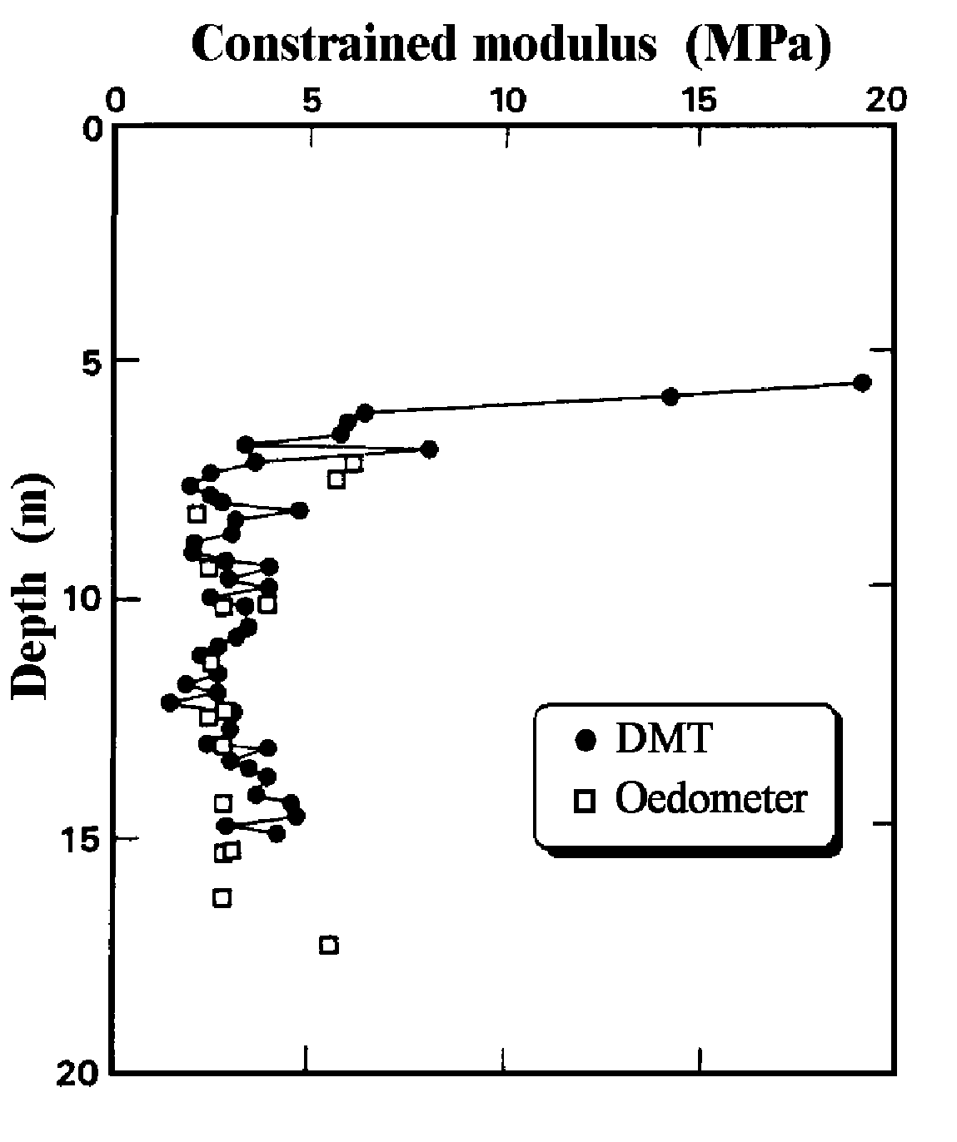

Iwasaki, K Tsuchiya H., Sakai Y., Yamamoto Y. (1991) "Applicability of the Marchetti Dilatometer Test to Soft Ground in Japan", GEOCOAST '91, Sept. 1991, Yokohama 1/6

SOIL PROPERTIES FROM IN SITU
TESTS by "TRIANGULATION"
-UNABLE MEASURE IN SITU PURE SOIL PROPERTIES
-RESPONSES IN SITU: MIXED FUNCTION PURE S.P.
-TO ISOLATE PURE S.P. : "TRIANGULATION"
-say DOMINANT STIFFNESS, STRENGTH, STATE STRESS
-NEED 3 INDEP. IN SITU RESPONSES R1, R2, R3

R1 = f1 (M, Strength ,σh)  R2 = f2 (M, Strength, σh)  R3 = f3 (M, Strength, σh) | invert  matrix  get | M  Strength  σh | = g1 (R₁,R₂,R₃)  = g2 (R₁,R₂,R₃)  = g3 (R₁,R₂,R₃)

TRIANGULATION ≈ 3-Chromia to re-create colors

R1 STIFFNESS

R2 STRENGTH

R3 STATE OF STRESS

DMT is a TWO-PARAMETER TEST
Makes a lot of difference compared with 1-parameter tests as CPT or SPT (3 would be better, but diminishing returns…
Moreover 3rd parameter would be valuable if truly independent - DMT tip qD not sure…)

1-parameter test ⇒ wide UNCERTAINTY
- 1 information : NO MATRIX to INVERT
- E=2.5 to 25 Qc (factor 10) = f(Dr, OCR-σh)
- Impossible get 3 unknowns (E, Dr, OCR) from just 1 information (Qc)

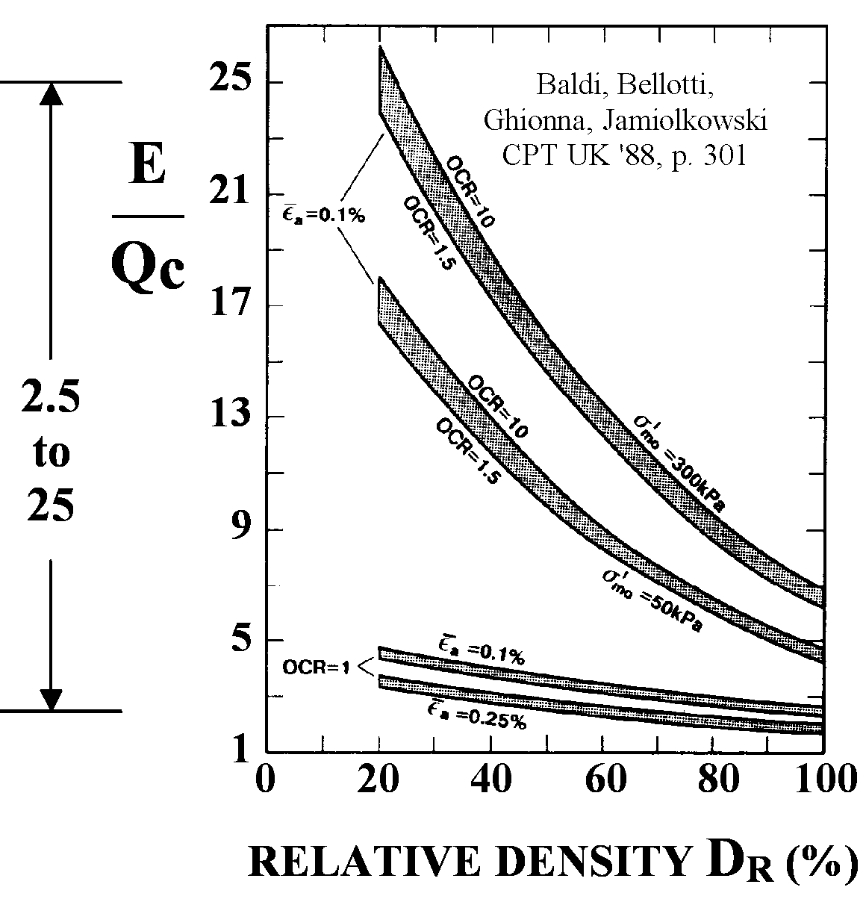

- If we adopt ave. E= 7 Qc, E could be off (settlements) by factor 3 (wide).
- Jamiolkowski et al. conclude (Isopt-1, '88, Vol. 1, p.263) :
"w/o Stress History, impossible to select reliable E (or M) from Qc"

1. Definition of M (no ambiguity)

M = Eoed=1/mv= Δσ'_{v}/Δε_{v} (at σ'_{vo}).
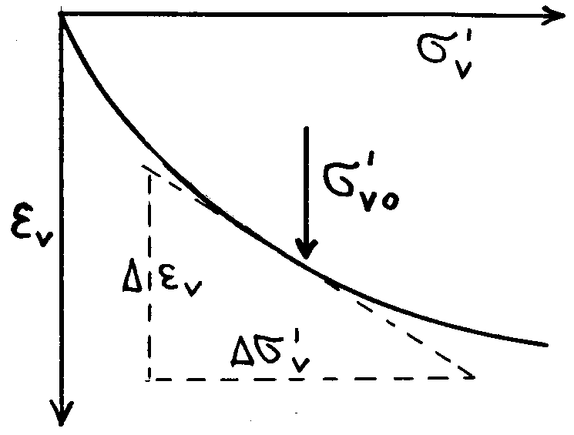 | Vert. drained confined tangent (at σ'_{vo}) modulus  Name : Eoed OK, traditionally measured by oedometer. Improper if not by oed (corre-lations). Hence "M", but same.  Usual range M_{DMT} 4 - 4000 bar

2. M for what settlement (initial, 1ry, 2ry) ?
M is just for primary. Correlations were established by calibrating vs Eoed (1-D). M_{DMT} must be treated as if by oedometer.
Use same methods as with oedometers, including, if applicable, usual corrections (depth, shape, rigidity, possibly Skempton-Bjerrum).

3. May use M = constant if Δσ'_{v} large ?
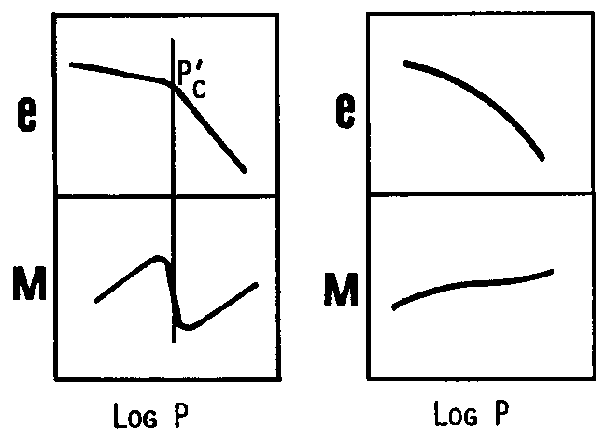 | If Δσ'_{v} large : σ'_{v} may exceed p_{c}. (?)  Many structured NC clays (eg some Canadian) : sharp break in e-log p curve ⇒ marked drop in M at p_{c}. There M_{DMT} may be too high.  But in many common clays, (in most sand?) M accross p_{c} mild fluctuation, hence M=const. ≈ OK

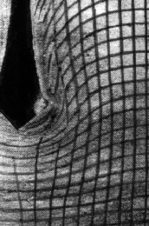
DISTORTIONS due to INSERTION
CONE
WEDGE

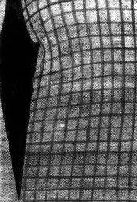

Photographs of distortions in clay from :
Baligh & Scott (Nov. 1975) "Quasi-Static Deep Penetration in Clay", Jnl. ASCE Geot. Eng. Div.

USE OF IN Situ / lab
SCHMERTMANN (BANQUET talk CPT '95 Sweden)
...while in the PAST LAB had PRIMARY ROLE in a SITE INVESTIGATION, and IN SITU TESTING COMPLEMENTARY today often IN SITU PRIMARY, LAB COMPLEMENTARY
EXAMPLE: SUNSHINE SKYWAY SUSPENSION BRIDGE IN TAMPA (Schmertmann & Crapps responsible for FOUNDATIONS) :
99% IN SITU, 1% LAB
(Reason of LAB : AVOID COLLEAGUE CRITICISM !)

(Provocative : We all respect lab = Source of our understanding, many behavioural details can be studied only in lab...)

TESTING IN THE LABORATORY
- TO STUDY PATTERN OF BEHAVIOUR / FORMAT OF THE MODELS
- TO MEASURE, IN CONTROLLED CONDITIONS, MANY PARAMETERS
BUT
- LAB Element ≠ INSITU Element (missing LINK)
- HIATUS : no matter how careful the sampling
- DIFFERENCE : Unknown, Variable, Non Reproducible

ELASTIC REGION very SMALL THRESHOLD to irricoverable ≈ 0.01%
Exceeded when element INSITU ➔ LAB
Recent low-strain research, starting from a lab TRX specimen in given stress state, identified 3 zones
p/p'e
ZONE I
Linear elastic
ZONE II
Non linear elastic
q/p'e
ZONE III
Irrecoverable strains
BOUNDING SURFACE
Jardine 1992, N.2. Soils and Foundations

Threshold to irrecoverable ε ≈ 0.01 %. By far exceeded by sampling

Not completely new ! Terzaghi-Peck (1967):
"Compressibility of even good OC samples may be 2 to 5 times larger than the in situ compressibility".
(to be sure, oedometer samples - especially OCR - resent, besides disturbance, also deficient σh ! Oed starts with σh =0. Even at σ'vo : σh,oed << σh,insitu)

Stress-Strain TRAUMA from INSITU to LAB
"IDEAL SAMPLE" (Ladd and Lambe 1963)
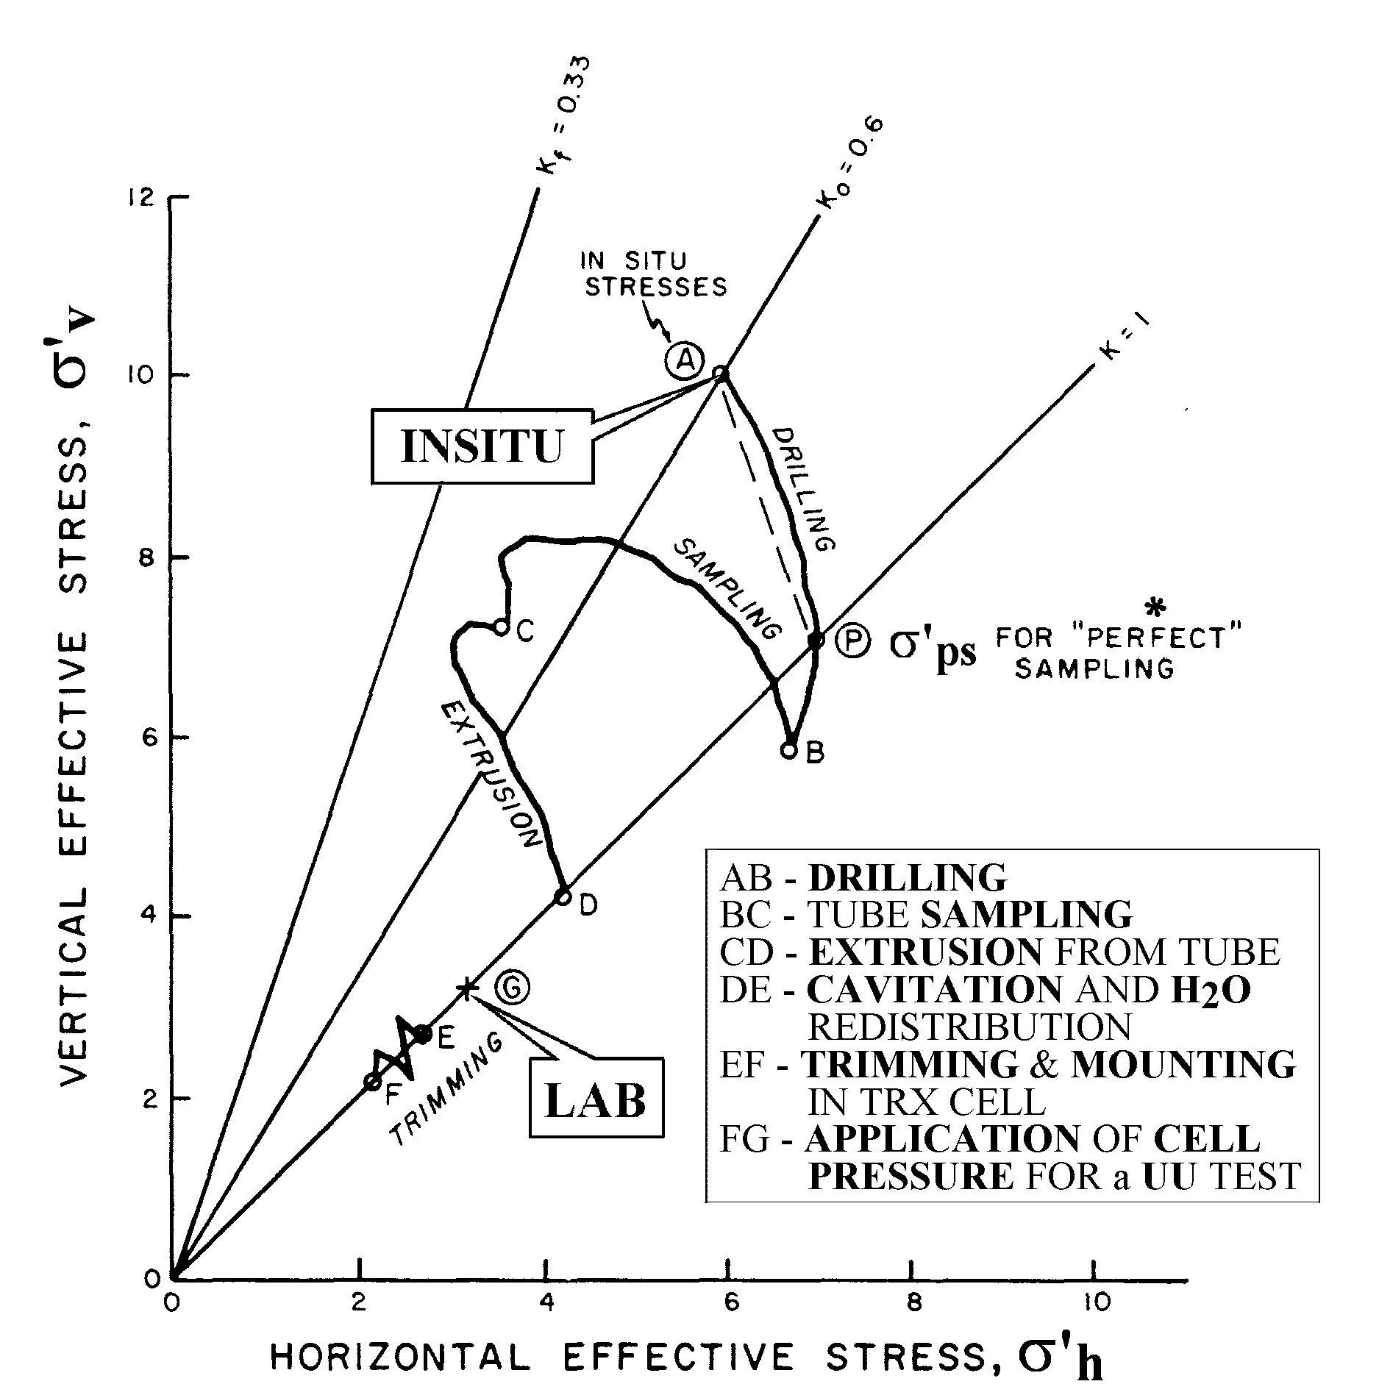

Ladd and Lambe (1963) "The Strenght of 'Undisturbed' Clay" from Undrained tests". ASTM-NRC Symposium, Ottawa

EXAMPLE OF DMT RESULTS

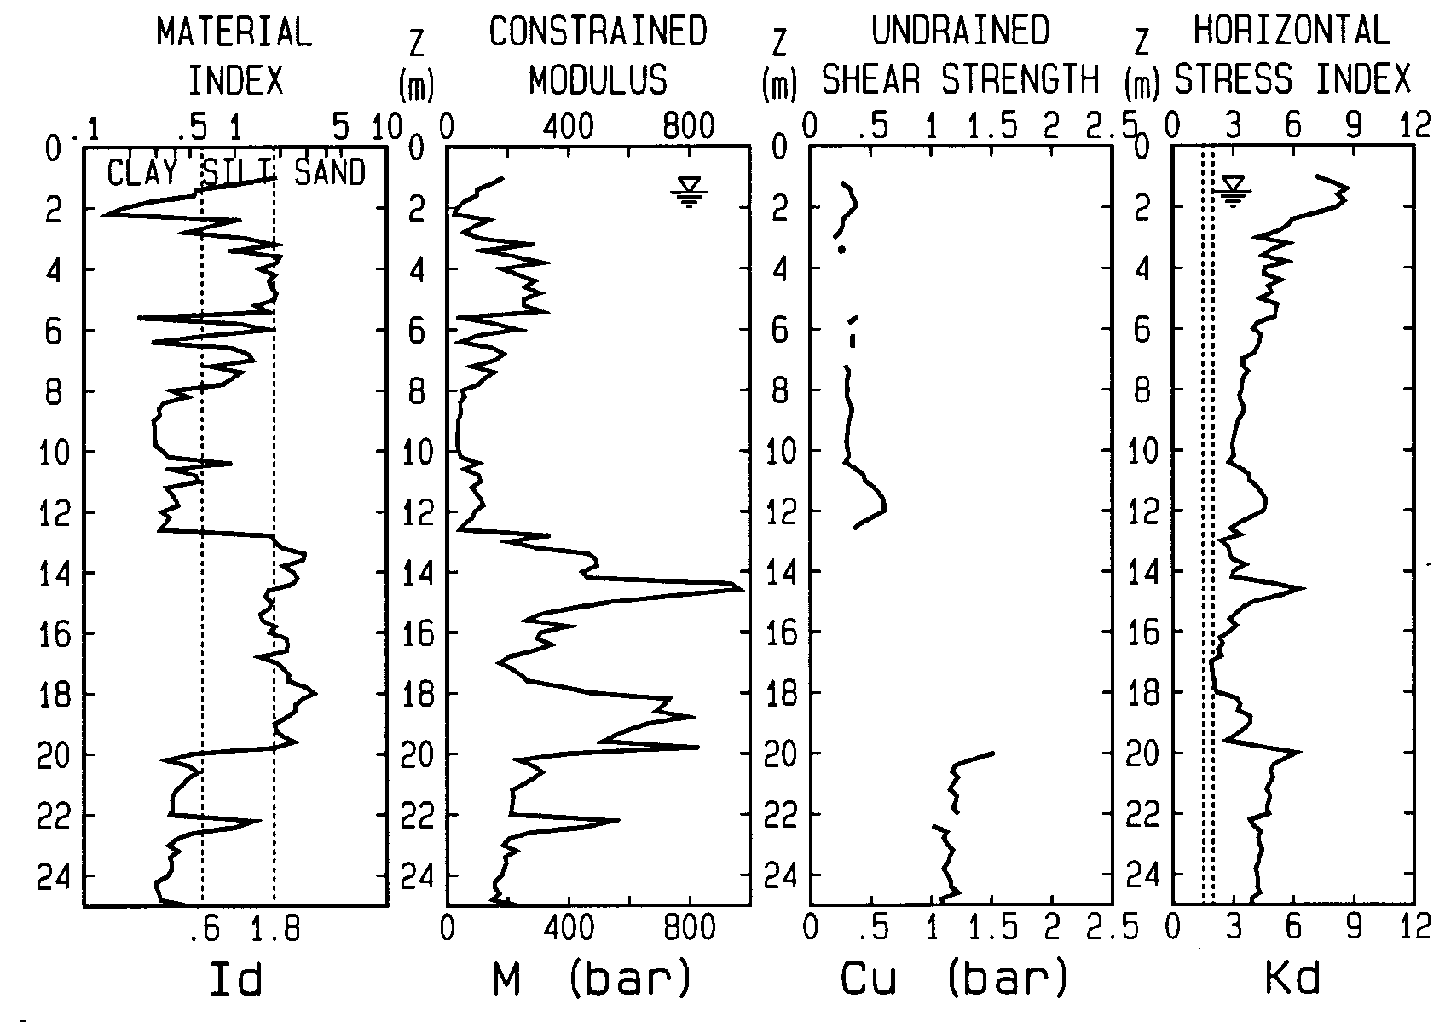

HOW TO USE DMT RESULTS
- M and Cu : common, usual way
- Id : soil type (sand, silt, clay)
- Kd same shape OCR (useful to understand history of deposit). NOTE : Kd=2 → OCR ≈ 1

EXAMPLE OF TABULAR OUTPUT

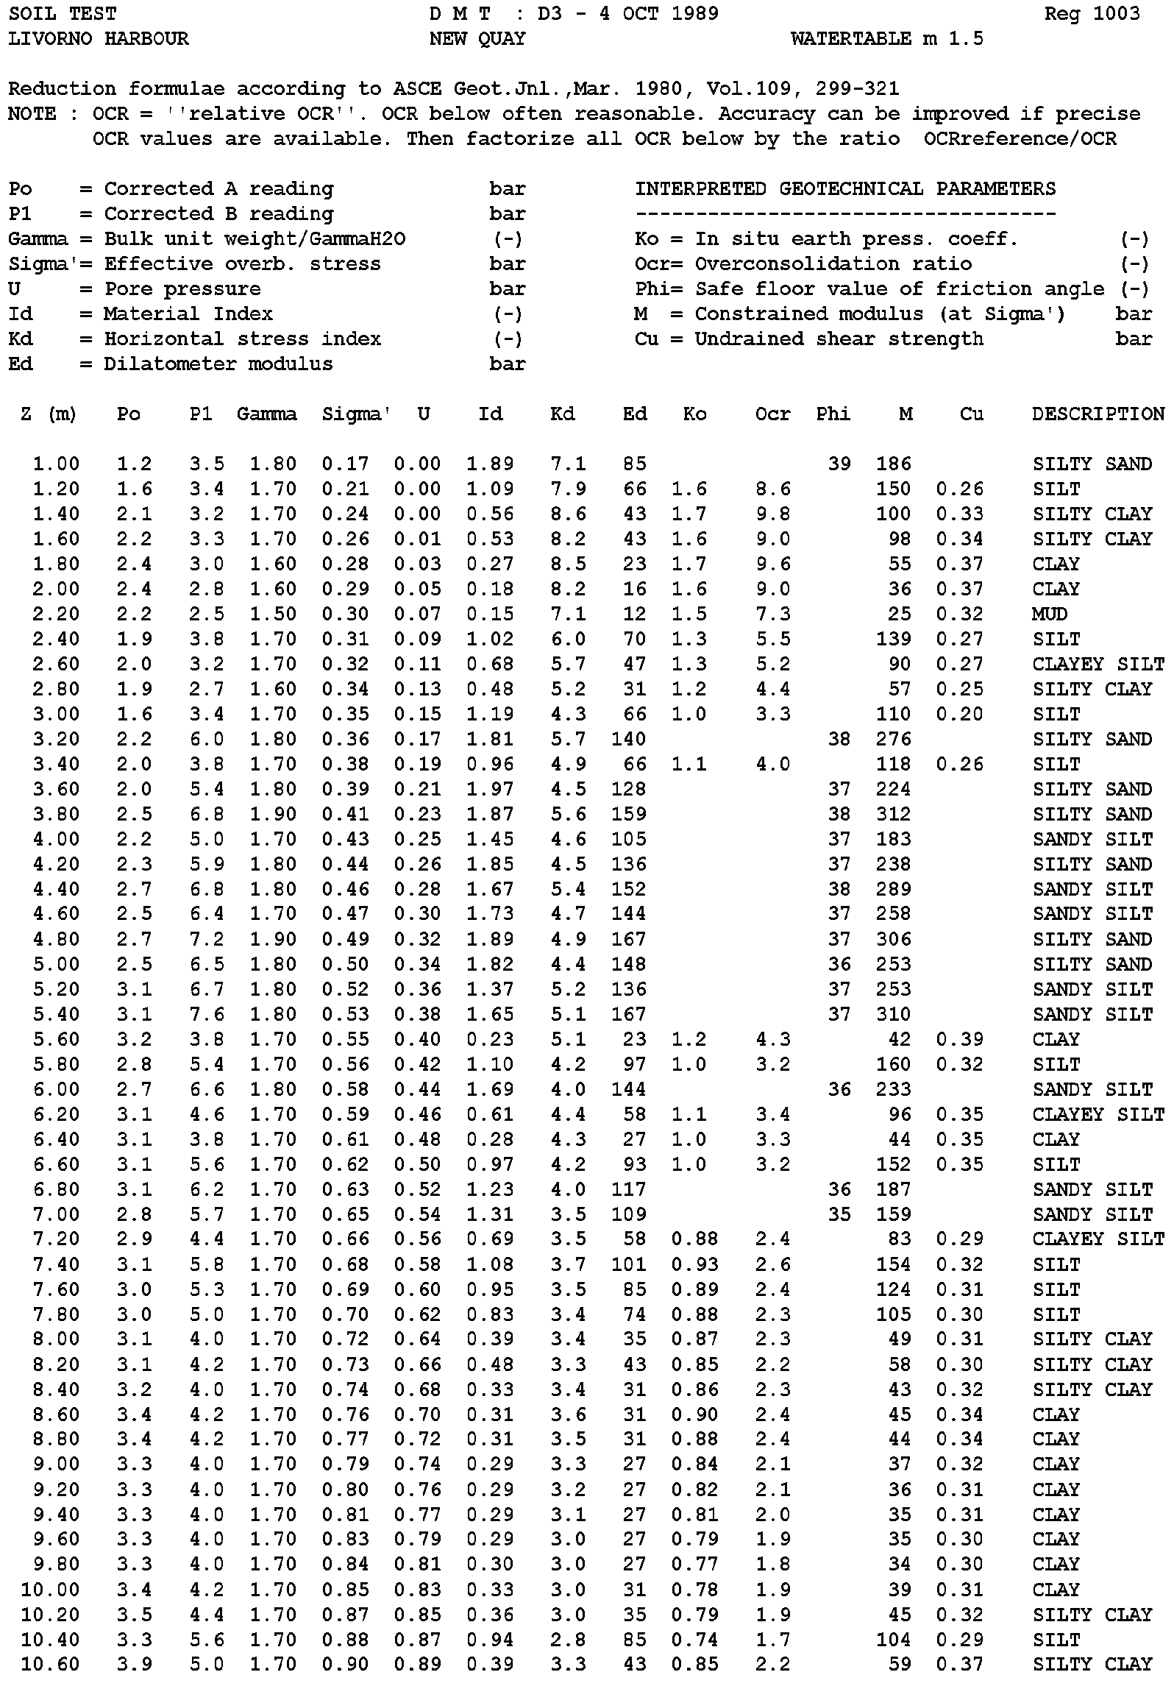

DMT in NC sites
VENEZIA LIDO
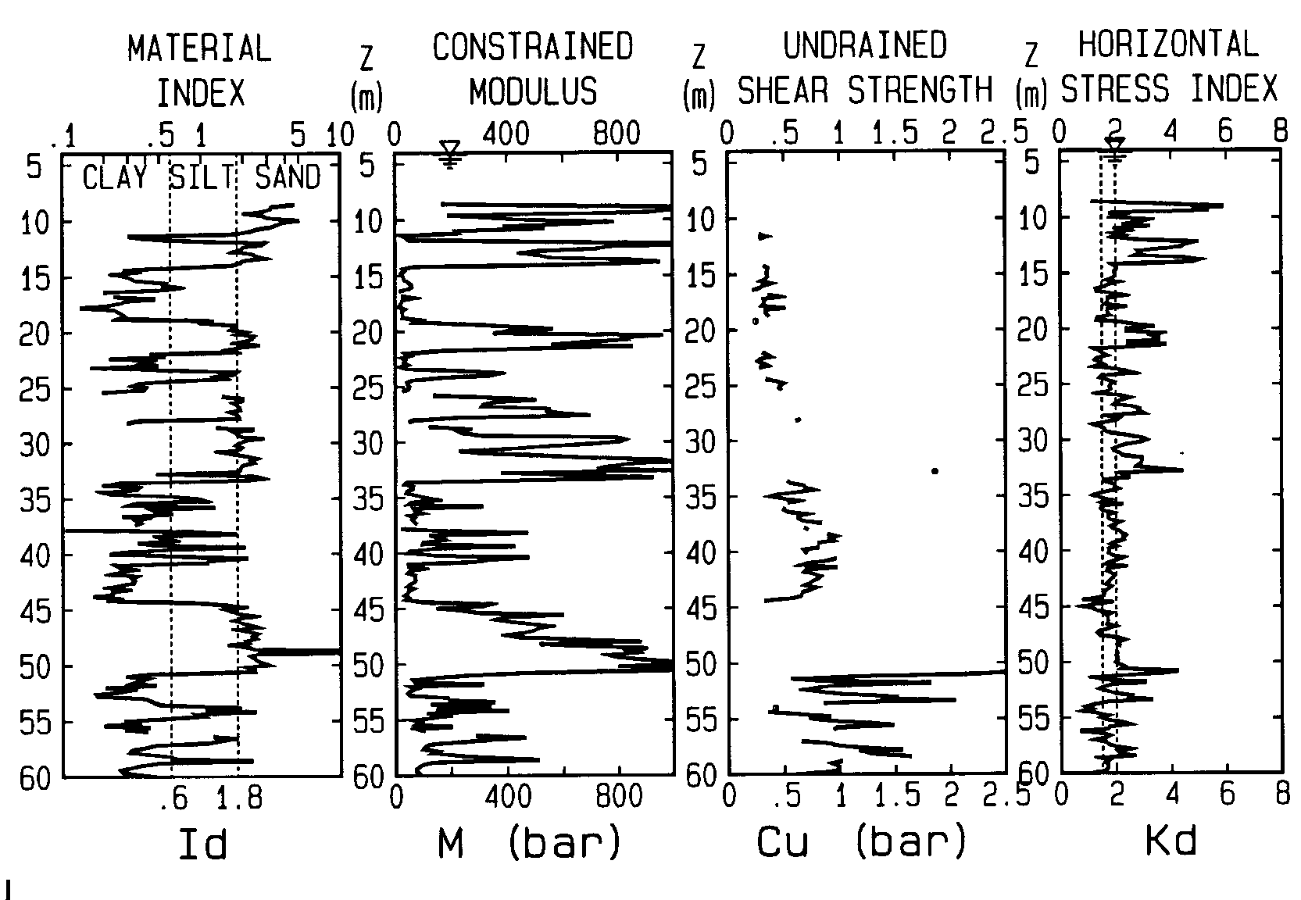

STAGNO LIVORNO
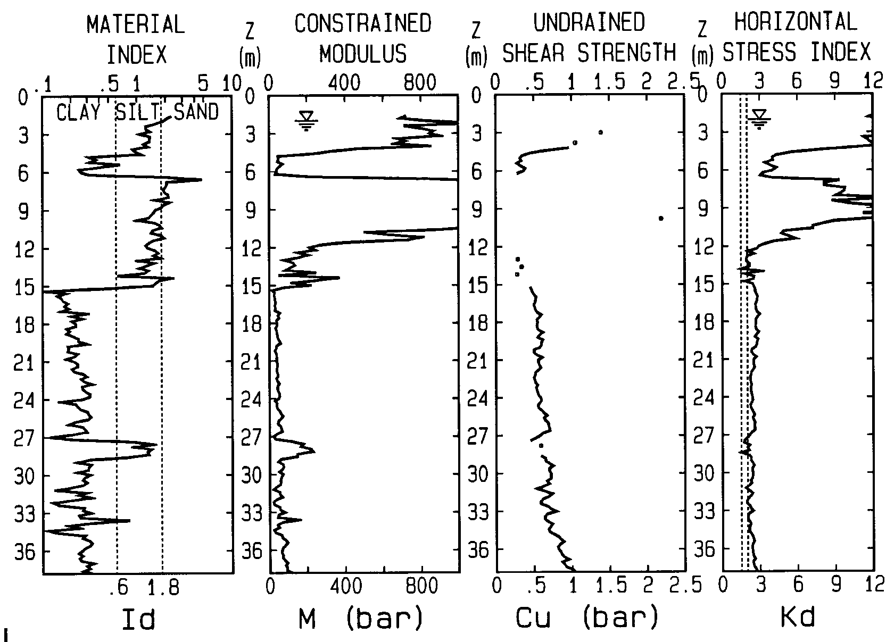
DMT in OC sites
AUGUSTA
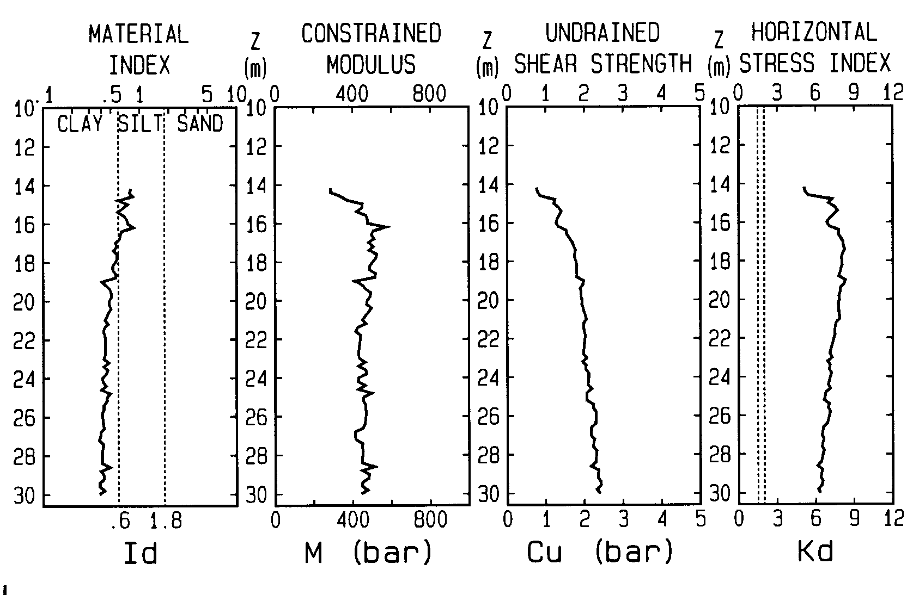

TARANTO
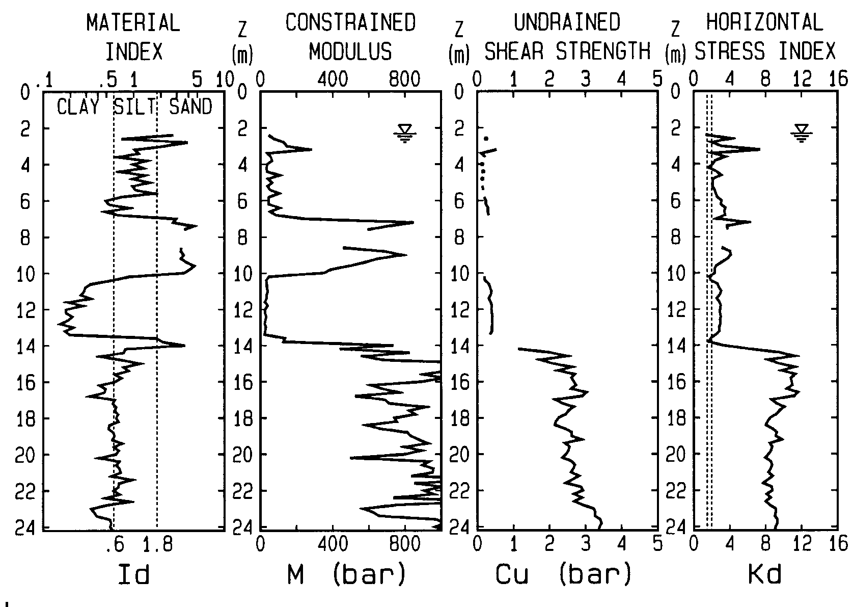

σh | High σh Reduce SETTLEMENTS

- Well documented by Massarsch (1994) in a LOOSE SANDFILL Compaction case (see also Leonards & Frost 1988...)
- Compaction /densification causes OC, increasing σh , which reduces substantially settlements.
i.e. same sand, same q : S2 <<S1
S1
❶
LOW
σh
S2
HIGH
σh
❷
Kf

Ko
1
2

Reasons why Sand #2 is stiffer:
(a) More distant from Kf (b) Higher σave (> M)
For a given sand Modulus = f (σo , Δσh , Path)

Since σ_{h} important for settlements, better be aware !

Cylindrical Probes Scarcely
Sensitive to σh due to ARCHING
Hughes & Robertson (Can. G. Jn. Aug. 1985) analysed stresses around circular probes in sand :
- Behind tip, enormous stress reduction
- Ring of high residual stresses (at some distance)
- "Parasitic" RING obstacle to σh (blinding effect) limits and makes undetermined σh,sleeve
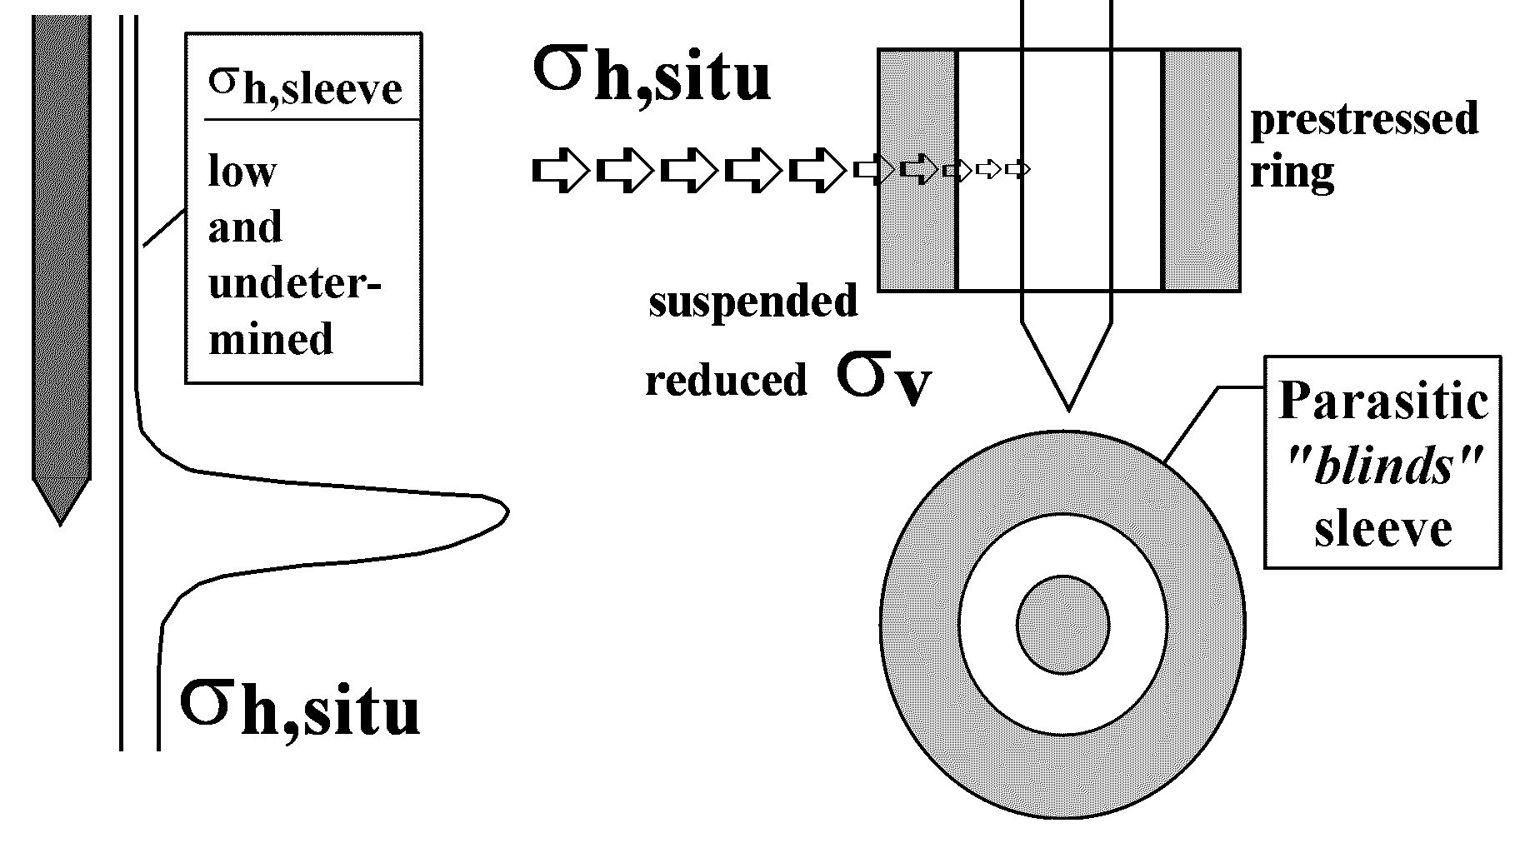
- Moreover σh,sleeve itself is not measured horizontally, but from fs (vert. force), via δ (?)

Laterally suspended floating "ring" also reduces σv at base ⇒ could be reason why Qc (z) < linear
Similar conclusions (sand) Huang, Can. G. Jn. Feb 1994
...σh,sleeve INSENSITIVE to σh,in situ + UNSTABLE
(reason why fs ≈ unused)

∴ PROBES circular + angular transition point (LSC, PIP) difficult to feel σh ⇒ problem, σh important for settlements, liquefaction etc.

flat SHAPE more reactive to σh
- Eliminates (reduces) arching (L/B=6)
- No angular transition point
- Stress measured are horizontal stresses
Higher reactivity of DMT to Δσh-Compaction demonstrated by Jendeby 92. He measured both Qc and Mdmt before and after compaction of a loose sandfill

BEFORE  MDMT  MDMT  Qc  Qc | AFTER

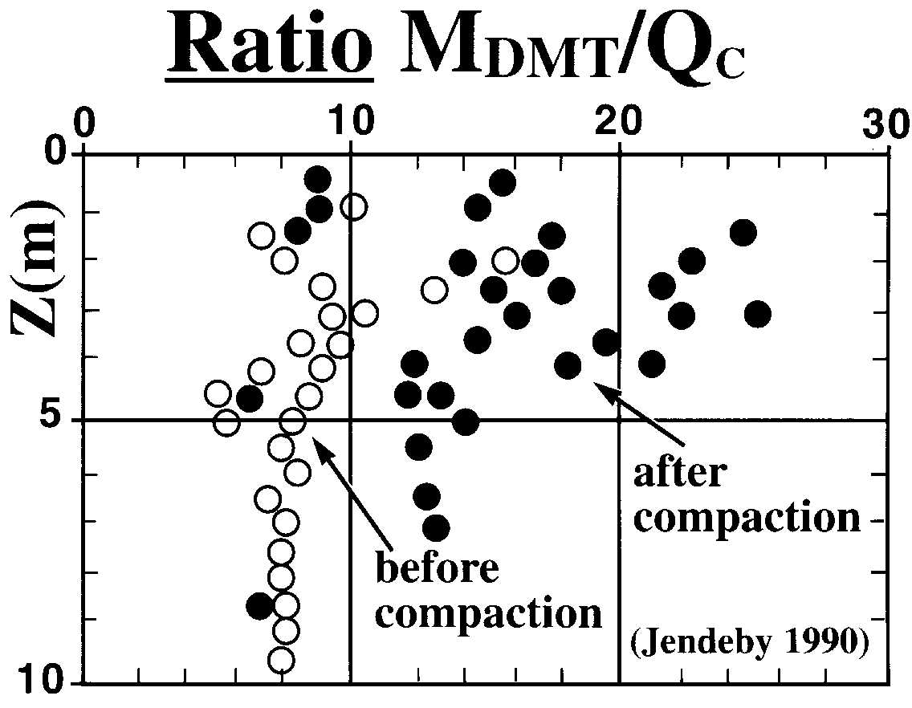

DMT more reactive to σh
- Compaction increases σh , OCR, Dr.
- In principle, higher reactivity of DMT to compaction could be due not only to σh.
- However we know Qc is quite reactive to Dr, DMT moderately reactive to OCR, hence higher reactivity of DMT primarily due to σh.
- Higher reactivity of DMT to σh also demonstrated by CC results by Jamiolkowski's group.

NOTE: higher reactivity of DMT to σh is NOT as saying we are able to derive quantitavely σh from DMT (the various effects must be separated).

On the other hand since many behaviours (settlements, liquefaction…) depend on σh, better use tools sensitive to σh than insensitive to σh.

ARCHING is HIGH for CIRCULAR SHAPE, but ≈ 0 for FLAT SHAPE
Pile : extraction force substantially less (arching)
⬆ ⬆
VENICE : ≈ NC
SANDS & SILTS
50-70% 100%
qc
Dr
40% 60% 80%
Flat sheet
same
contact area
Pile
Z
(m)
for a given Dr
po less than linear with Z
$$K_{D}=\frac{p_{o}−u_{o}}{σ_{\text{vo}}^{'}}$$

DMT sensitive to COMPACTION and Δσh
Before-after CPT/DMTs used to monitor compaction
often $\frac{Δ{\text{Mdmt}}/{\text{Mdmt}}}{Δ{\text{Qc}}/{\text{Qc}}}≈2$
Schmertmann (1986) dynamic compaction of sand site. MDMT % increase ≈ twice % increase in qc.
Jendeby (1992) monitored deep compaction in a sand fill by vibrowing. MDMT increase ≈ twice increase in qc.
Pasqualini & Rosi (1993) vibroflotation job :
"DMT clearly detected improvement even in layers where benefits were undetected by CPT".
Ghent group (1993) before-after CPTs DMTs to evaluate effects (±Δσh , Dr) by pile (Atlas) installation
"DMTs before-after installation demonstrate more clearly [than CPT] beneficial effects of Atlas installation".
Above concurrently suggest DMT:
- uniquely sensitive to slight ±Δσh , Dr.
- can feel changes undetected by other methods
e.g. relaxation behind diaphragm walls.

EVALUATING OCR in sand
Since Mdmt increases faster than Qc when compacting (=imparting OCR to a loose ≈ NC fill), the ratio Mdmt/Qc increases with OCR. Such ratio may in fact be used as a rough indicator of OCR : Mdmt/Qc = 5-10 means NC sand, 12-24 means OC sand

A SCRUPOLOUS INVESTIGATOR SHOULD MEASURE 36 PARAMETERS
    - To predict deformations, convert
σij (6) εij (6)
{εij} = $\begin{aligned}\left[6x6 | \right]\left[= | \right] \\ \end{aligned}$ {σij}

Matrix 36 non constant (!) parameters (constitutive laws)
    - Investigation : 36 parameters!!! at each Z !
    - Should remember when trying predict behaviour from 1 parameter such as penetration resistance !
    - With DMT 2 parameters, still << 36, but + 100%
    - Note : first parameters most important.
The 36th → negligible gain.
Difference DMT vs PMT (pressuremeter)
DMT is not a PMT. PMT in a predrilled hole, DMT pushed in fresh soil.
- Act 1 PMT : borehole = destroy σh drastic !
(DMT amplifies σh , hence at least ⇒correlations)
- Borehole ⇒ Disturbance ⇒ Dependent on
operator & soil ⇒ repeatibility : strong limitation!
- Slower, + costly, less soil layers tested
- Multiplicity of methods for correcting for disturbance (subjectivity)
Dumas and Ortigao report very similar settlement predictions by DMT-PMT provided "special" correction-curve-fitting applied to PMT...

As to SBPM
- ≈ Prohibitive (PhD required?)
- After 2 decades research, Jamiolkowski concludes (CPT'95 Linkoping and 1998) : SBPM cannot be used - as previously hoped - as a standard for σh i.e. σh,SBPM dubious reliability.
Some colleagues not sure it is advantageous to run PMT in place of DMT (except rocks).
DMT APPLICATION N° 1
SETTLEMENT CALCULATION
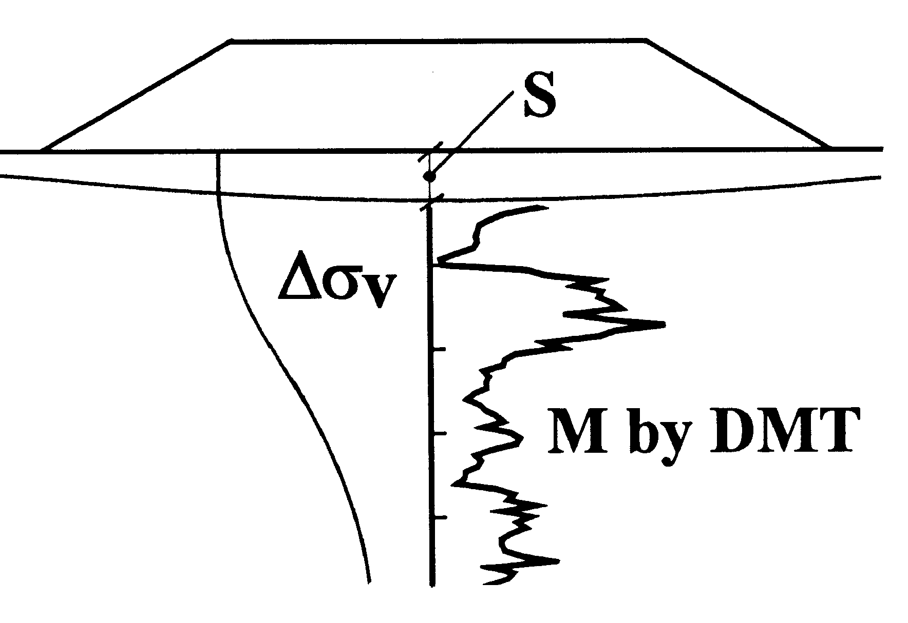
by Boussinesq

$$S=\sum{\frac{{Ds}_{v}}{M}⋅DZ}$$

1-D vs 3-D settlement formulae
In general, in conventional elasticity :
- 1-D formula in 1-D problems (large rafts)
- 3-D formula in 3-D problems (small isolated footings)
$S_{1−D}=Σ \frac{{Δσ}_{v}}{M}⋅ΔZ$
$$S_{3−D}=Σ\frac{1}{E}⋅\left[{Δσ}_{v}−ν⋅\left({Δσ}_{x}+{Δσ}_{y}\right)\right]$$
However our recommendation : use 1-D in all cases:
- S3-D involves ν and σh (uncertainties)
- S1-D v. similar S3-D (10%) (≈ compensation)

- Since results similar, preferable 1-D: simpler, conventional, engineer independent.
- If engineer wants to use 3-D, E' ≈ 0.8 M (elasticity).

S1-D above = end product of a seamless non subjective chain, from in situ to the office :
- Field raw data are independent from operator
- RM for converting ED to M not chosen by person making interpretation, but RM =M / ED =f (ID, KD)
- S1-D independent from person calculating settlements (once Mdmt in computer, push button and by Boussinesq get S)
Such settlement cannot be manipulated !

RECOMMENDED METHOD OF SETTLEMENT CALCULATION : "MDMT + 1-D method"
$$S=S\frac{{Ds}_{v}}{M}⋅DZ$$
Why 1-D preferred to 3-D : see ASCE Jnl GE Jan 1991, Marchetti discussion to Leonards. A side benefit of the 1-D method : continuous
non-subjective chain from in situ testing to S1-D :
- Ed independent from operator
- M independent from person making interpretation, being Rm=M/Ed=f(Kd)
- S1-D independent from person calculating settlements

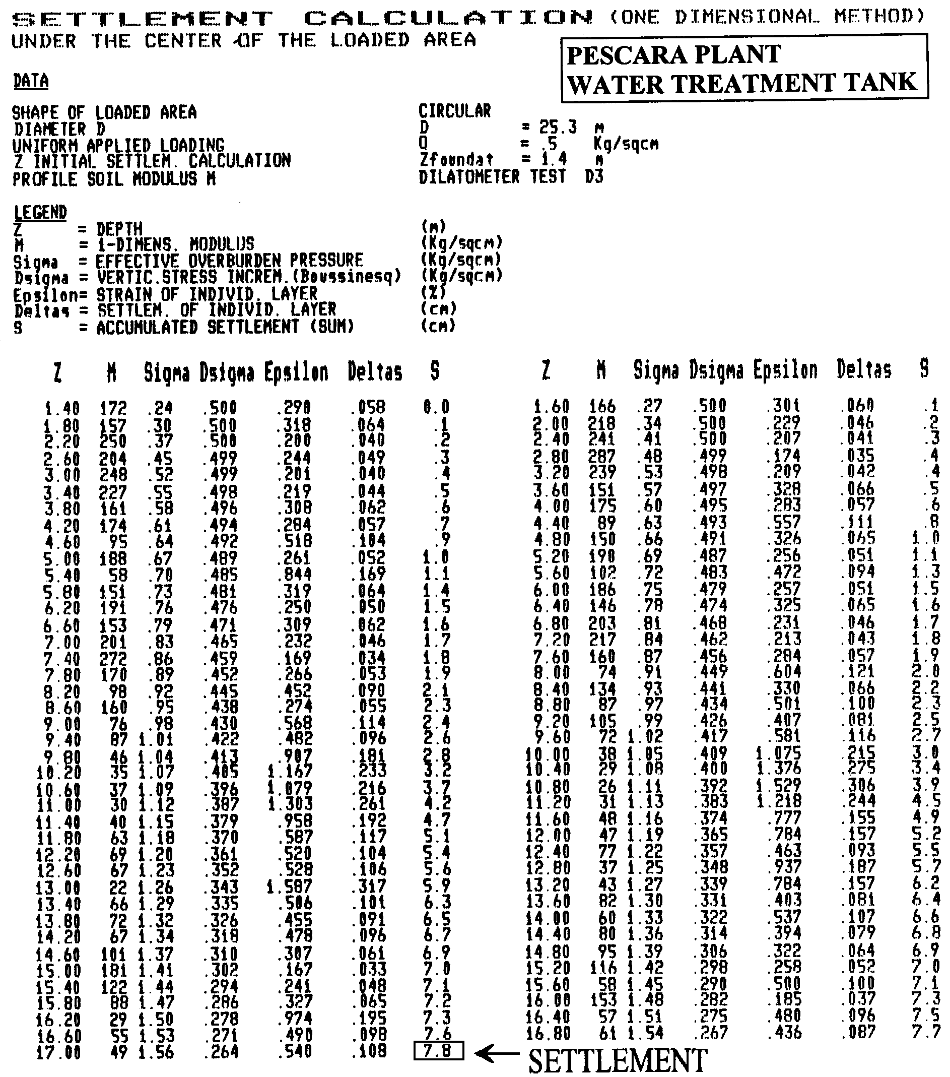

DMT-calculated vs observed SETTLEMENTS

SCHMERTMANN, 1986 - 16 CASE-HISTORY
Proc. In Situ '86 ASCE Spec. Conf. VIP, Blacksburg, p.303.

No | Location | Structure | Compressible soil | Settlement (mm) |  |  | Ratio  DMT/meas.
 |  |  |  | DMT | ** | meas | Ratio  DMT/meas.
1 | Tampa | Bridge pier | HOC Clay | *25 | b,d | 15 | 1.67
2 | Jacksonville | Power Plant | Compacted sand | *15 | b,o | 14 | 1.07 (ave.3)
3 | Lynn Haven | Factory | Peaty sd. | 188 | a | 185 | 1.02
4 | British Columbia | Test embankment | Peat  org. sd. | 2030 | a | 2850 | 0.71
5a  b  c | Fredricton  "  " | Surcharge  3' plate building | Sand  Sand  Quick cl.  Silt | *11  *22  *78 | a  a  a | 15  28  35 | 0.73  0.79  2.23
6a  b | Ontario  " | Road embankment building | Peat  Peat | *300  *262 | a,o  a,o | 275  270 | 1.09  0.97
7 | Miami | 4' plate | Peat | 93 | b | 71 | 1.31
8a  b | Peterborough" | Apt. bldg Factory | Sd. & si. | *58  *20 | a, o  a, o | 48  17 | 1.21  1.18
9 | " | Water tank | Si. clay | *30 | b,o | 31 | 0.97
10a  -30%  +50%  b | Linkoping  " | 2x3 m plate  1.1x1.3m plate | Si. sand  Si. sand | *9  *4 | a,o  a,o | 6.7  3 | 1.34  1.33
11 | Sunne | House | Silt & sand | *10 | b,o | 8 | 1.25
CALCULATED/OBSERVED AVE : 1.18
Similar agreement by many others, e.g.:
Lacasse, S. & Lunne, T. 1986. Dilatometer Tests in Sand. Proc. In Situ '86 ASCE Spec. Conf. Virginia Tech, Blacksburg.
Sallfors G. (1988) "Validity of compression modulus determined by dilatometer tests", Proc. of two-day seminar at NGI on calibration of in situ tests.
Steiner ('94), Woodward ('96), Mayne, Failmezger ('98), Didaskalou ('99), Tice (2000) ...

observed vs dmt calculated settlement
HaYes, 1990 (°)
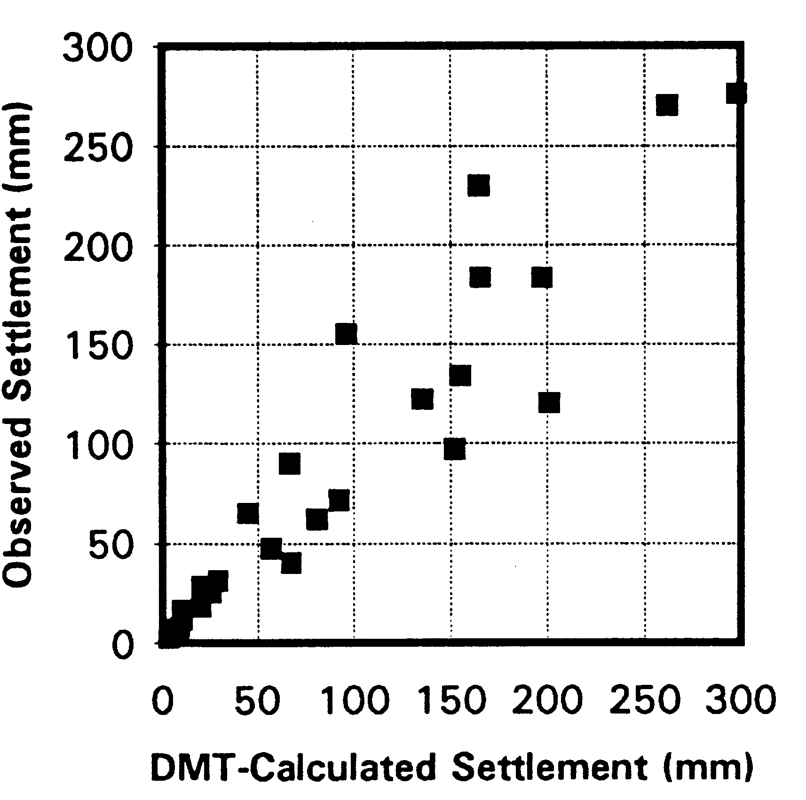

HAYES J.A. (1990) "The Marchetti Dilatometer and Compressibility"
Paper to Southern Ontario Section of Canad. Geot. Soc.
Seminar on "In Situ Testing and Monitoring". Sept.

ACCURACY OF SETTLEMENT PREDICTIONS

CPT
DMT

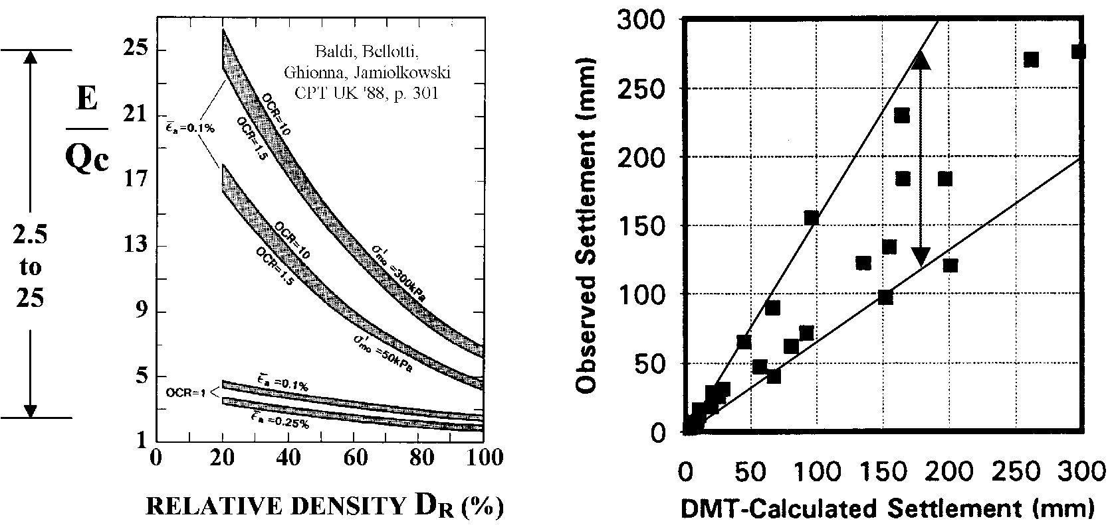

A comparison of band amplitude in Jamiolkowski and Hayes data indicates a settlement prediction bandwidth (max/min) for DMT 3 times narrower than CPT

Higher accuracy of DMT believed due to :
1. Sensitivity to σh, Stress History
2. Wedge shaped tips deform soil << than cones
3. The modulus obtained by expanding a membrane (a mini load test) is more closely correlated to insitu soil modulus than is a penetration resistance

C-READING (pressure on membrane at "membrane closure") in SAND = Uo
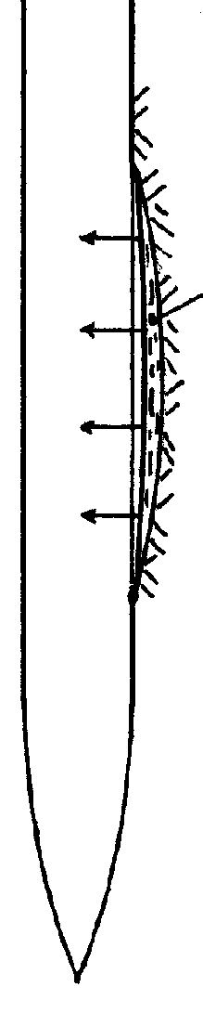
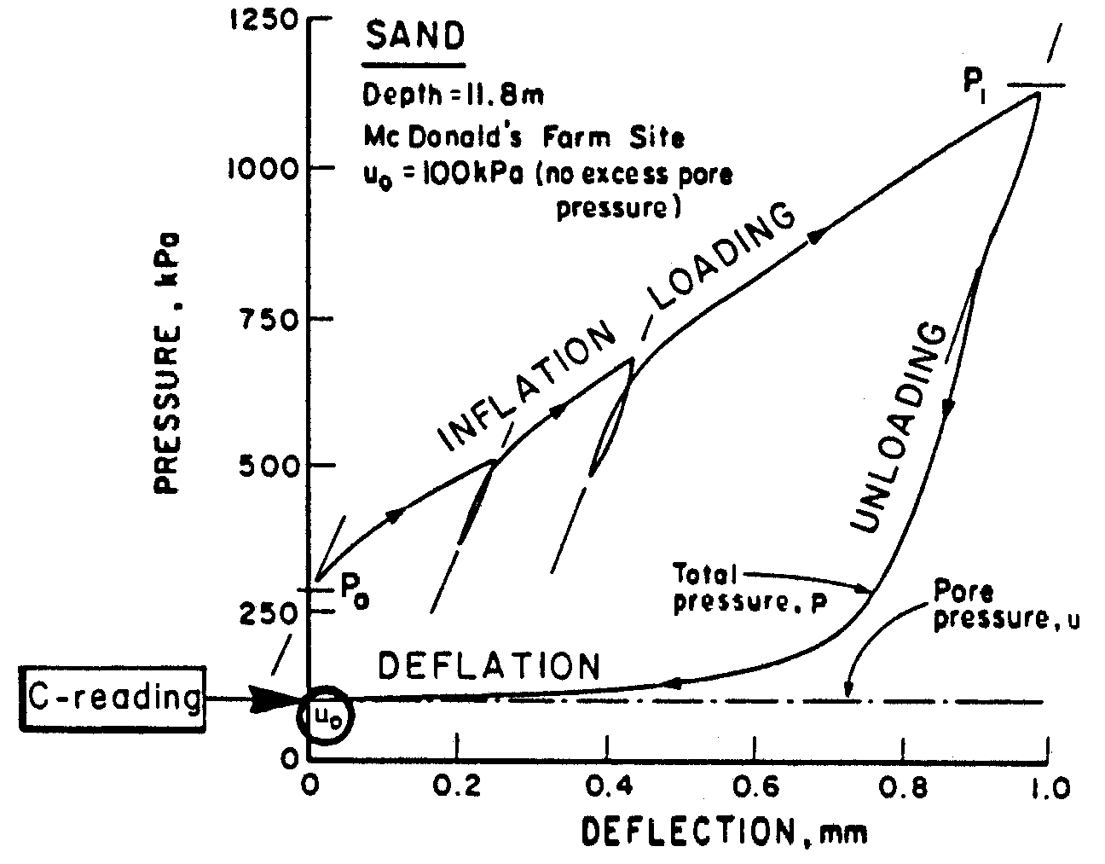
Water film between sand and membrane
Campanella et al. (1985) Proc 11 ICSMFE, S. Francisco, 2, p. 852.

≈ no contact Sand/Membrane ⇒
σ = σ' + Uo
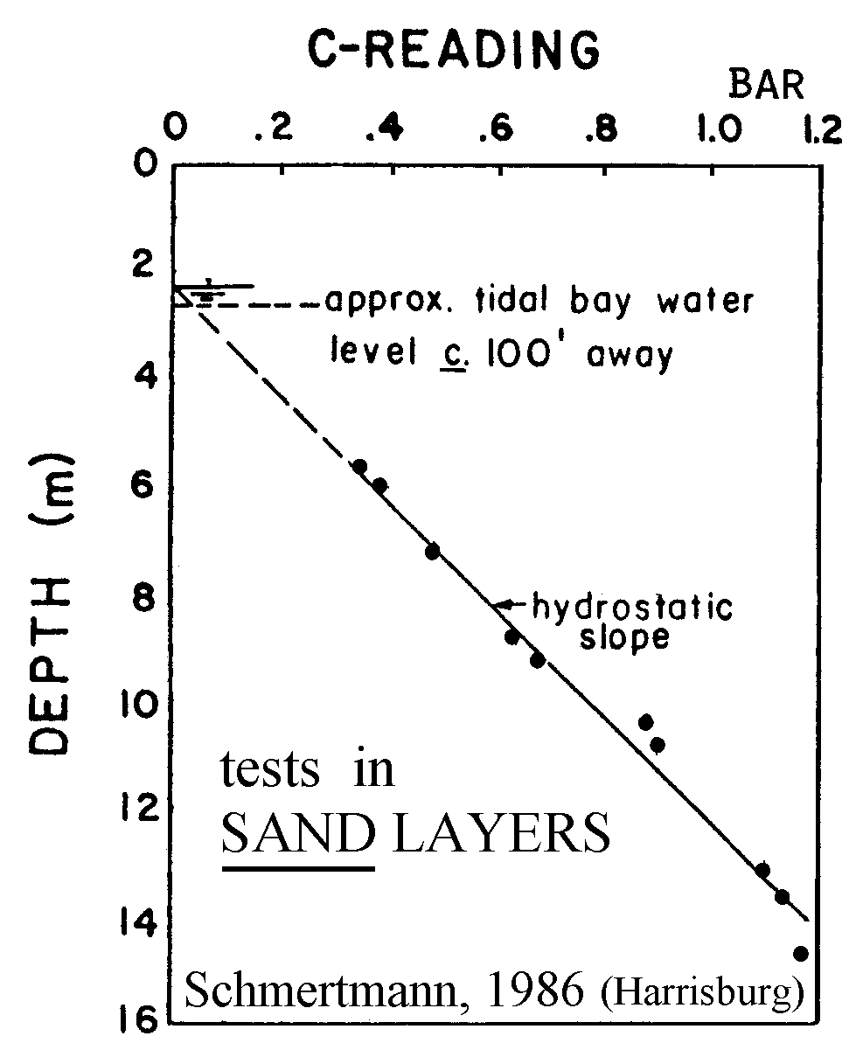
Same Uo as from a piezometer, without problems of :
Filter clog
Smearing
Saturation

Schmertmann, J.H.S.(1986). Some 1985-86 Development in Dilatometer Testing and Analysis. Proc. PennDOT and ASCE Conf. on Geotechnical Engineering Practice, Harrisburg, PA.

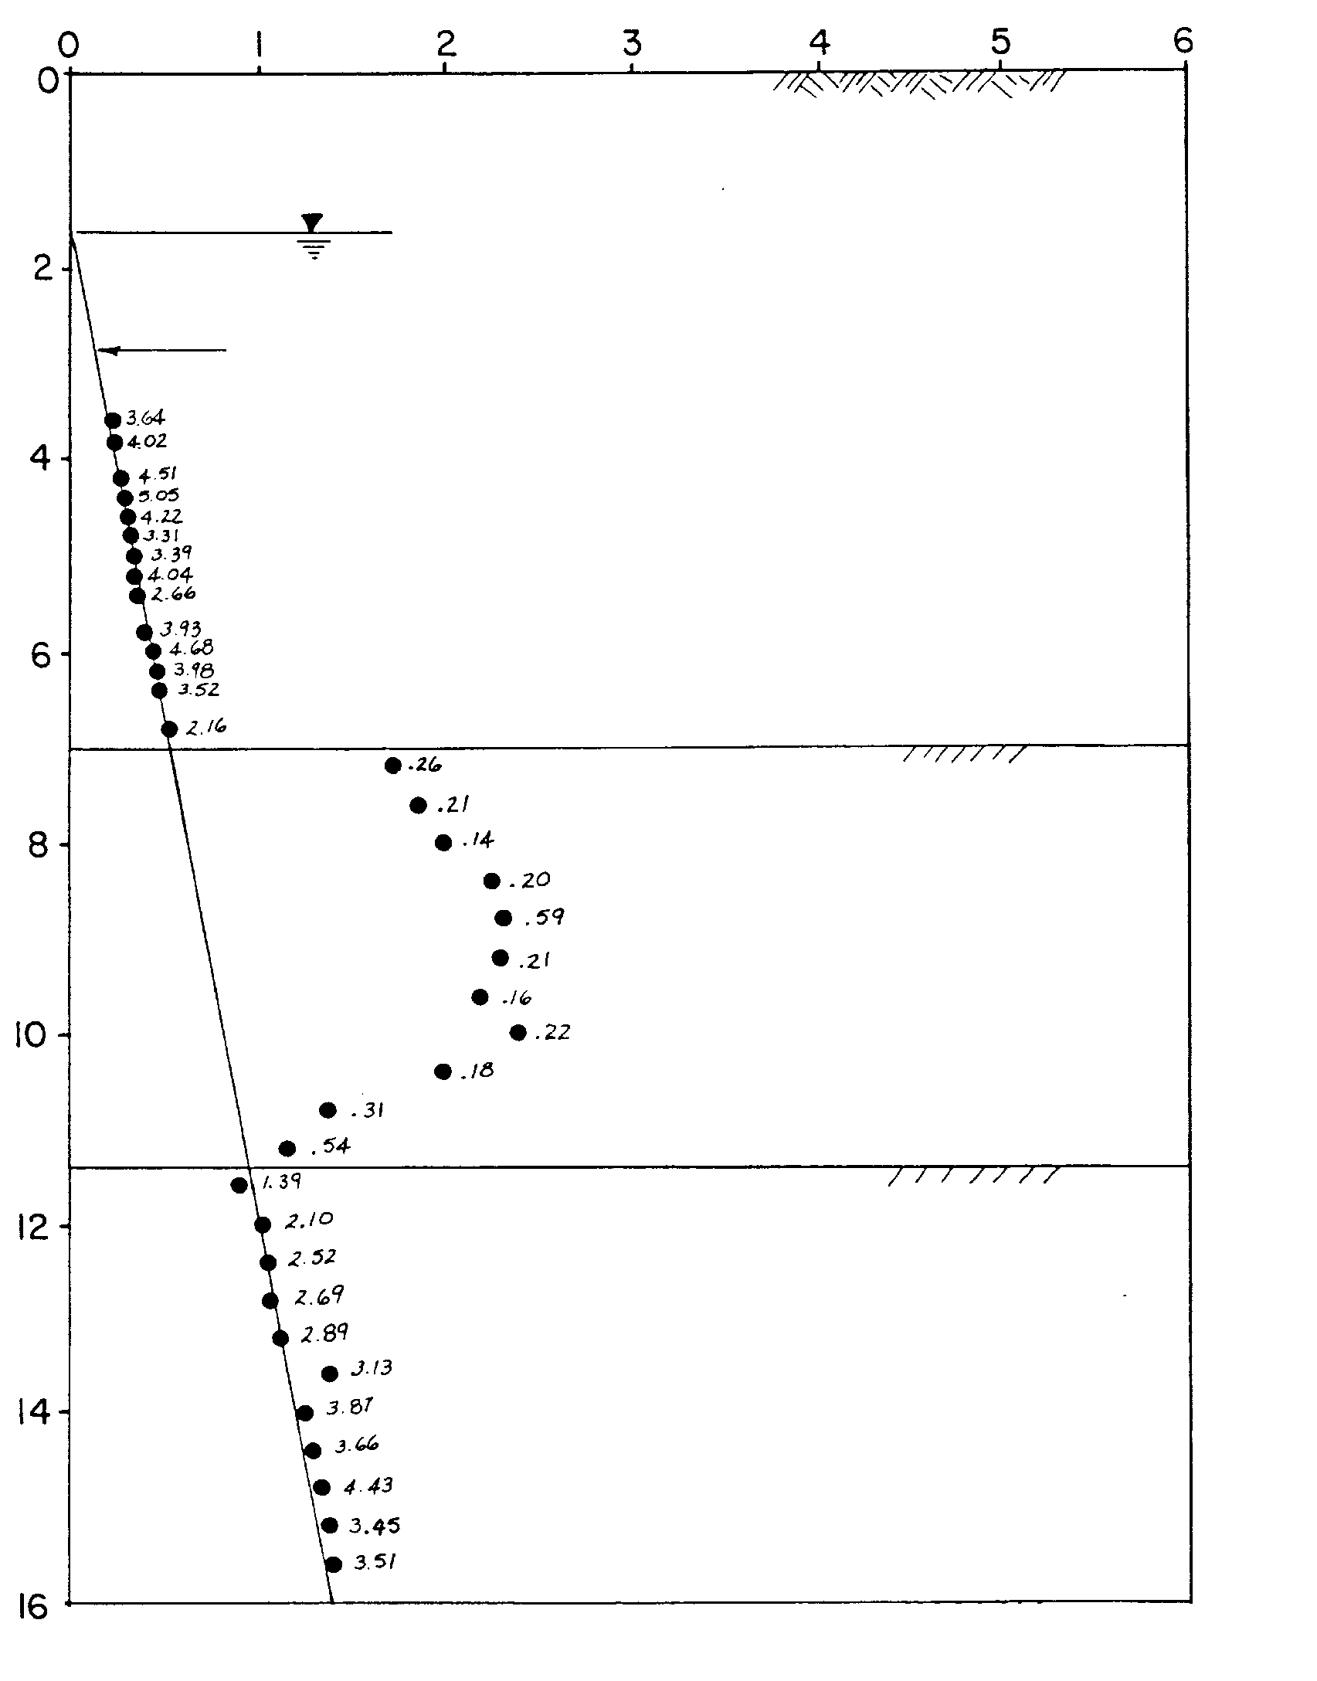
C-reading (P2)
Hydrostatic line
SAND
CLAY
SAND
DEPTH (m)
C-reading (bar)
Indicates ID Hydrostatic line
- in SANDS measures Uo (≈ piezometer)
- in CLAYS evidences Δu (i.e. non freely draining)

Schmertmann, 1988 (DMT Digest No. 10, May 1988, Fig.3)

Coefficient of consolidation /
permeability from Tflex
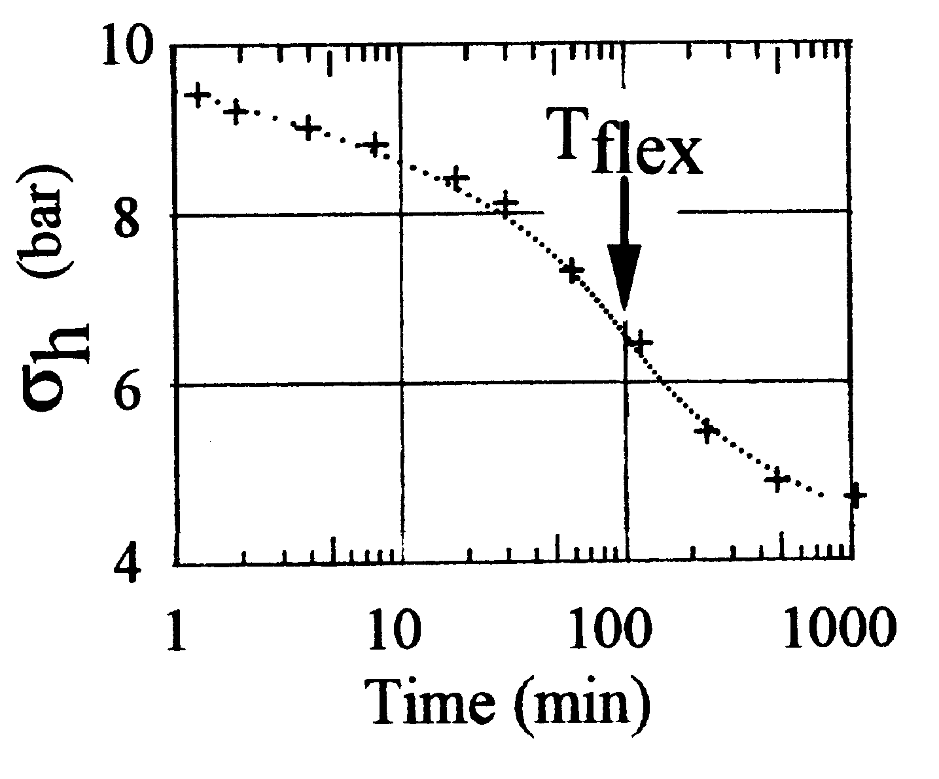

$$C_{h}≃\frac{7{\text{cm}}^{2}}{T_{\text{flex}}} k=\frac{C⋅γ_{w}}{M}$$

Marchetti, S. & Totani, G. 1989.
Ch Evaluations from DMTA Dissipation Curves.
Proc. XII ICSMFE, Rio de Janeiro, Vol. 1: 281-286.

(Interestingly Mesri et al (ASCE Jnl GGE, Aug 1999, 716) advocate use of "inflection point method" even for Cv from oedometer, in place of the usual Casagrande or Taylor methods).

RELIABILITY OF Ch by DMT
Difficult to evaluate : scarcity reliable reference Ch
Comparisons complicated by:
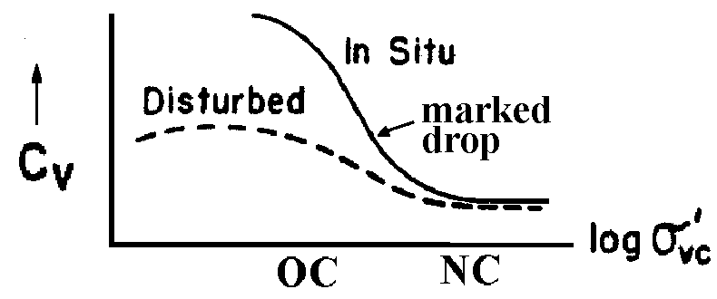
- Chorizontal ≠ Cvertical
(oedometer gives Cv!)
- Coc ≠ Cnc (Load Range)

But Common sense : If we had to backcalculate Ch under an embankment, would we prefer to infer Ch…
u(t) ? where
σh

…from u(t) in a singular POINT in highly distorted clay...?  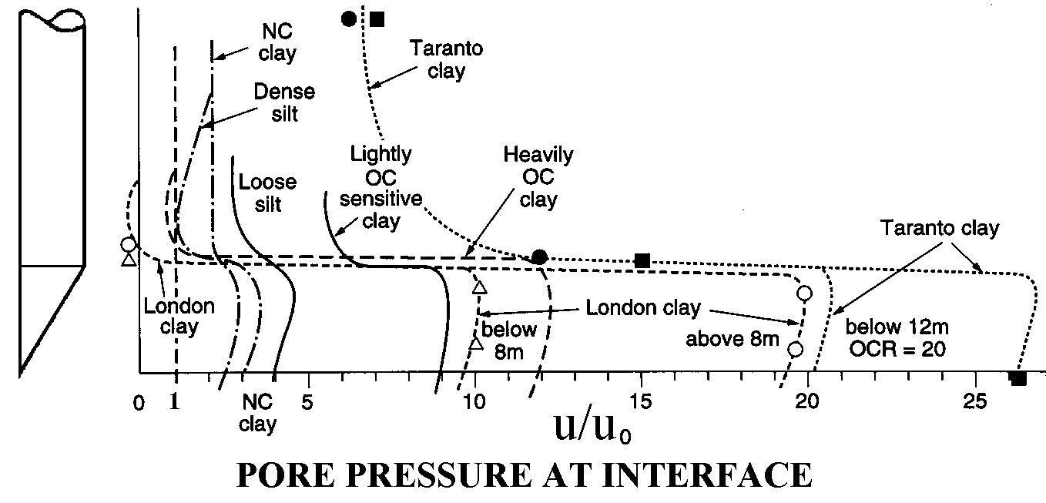  Robertson et al. (1986). "Use of Piezometer Cone Data", Proc. "In Situ '86" ASCE Spec. Conf., Virginia Tech, Blacksburg, p. 1265 | ...or from σh - decay under this  MINIEMBANKMENT ?  - Integral (more stable)  - Larger volume  Instrumentally, the bloodless (dry) DMT dissipations easier:  -No Filter clogging/ smearing  -No Loss of saturation  ≈ No Dependent on push force

CASE HISTORIES : Ch,dmt underpredicts Ch from real scale works by a factor 1 to 3. (Still on the "slow" side, but much faster than the usually too slow oedometer predictions)
Totani et al. 1998, In situ determination of Ch by DMT", Proc. ISC '98, Atlanta, 2, 607.
Evaluating STABILITY of a SLOPE

Verifyies if an OC Clay SLOPE contains ACTIVE (or old quiescent) SLIP surfaces

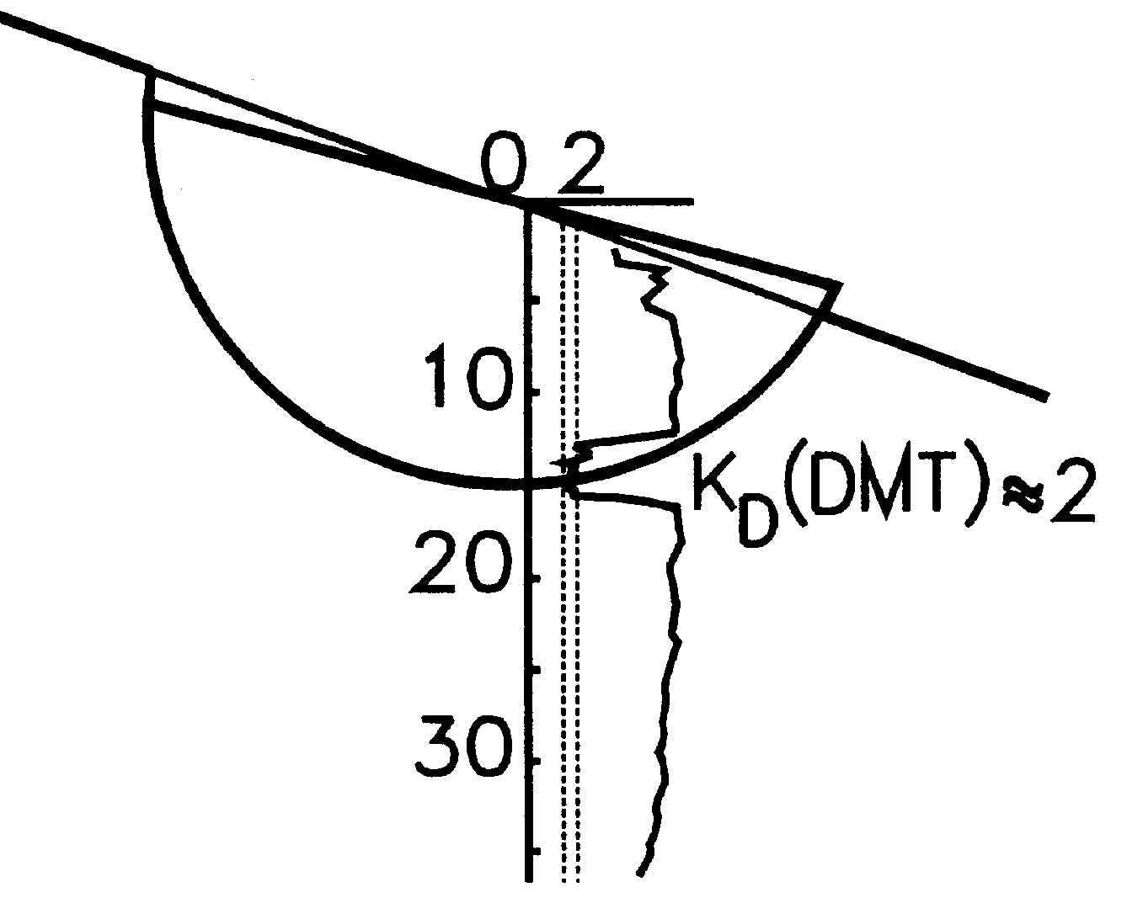

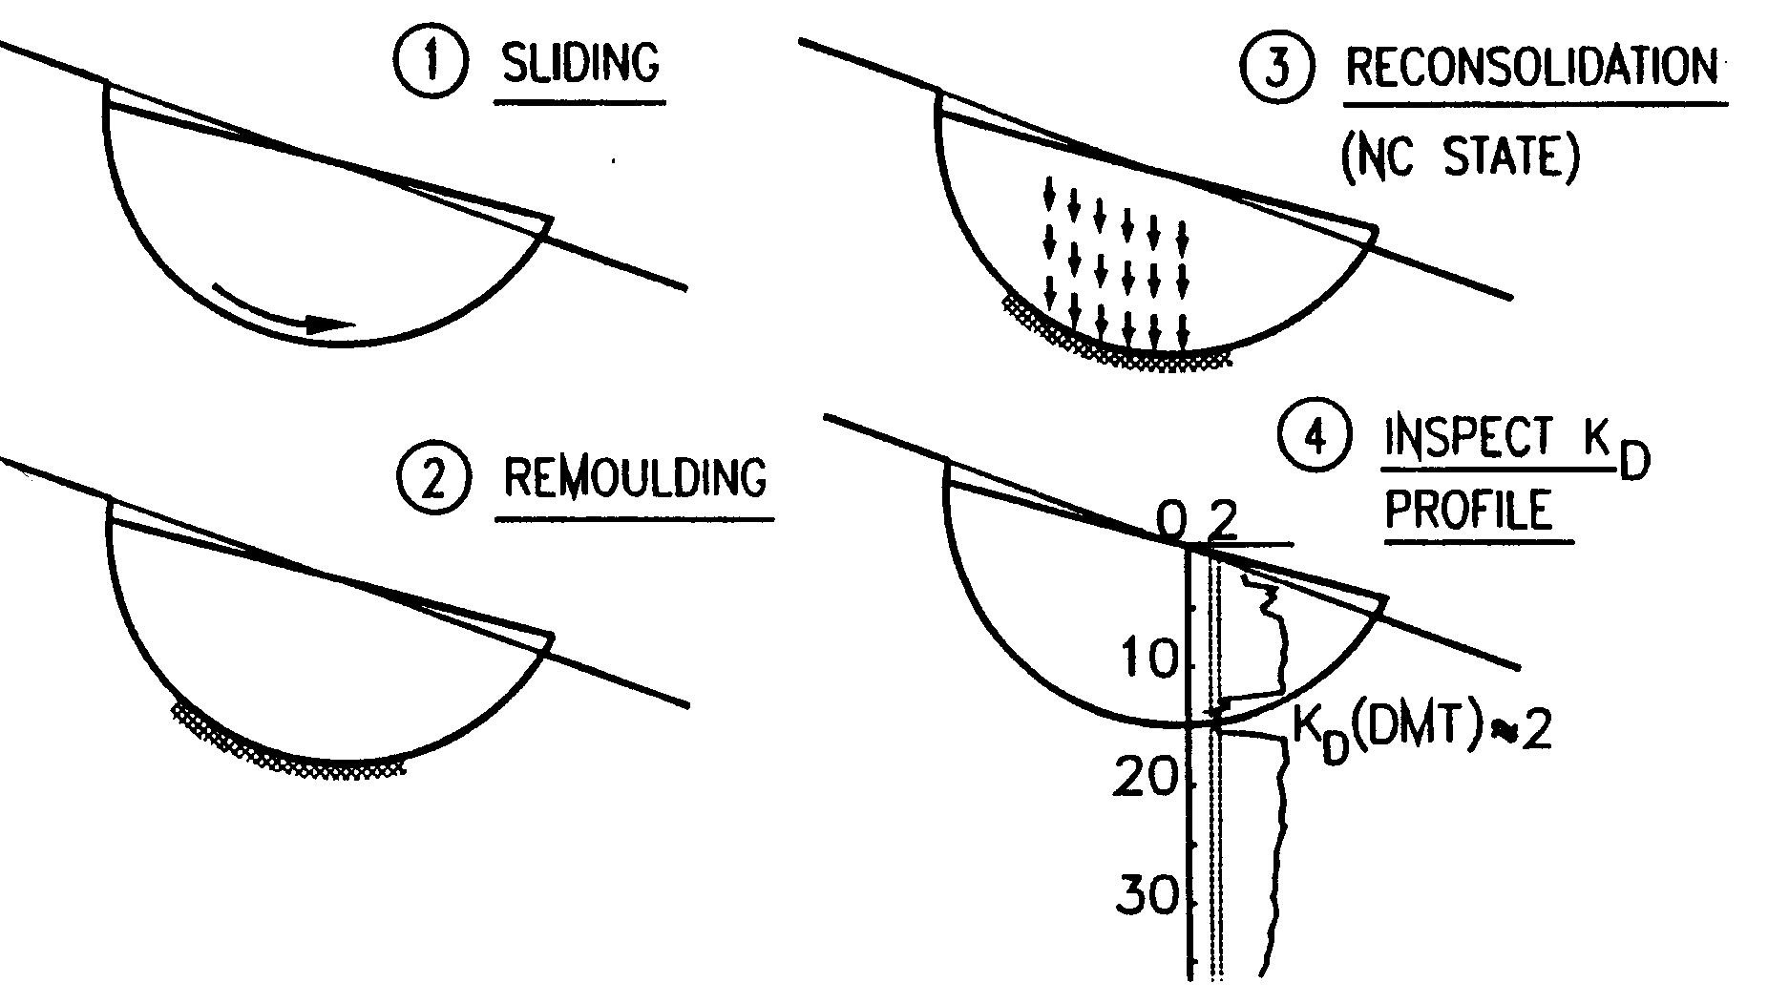

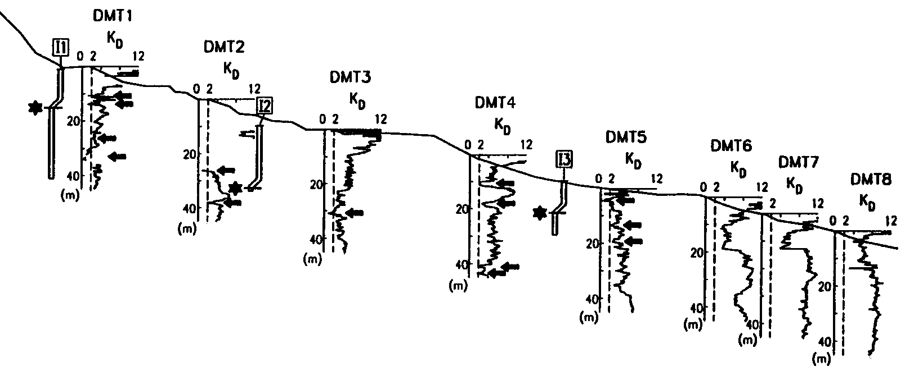
KD=2 LAYERS CORRESPOND TO SLIP SURFACES BY INCLINOMETERS
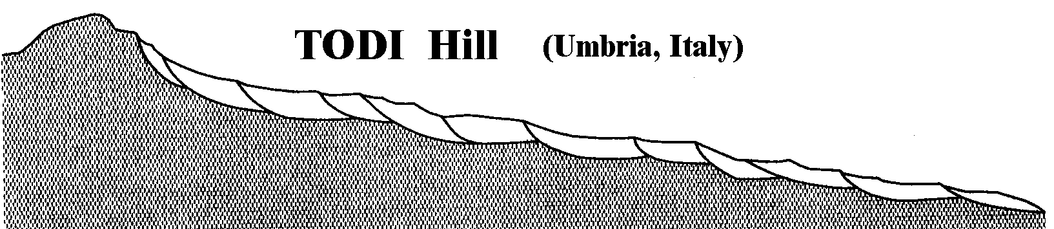

Qualitative reconstruction (Tonnetti, 1978)

Example - DMT 4
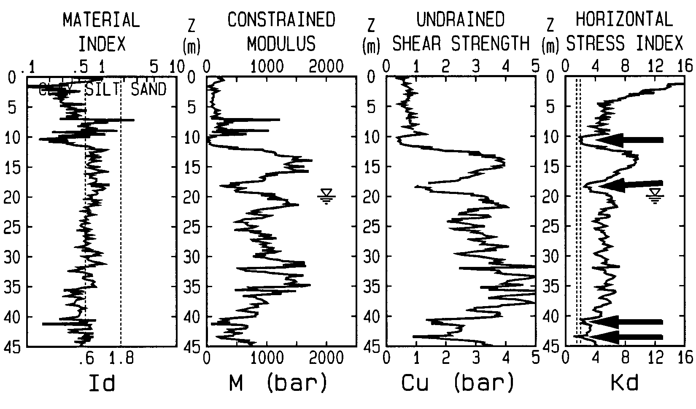

- Specific value Kd ≈ 2
- Detects quiescents planes (inclinometers can't - must move)

Case history, Chieti Hills, 1996. SAFETY of proposed VERY HEAVY BUILDING on an OC Clay SLOPE
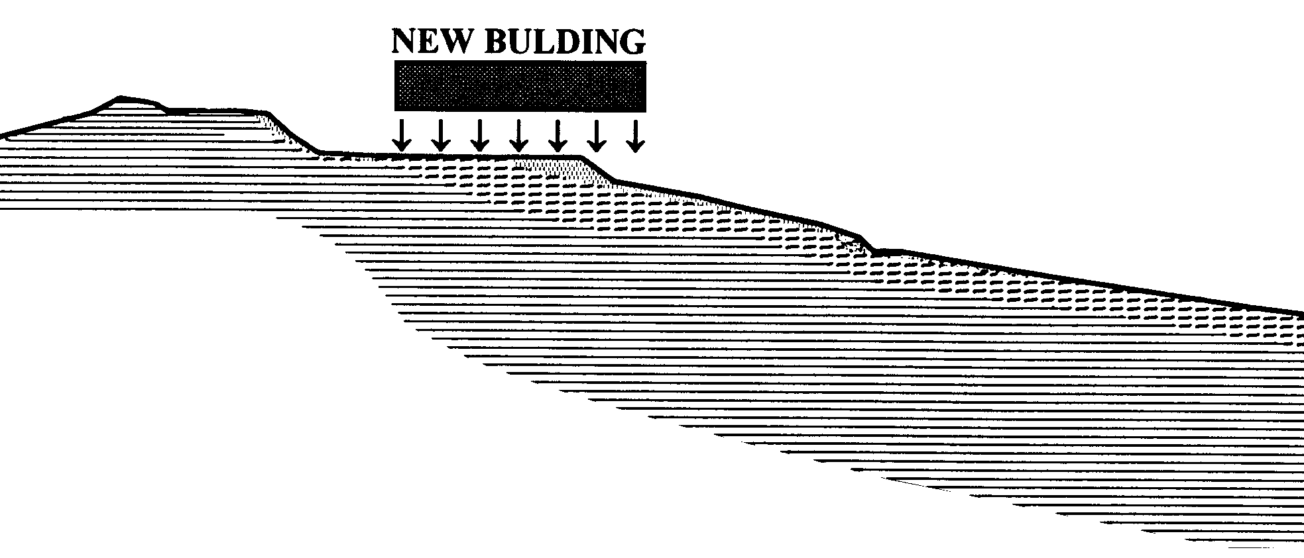
1. Slope stable ???
Attacked by verifying via KD presence of previous slip surfaces

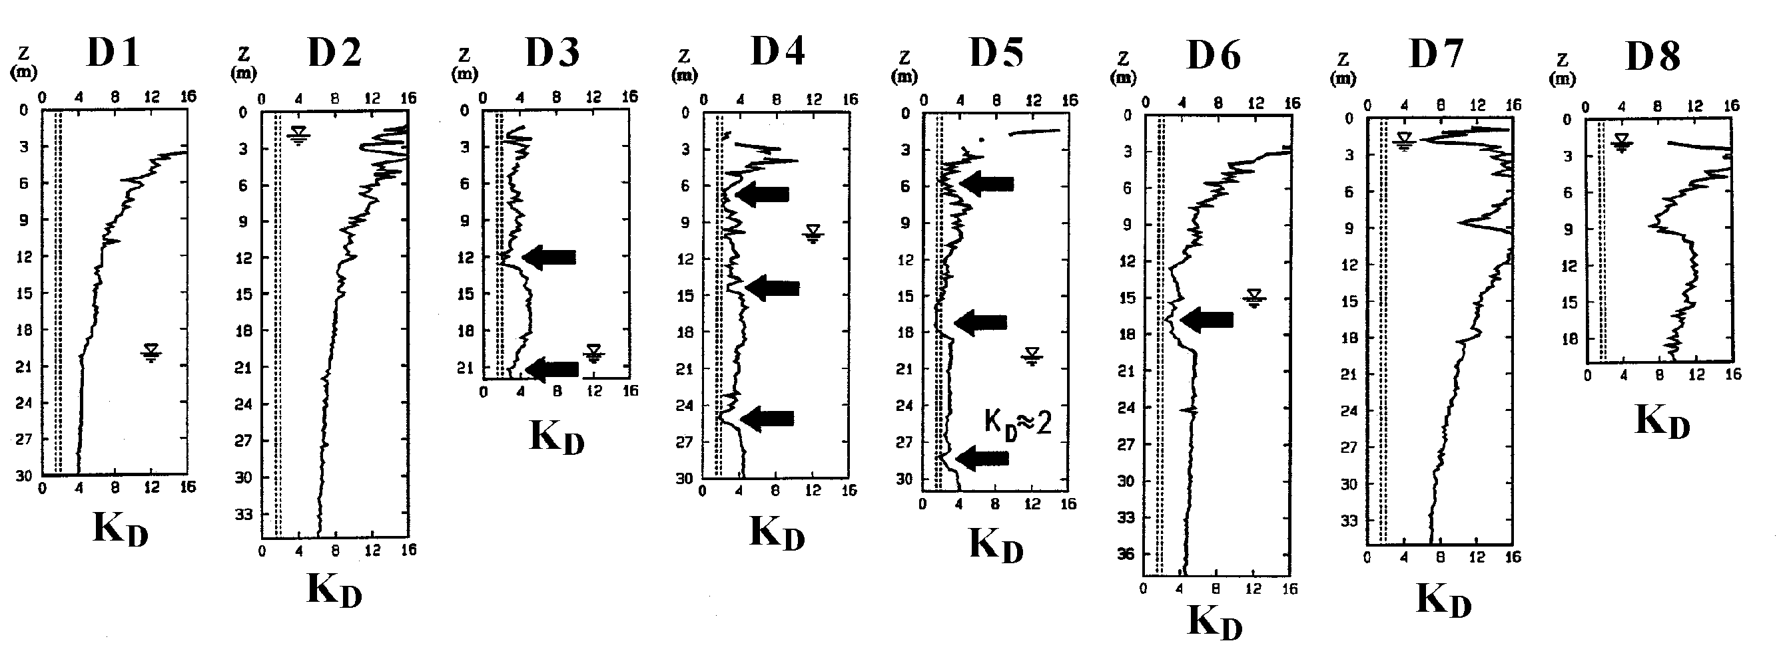
Central part "infected" by Kd ≈2 layers (bleeding wounds) = past/ present shear planes
sound clay
sound clay

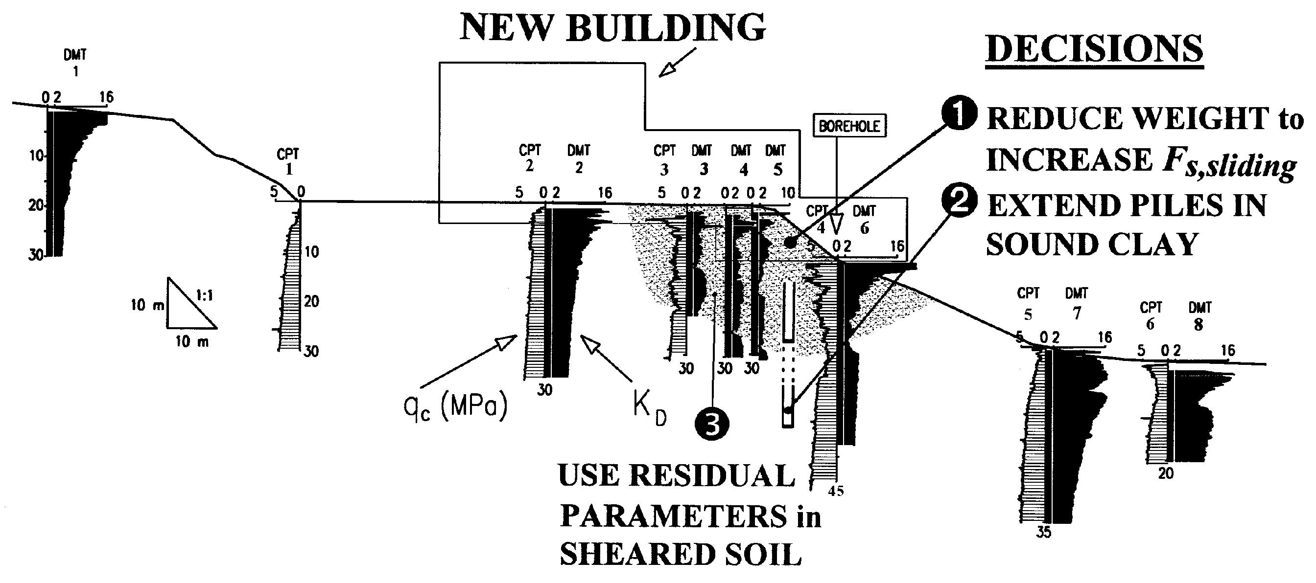

Examples of Kd ≈ 2 in SLIP SURFACES

LANDSLIDE "FILIPPONE" (CHIETI)
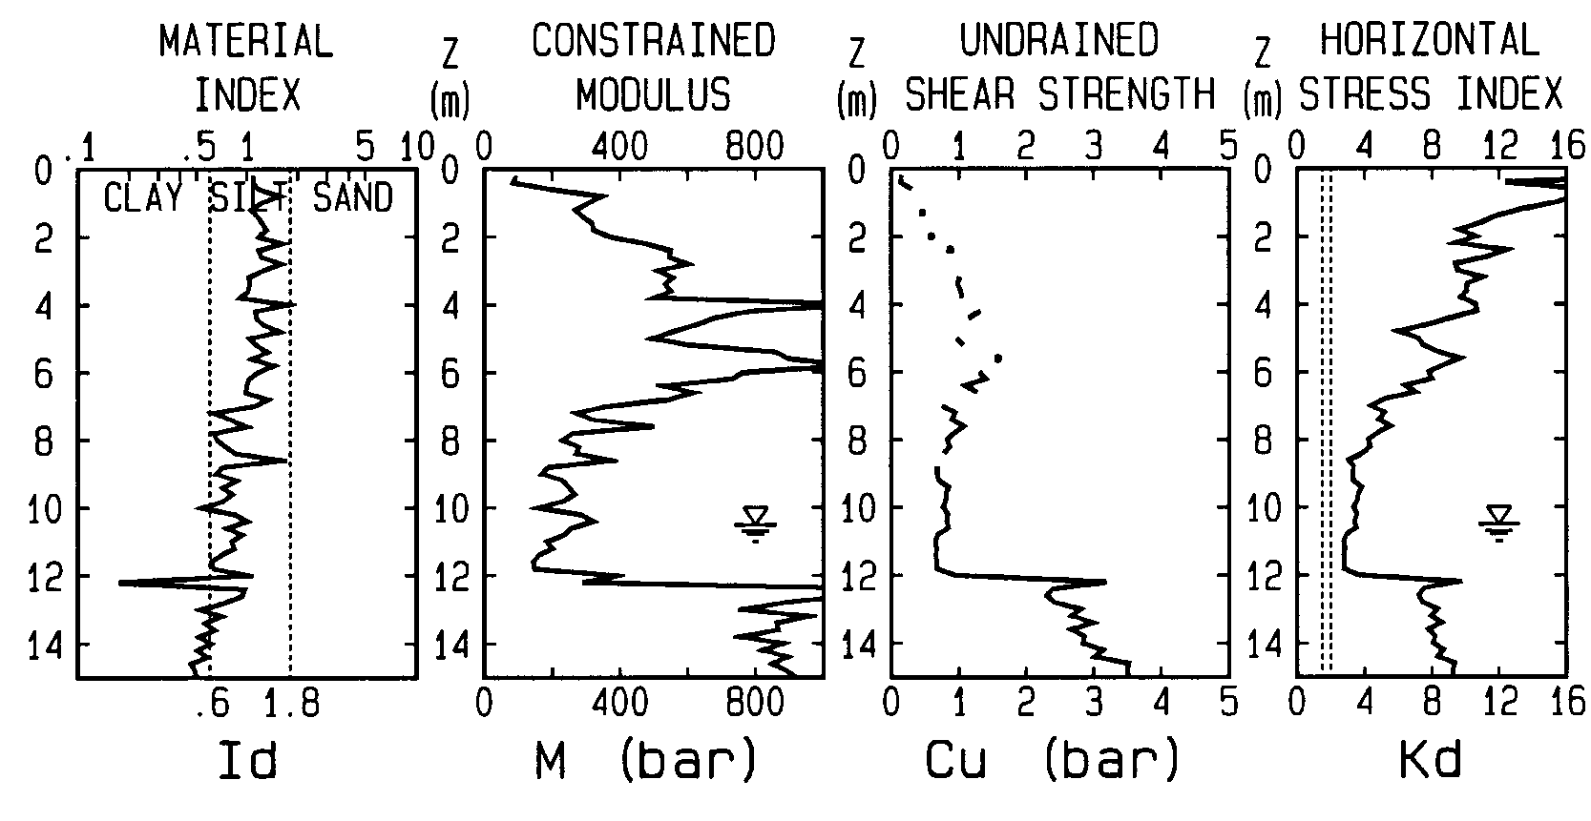
DOCUMENTED
SLIP SURFACE

LANDSLIDE "CAVE VECCHIE" (S.Barbara -AR)
DOCUMENTED
SLIP SURFACE

DMT for LATERALLY LOADED PILES
Recommended methods p-y curves from DMT:
Robertson et al. (1987)
Marchetti et al. (1991)

VALIDATIONS on FULL SCALE PILES by
Marchetti et al. (1991)
NGI (1998)
Georgia Tech (1998)
- The two methods similar results
- V. good agreement predicted-observed behavior

Note : DMT initially conceived for LL PILES
Similarity DMT - LL piles :
a. Structural element installed in soil
b. Lateral deformation

LL PILE GROUPS :
Ruesta & Townsend Jnl ASCE GGE, Dec. 1997

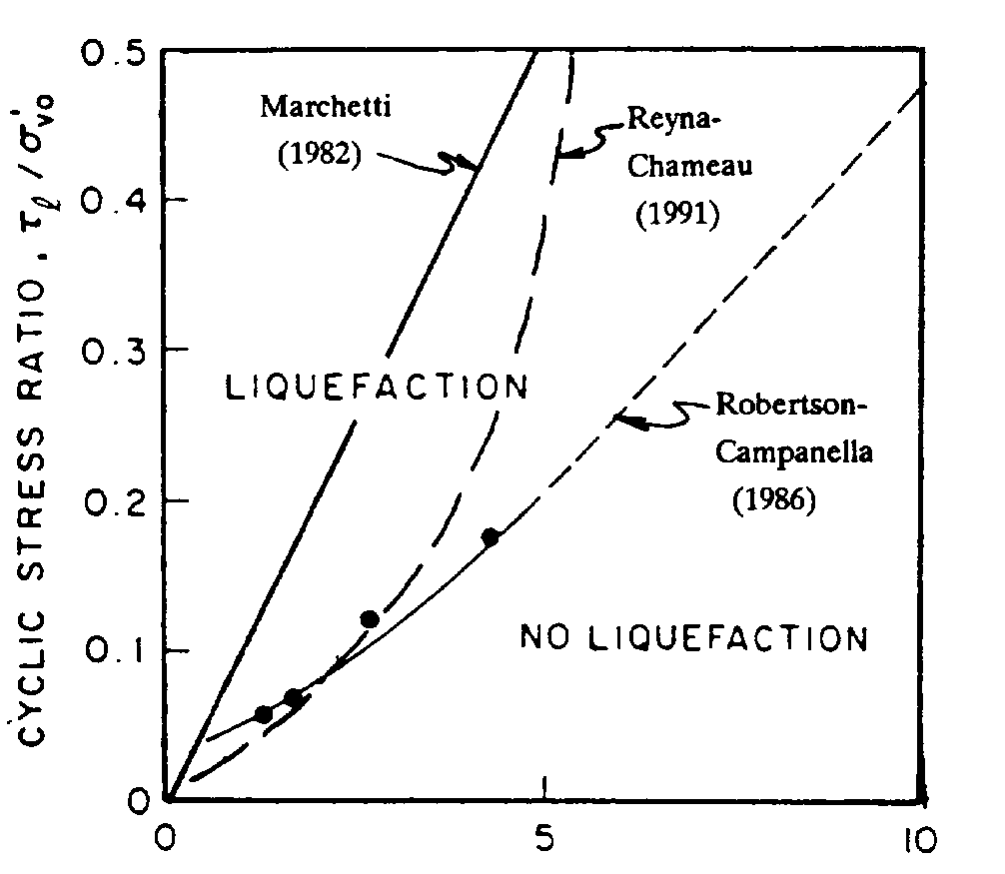
DMT FOR LIQUEFACTION
KD
Summarizes available knowledge →

- Enter KD in Reyna & Chameau curve (°) to estimate cyclic stress ratio to cause liquefaction
- Use Seed-like method.

- Above diagram + available information suggests that a clean sand (natural or sandfill) is adequately safe against liquefaction (M=7.5 earthquakes) if Kd :

Seismicity of the area | amax/g | Kd,min
Nonseismic | / | 1.7
Low seismicity | 0.15 | 4.2
Average seismicity | 0.25 | 5.0
High seismicity | 0.35 | 5.5

(Compacted sandfills normally easily exceed these Kd).

(°) Reyna, F. & Chameau, J.L. (1991) "Dilatometer Based Liquefaction Potential of Sites in the Imperial Valley" 2nd Int. Conf. on Recent Advances in Geot. Earthquake Engrg. and Soil Dyn.. St. Louis. May.

Correlation Kd-Dr for NC sands (Reyna-Chameau 1991)

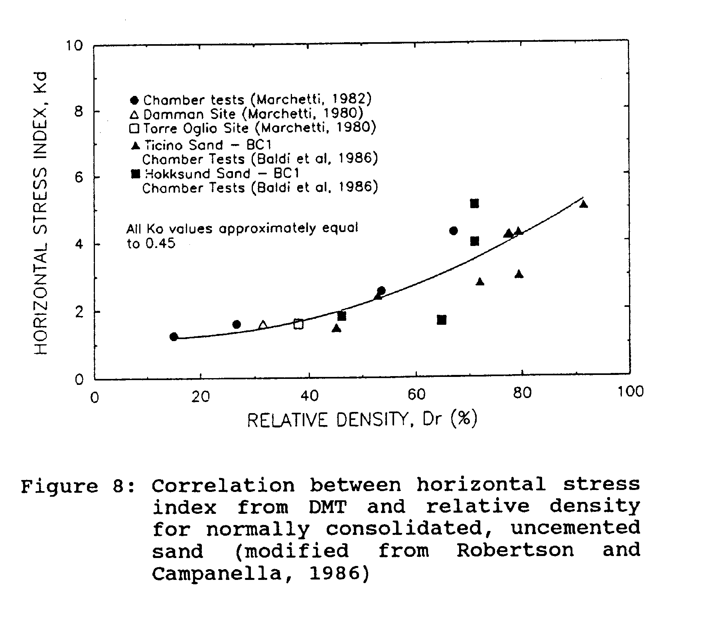
KEMIGAWA
OHGISHIMA

- Note new datapoints (rectangular areas) by Tanaka & Tanaka (1998) found on top quality freezed samples (Sept. 98, Jap. Soils & Found., p.61 Fig. 13)

- Since the Reyna-Chameau liquefaction curve largely rests on their Kd-Dr curve above, the new Japanese data reinforce indirectly the Reyna-Chameau liquefaction curve.

COMMENTS on using DMT
for liquefaction

- DMT demonstrated to be ≈ twice more sensitive than other tools to densification. Arguably also more sensitive to "liquefiability" (a state of "negative compaction").
- σ_{h}, OCR, aging and cementation (all factors increasing liquefaction resistance) are felt by K_{D}, but scarcely felt by other tests.
- In any case a less disruptive insertion in a liquefiable collapsible sand should increase meaningfulness of what is measured.

PROBLEMS IN EVALUATING LIQUEFACTION by CPT

- CPT Research (Sladen 1989, Yu, Schnaid, Collins 1997…) has shown, contrary to attempts by Been et al. (1987), that correlation Qc-SP (state parameter) is no unique.
- Use in design CRR (cyclic resist. ratio) from CPT ignoring non unicity of the SP-Qc correlation can lead/ has lead (Sladen), to catastrophic consequences (e.g. large scale subsea liquef. flowslides at Nerlerk, Canadian Beaufort sea).
- The strong dependence of the Qc-SP correlation on stress level (=non unicity), given the strong link SP-CRR, cast doubts on unicity of Qc-CRR correlation - unicity at the base of routine method of evaluating liquefiability by CPT.
- Sladen's conclusion : "while CPT is ideal for providing a qualitative profile, future research for assessing liquefiability should probably be directed towards other tools".

Sladen Geotechnique 1989, No.2
Yu et al. 1997, ASCE J. GGE, No. 9 Sept.
CONT PROBLEMS…

- Similar remark by Jamiolkowski's res. group (1985, 11 ICSMFE, S.F. V.4, p.1896 ), while questioning the use of Nspt and/or Qc for assessing liquefiability of sand deposits with complex stress-strain history. They state : "reliable predictions of CRR in such deposits require the development of some new in situ device [other than CPT or SPT] much more sensitive to the effects of past stress and strain histories".
- Also Robertson (1998 - Can. G. Jnl. June) warns that CRR evaluated by CPT (preferred to SPT, due to the poor repeatability) may be adequate for low risk, small scale projects. However for medium to high risk projects he recommends evaluating CRR by more than one method.

Dependency of Qc-SP correlation on stress level (Sladen), affects reliability of liquef. estimates by CPT.
- Dependency of Qc-SP correlation on stress level could be a problem specific of CPT, where arching, Qc(z) curvature… more pronounced.
- SPT & DMT ≈ unaffected by arching because :
SPT: blows/vibrations & shallow penetration
DMT : flat shape of probe.
- For linearity of SPT lines, see: Gibbs & Holtz, Christian & Swiger (ASCE GE 1975 No. 11), Skempton (Geotechnique Sept 1986).
- For linearity of po,DMT (Kd ≈ constant) see e.g the Venice Kd profile.

As to CRR from lab "undisturbed" samples:
- Reconstituted samples may bear little relation to the degree of compactness of the in situ sand (Christian & Swiger ASCE GE 1975 No. 11).
- Even good samples do not reflect in situ structure, fabric, aging - affecting significantly CRR
- Even high-quality fixed piston samples produce CRR values different from those on top quality freezed samples (Robertson, Can. G. Jnl. June '98).

CURVATURE - ARCHING
AFFECTS MAINLY CPT ?
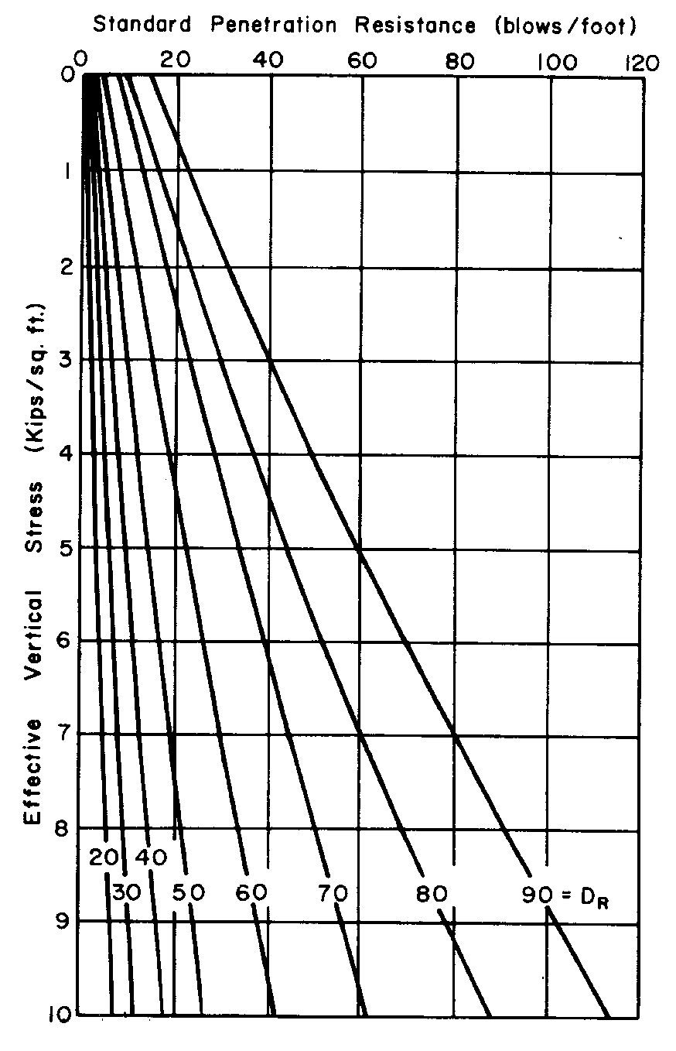
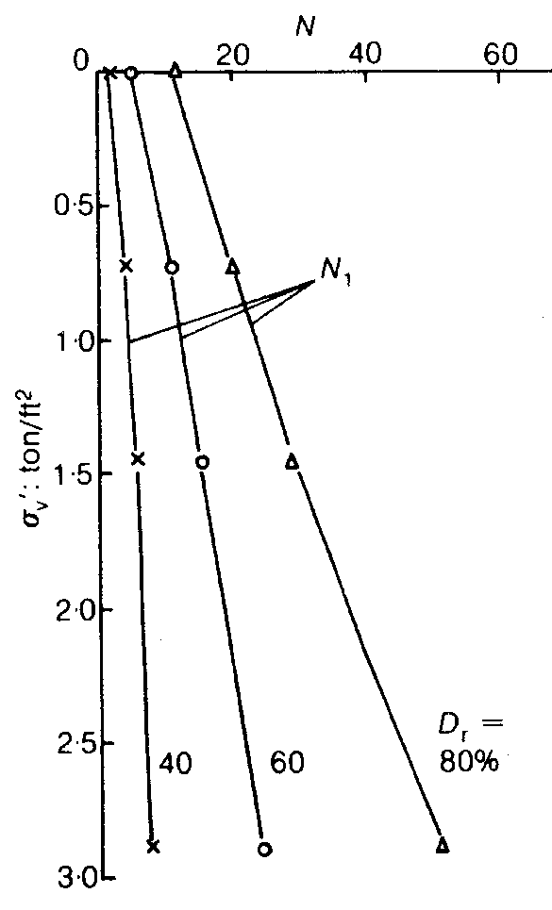
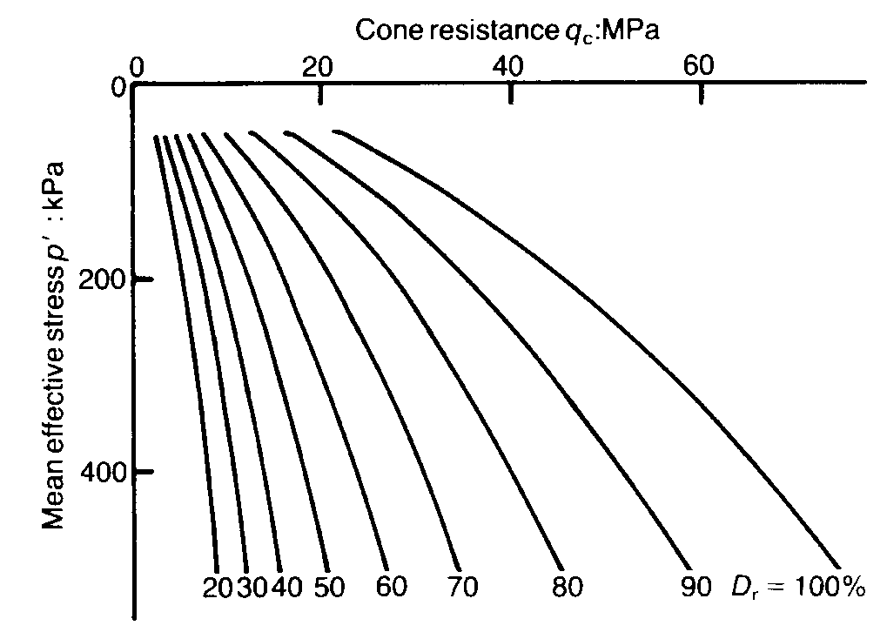
SPT
CPT
SPT
KD-DMT
Gibbs & Holtz (reported by Christian & Swiger, Asce GED, Nov '75)
Jamiolkowski's res. group - CC Ticino sand (reported by Sladen, Géotechnique, June '89)
Bieganousky & Marcuson '76 and '77 (reported by Skempton Géotechnique, Sept '86)
Venice , 60 m
(Marchetti, '99 "Sand liquefiability assess-ment by DMT", unpublished Techn. Note)

Kd constant
⇓
po linear

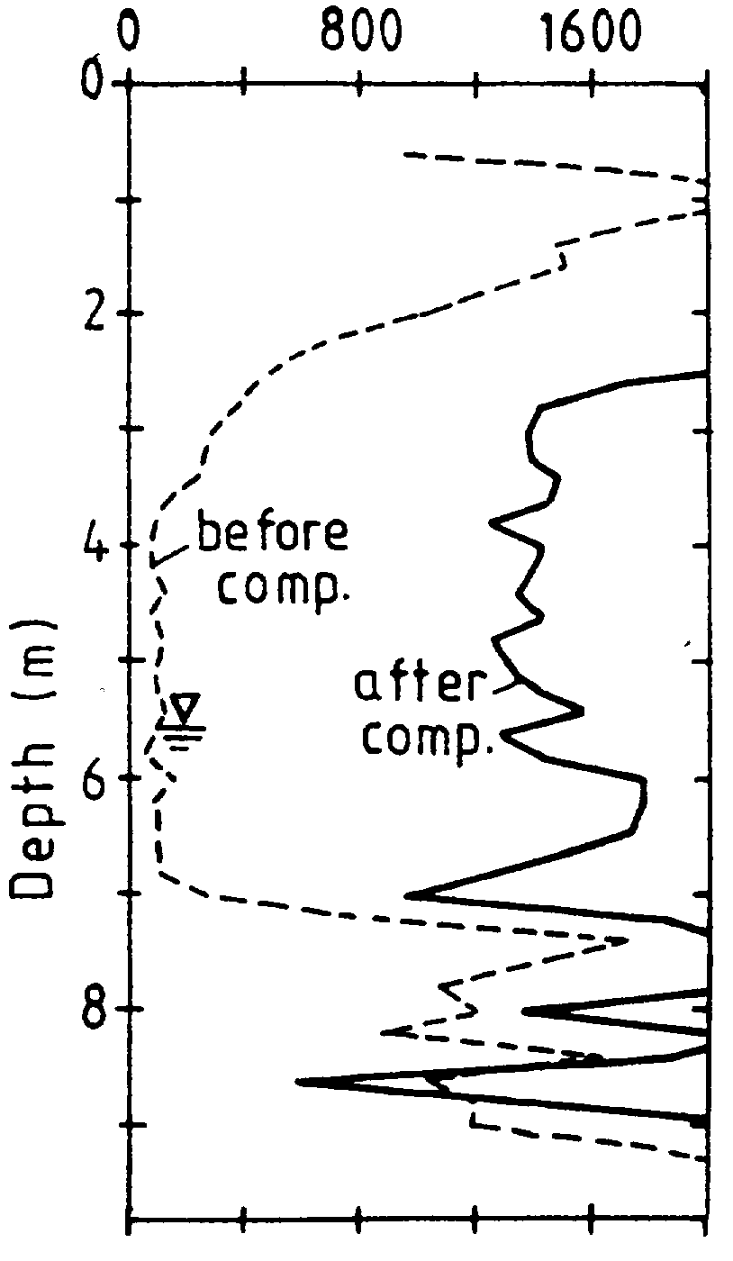
DMTbefore-after for
COMPACTION CONTROL
MDMT (bar)
Van Impe, De Cock, Massarsch, Mengé - New Delhi (1994) Vol.3 , p. 1151
Reasonant
vibrocompaction
technique

Since compaction increases MDMT at rate
≈ twice Qc (Schmertmann 1986, Jendeby 1992, Pasqualini & Rosi 1993, De Cock et al. 1993..)…
…DMT suitable when changes of σh, Dr difficult to detect by other methods
DMT usable to detect small changes σh, Dr e.g.:
- Relaxation behind diaphragm walls (Hamza '96)
- Compression/Decompression due to installation of piles (De Cock, Van Impe, Peiffer 1993.Bap 2 Ghent p.359)

COMPACTION CONTROL
Here, sensitivity of DMT to σh esp. advantageous.
In fact, if Qc is used to control compaction:
- Since Qc scarcely sensitive to σh
- Qc reflects PART of the benefit (benefit due to Δσh mostly missed !)
- Settlement predicted from Qc after compaction too big : +200-300% (Massarsch'94). Consequence : compact more than necessary ⇒ waste $
If Mdmt is used to control compaction:
- Since Mdmt incorporates σh,compaction
- Settlement predictions incorporate benefit of increased σh + realistic (lower). Waste avoided.

In general, since scope of compaction is to limit settlements, is more rational to base controls on modulus than Dr or Qc (Schmertmann, 1986)
Schmertmann, J.H., Baker, W., Gupta, R. & Kessler, K. (1986). "CPT/DMT Qc of Ground Modification at a Power Plant", Proc. "In Situ '86" ASCE Spec. Conf., Virginia Tech, Blacksburg, p. 985.

Correlations Qc-Dr for one sand may differ 20% for another sand. Specify "Dr = 80%" vague.
Dr elusive and NOT ultimate scope.

Dr In Situ ≈ UNMEASURABLE
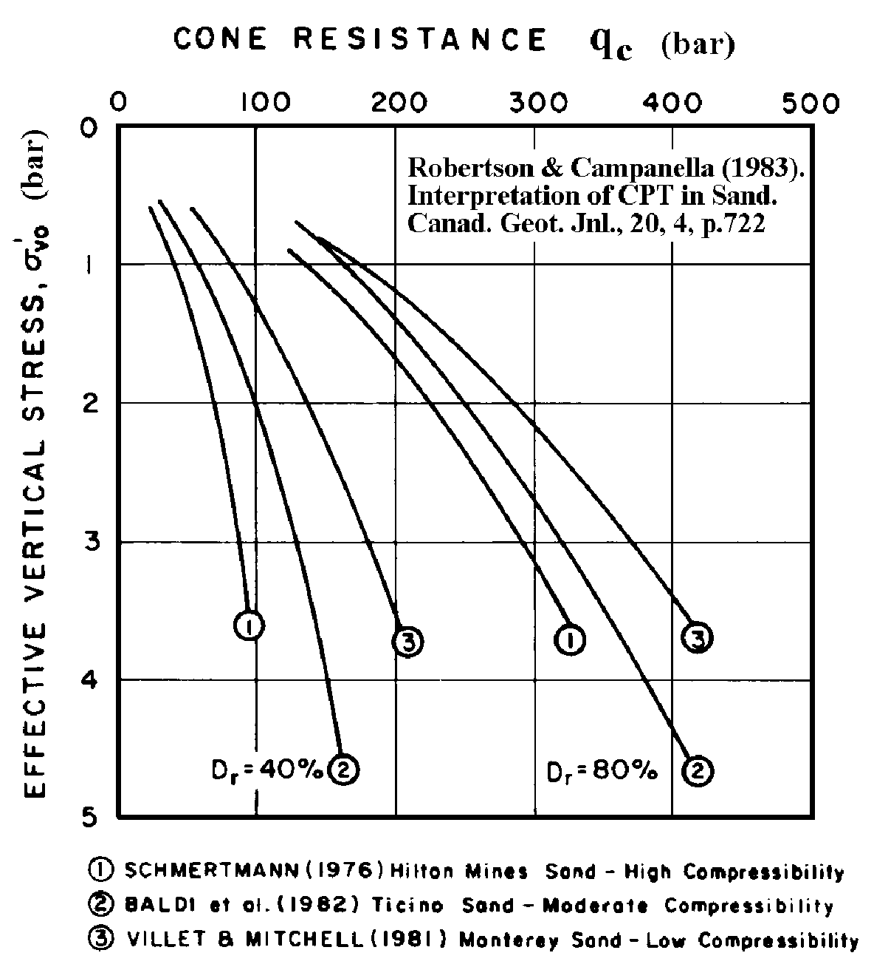
Jefferies & Been (CPT '95) : No unique mapping Qc–Dr applicable to all sand. Hilton mines sand at Dr=60% has same Qc as Monterey sand at Dr=40%.

Is a problem: in most jobs Dr = 40% definitely inacceptable, while 60% could still be acceptable.
(A way: Calibr. Chamber for each job ! non realistic).

Caveat for lab research (Ladd 1977 SOA Tokyo V.2, 461):
"The adequacy of using reconstituted lab sand specimens , even exactly (!) at the same in situ density (?), is highly questionable" (fabric/ particle orientation affect results)
(this even for CC + loss of nat. cementation, aging…)

DMT to control subgrade Compaction
Subgrade = top 30 cm soil supporting superstructure (compaction generally checked by CBR, Proctor, Eplate).
Two methods developed for DMT.

Method 1
Relate Ed to CBR (Borden 1986), or Ed to Eplate then use CBR, Eplate as usual....but physical mis-matching :
CBR, Eplate apply load on surface, Ed is a profile f(z).
Method 2 (a calibration)
Is based on the MDMT acceptance profile (see case history Marchetti 1994, to check subgrade of a 90 km road in Bangladesh).
- Perform a few preliminary DMTs in areas of accepted (vs conventional specs) subgrade, and define a MDMT acceptance profile
- Use such MDMT acceptance profile as an economical production method for quality control of compaction, with only occasional verifications

Bangladesh Subgrade Compaction Case History
Specs in terms of (Proctor/ CBR / Eplate) ⇒ in terms of Modulus
Specs were
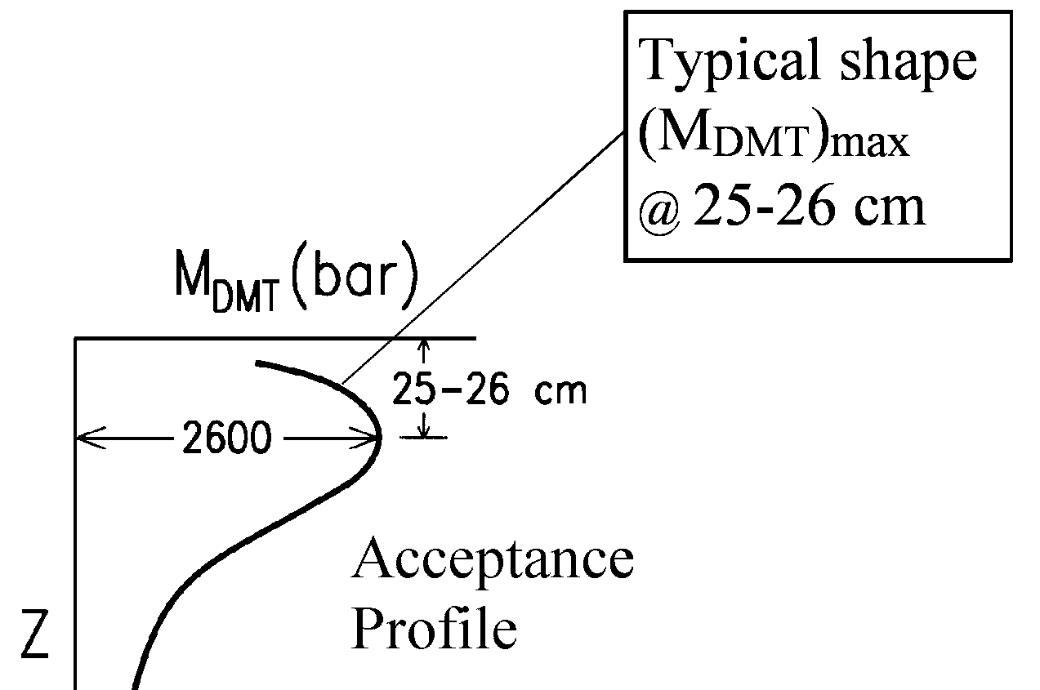
Modif. Proctor=95%
CBR = 10
Eplate =300 bar (0.5-1.5 bar)

DMT
in accepted
areas ➔

- V. fast (60 DMT profiles to 2-3 m / 10 cm, in 4 days). Avoided large n. time cons. CBR, Plate load tests.
- It would be helpful to define acceptance profiles similar to Fig. but pertaining to various classes of roads.

REASON OF STUDY : CLAIM
- Contractor unable to compact to specs top 30 cm without also compacting underlying low Dr sand.
(Δenergy + Δtime + Δsoil + Δ$ = claim)
- M_{DMT} clearly indicated ΔDr to ≈ 1.2 m >> 30 cm payed
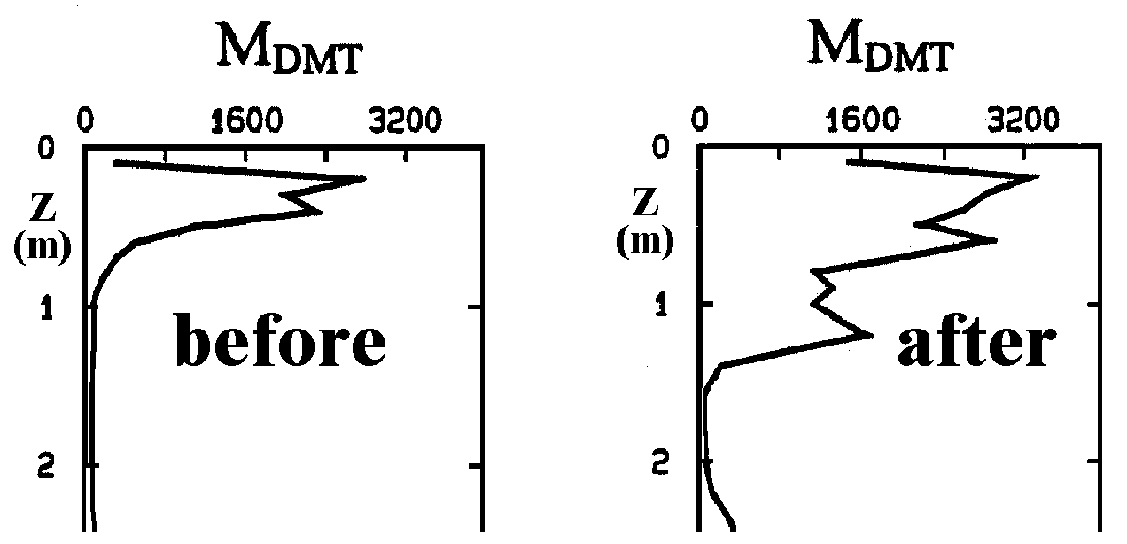

SUBGRADE MODULUS FOR MULTI ANCHORED DIAPHRAGM WALLS
Classic limit pressure methods (Terzaghi, Blum…) are inapplicable, because anchors limit deflections, hence Ka, Kp are not reached. Kh,winkler required. True interaction problem. (Pressure ?? not active/passive).
Deriving Kh (springs) from E or M (continuous) not univocal : models different. Yet engineers familiar with M, not Kh . Useful even crude relations M to Kh.
Many studies on M to Kh (see next page). Found : depends on inter-anchor distance, cantilever height, anchor stiffness… But in essence ≈ all arrive to similar conversion formulae :
- Balay '84 Kh ≈ 2M/B (for diaphragm walls)
- Viggiani '99 Kh ≈ M/B (for shallow foundations) (°)
M (1-D mod) can be taken as Mdmt (see p. 85).
B is a dimension representative of soil area loaded by the wall (often B taken as : free height for cantilever walls, distance of props for propped walls). Frequently: B ≈ 4m. (Fortunately even a factor 2 on B changes little the results).
Example Kh values : Using the above formula(Balay), a medium clay (M=100 bar) would have Kh= 5000 KN/m^3. A stiff sand (M=1000 bar) would have Kh= 50000 KN/m^3.

(°) The above approximate formula by Viggiani uses Boussinesq formula w=f(q,B,E,m) to calculate settlement of a shallow foundation of width B loaded by q, then Kh=q/w

For less primitive approximations on converting E to Kh for diaphragm walls see next page.

BIBLIOGRAPHY ON COEFFICIENT OF SUBGRADE REACTION (WINKLER) FOR DIAPHRAGM WALLS
Balay Jean (1984). "Recommandations pour la choix des paramètres de calcul des écrans de soutènement par la méthode aux modules de réaction - in French ". Note d'information technique, Ministère Urbanisme, Laborat. Central des Ponts et Chaussées, 18-22.
Potts and Fourie (1986). "A numerical study of the effects of wall deformation on earth pressures", Int. J. for Numerical and Analytical Methods in Geomech. 10, 383-405
Fourie and Potts (1989). "Comparison of finite element and limiting equilibrium analyses for an embedded cantilever retaining wall", Géotechnique, 39, No. 2, 175-188.
Vezole P. (1995). "Retaining walls. Ground - Structure interaction about the reaction coefficients method", in French. Revue Française de Géotechnique, N. 71, 2° trimestre 1995, 31-37
Schmitt. P.(1995). "Estimating the coefficient of subgrade reaction for diaphragm wall and sheet pile wall design", in French. Revue Française de Géotechnique, N. 71, 2° trimestre 1995, 3-10
Simon B (1995). "Comments relating to the choice of the coefficient of subgrade reaction for the design of earth retaining structures", in French. Revue Française de Géotechnique, N. 71, 2° trimestre 1995, 11-19.
Becci e Nova (1987). "Un metodo di calcolo automatico per il progetto di paratie", in Italian. Riv. Ital. Geot. 21, N. 1, 33-46
Viggiani C. (1999). Fondazioni, in Italian. Editor Cuen, p. 225.

DMT for FEM INPUT PARAMETERS
- Simplest use : lin. elastic, 1 param. E (ν). Hamza reports using E from DMT in Cairo Metro design (with E ≈ 0.8 MDMT)
- "Brute force" approach : model by FEM the complete DMT cycle. Vary input parameters until matching DMT responses. Drawback : need many additional (unknown) parameters
- A less ambitious - viable - approach :
- Assume tentative set FEM input parameters, (available soil info + experience of programmer)
- Simulate by FEM simple lab tests (e.g. oedo-meter) . Verify the matching MFEM vs MDMT.
- Adjust tentative set of FE parameters to improve matching
i.e. use MDMT as BENCHMARK. Could avoid gross mistakes in selecting deformation parameters. (Similar "squaring" possible on Cu - clays).
- Other approaches : identify an "equivalent average" DMT strain. Aim : generating a point in the G-γ degradation curve

CHECK FEM PARAMETERS by VERIFYING THEY PREDICT RIGHT SETTLEMENT UNDER SIMPLE FOUNDATIONS
Often FEM are used in complicated cases, when linear elasticity would give inadequate answer (e.g. settements outside diaphragm walls).
Yet, in simple geometries and simple loading , FEM model should yield prediction similar to conventional elastic with tried-and-trusted moduli.
E.g. conventional methods, with conventional moduli , should predict well settlement under a circular tank 5 m diameter with 100 Kpa load.
Hence a way to check FEM parameters.

MDMT values very close to "operative moduli" recommended by textbooks
MDMT are strikingly similar to Moduli recommended by classic textbooks e.g.

Type of soil  - Table 19.5 on p. 567 of: "Foundation Engineering Handbook". Winterkorn and Fang, Van Nostrand Reinhold Co.  - 1 Kg/cm2 ≈ 1 bar = 100 KPa  - E ≈ 0.8 M | E (Kg/cm2)
Very soft clay | 3.5-30
Soft clay | 20-50
Medium clay | 40-80
Hard clay | 70-180
Sandy clay | 300-400
Silty sand | 70-200
Loose sand | 100-250
Dense sand | 500-800
Dense sand & gravel | 1000-2000

- Agreement important because Moduli by Manuals carry heavy experim. weight. Tables are distilled normalized case histories.
- E from manuals have predicted satisfactorily for decades real settlements in real cases.

Alternatively, FEM elastic, with judicious choice of moduli (e.g. E ≈ 0.8 MDMT + reduction of E in unloading zones - e.g. by 4) may give (at least in simple loading cases) approx right deformation.

A disadvantage : Modeling DMT more difficult than axisymmetric for 2 reasons
- Problem 2-D ⇒ 3-D
- DMT involves 2 STAGES : Insertion + MEMBRANE expansion (not continuation)
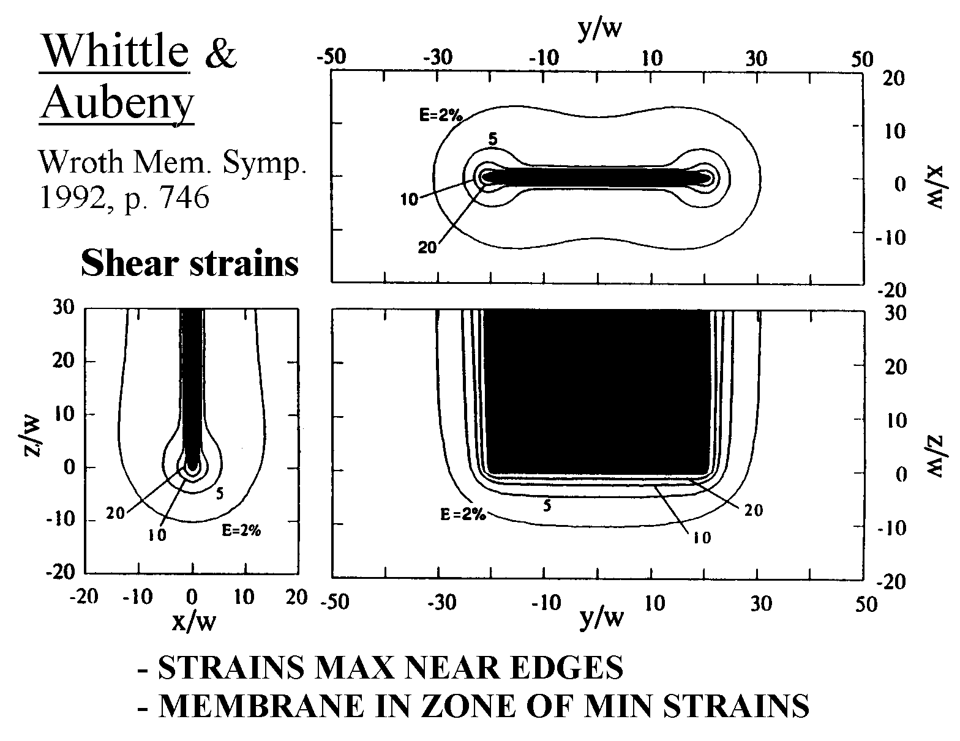
SOLUTIONS AVAIL. SOFAR ONLY for 1st STAGE

❶

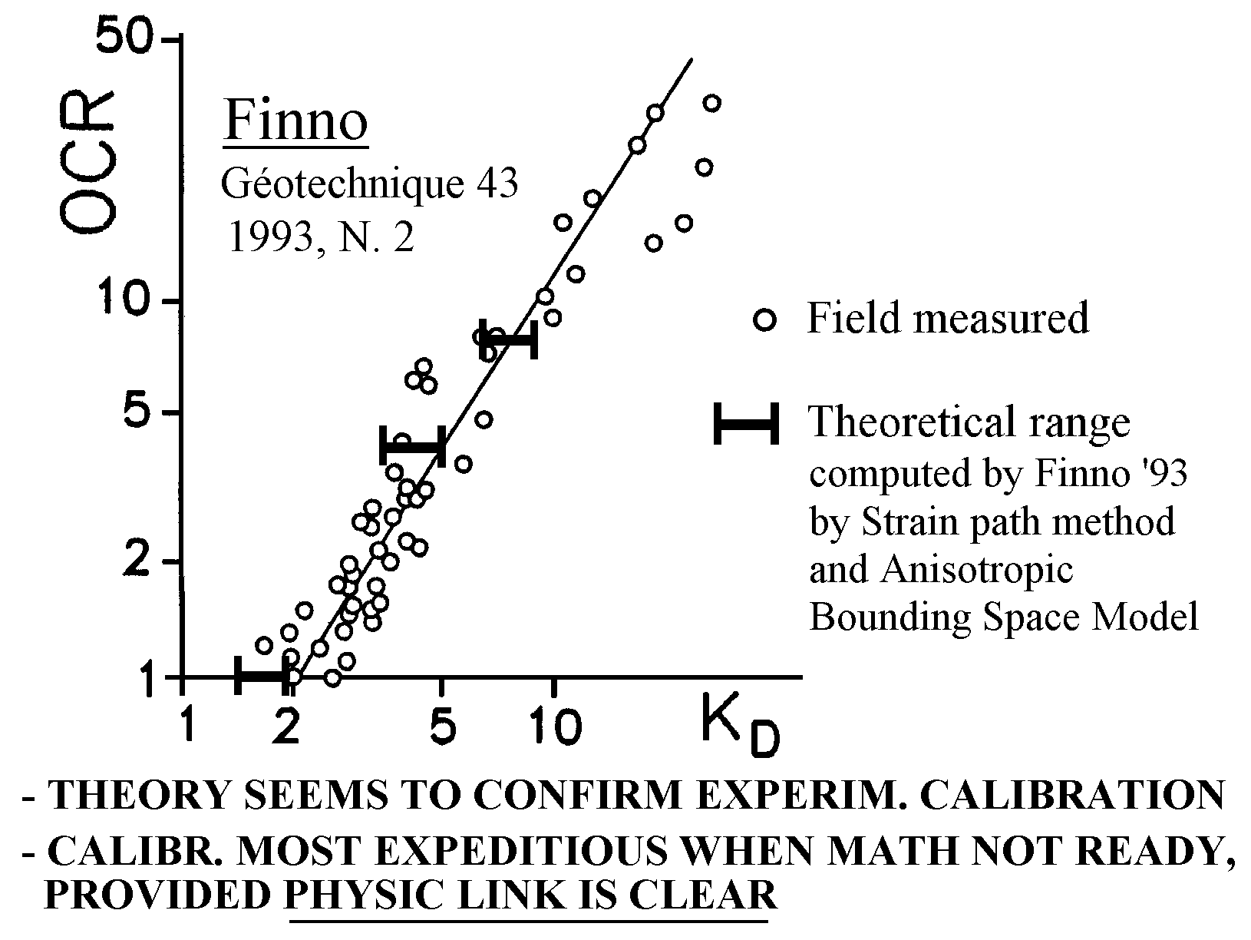
❷

❸ Yu et al. Another solution (Wroth Mem. Symp. 1992 p. 783)

DMT BEST APPLICATIONS
- M and Cu profiles
- Estimating settlements, deformation analysis
- Monitoring soil improvement
- Recognizing soil type
- Distinguish freely-draining layers from non f.d.
- Verify if a clay slope contains active/old slip surfaces

Useful information also on:
- OCR (uniquely sensitive to OCR details) and Ko in clay
- Coefficient of consolidation / permeability
- P-y curves for laterally loaded piles
- Sand liquefiability
- Friction angle in sand
- (Ko in sand + OCR)

PERCEIVED ADVANTAGES
EXECUTION
Quick, simple, economical, reproducible.
Variety of insertion equipment.
Very short training time
"Not many things can go wrong"

INTERPRETATION
- DMT a two-parameter test, one related to stress history (dominating soil behavior).
- Flat blade ≈ avoids arching typical of cylindrical probes, hence sensitivity to σh
- DMT uniquely sensitive to slight variations of σh and Dr
- Compaction : evidences benefits missed by other tests
- Settlement Calculations : Mdmt incorporates
σh / OCR effects. Available documentation indicate:
DMT reduces the settlement prediction bandwidth by a factor ≈ 3 compared with conical tips

ACKNOWLEDGMENTS
The writer expresses his appreciation to his longtime coworkers Totani G., Monaco P. and Calabresi M. for the enthusiastic cooperation and for the many original contributions and innovations in the development of the Flat Dilatometer and its Applications to Geotechnical Design.

Recommended further Dmt research
- Compare DMT-predicted vs observed settlements (execut e a couple of DMT nearby a foundation whose settlements have been observed)
- Having access to a geotechnically well documented (research) site : compare parameters predicted by DMT with established parameters.
- Assess the possibility of feeling relaxation behind a diaphragm wall by comparing DMT before/after the excavation
- Detect slip surfaces in OC clay slopes, as Kd=2 surfaces.
- Confirm the higher sensitivity of Mdmt compared with Qc by performing before-after CPT and DMT in compaction works.
- Attempt to feel aging, e.g. in sand tailings
- Usability of the ratio M/Qc as an indicator of Sigmah (Jendeby, 1992)
- Having the results of laterally load test on piles, perform a couple of DMT nearby, and evaluate accuracy of DMT predicted lateral displacements using Robertson 1987 method (p-y curves from DMT)
- Usability of MDMT with Schanz's (1997) method, in preparing input data for numerical analysis. In general : use of DMT for FEM parameters.
- Liquefaction : Relation Kd - Phi - State parameter in sand.
Start accumulating Kd profiles in sites that later have liquefied (to add datapoints in Fig. 22 of Cairo paper).
- Verify if a sand layer is safe against liquefaction if the currently recommended safe limits are met (see section on liquefaction).
- Compaction of subgrade (last top 30 cm of natural soil).
Establish Mdmt profiles for various degrees of required compaction (see Fig. 27 in Cairo paper).
- Interpretation in c', Phi' soils, and in unsaturated soils
- Having a Calibration Chamber :
- Penetrate to mid height. Increase Sigmah. Complete penetration. Compare increases in CPT & DMT
- Penetrate to mid height. Add a cementing agent. Complete penetration. Compare increases in CPT & DMT
- Having a sandy site (sand uncemented) of known Phi :
- Compare Phi evaluated by the (lower bound) Kd - Phi relationship in Fig. 12b of Cairo paper with the known Phi values
- Having an embankment (or a mat foundation) to be constructed :
- Monitor vertical strain of individual layers, compute Boussinesq DSigmav, backcalculate M, and compare it with Mdmt.
- Compare Ch,dmt (Ch,dmt=7 sqcm/Tflex) vs Ch from real life back calculations (then coeff. of permeability k)

